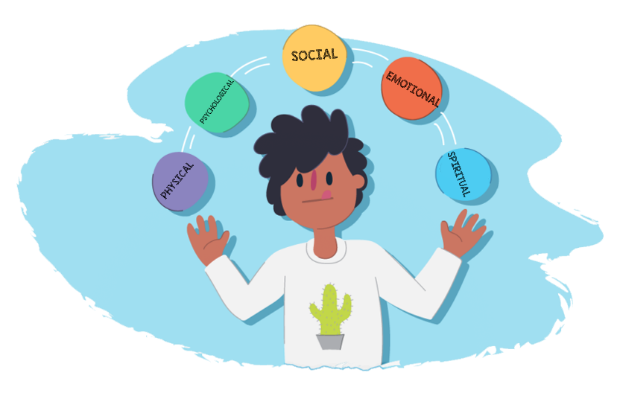

Lifestyle Choices
Development of the self in society

Grade 11- Term 3
Individual Research Project

DATE ISSUED:
DUE DATE:
Recommended Duration: 3 Weeks Total Marks: 90
Learner Information:
NAME AND SURNAME | ________________________________________________
GRADE 11 REGISTER CLASS | ________________________________________________
LO TEACHER | ________________________________________________

Summary of Assessment Rubric:
Activity | Description | Possible Mark | Mark Obtained | Moderated Mark
Section A | Question 1 | 20
 | Question 2 | 20
Section B | Question 3 | 30
 | Question 4 | 15
Section C | Referencing | 5
TOTAL |  | 90

Educator Feedback
______________________________________________________________________________________________________________________________________________________________

Instructions:
- This research assignment must be handed in on the ______________
- You will need to manage your time effectively in order to complete this project in time.
- In this task you will be required to complete Section A, B and C. Complete all the activities in each section. You will need to submit each activity typed out and attached to the cover page of this handout.
- In this project you will be required to research extensively and provide evidence of your research in your bibliography.
- The project should be well-structured by including the following aspects:
- A completed cover page with learner and task details (provided by the teacher).
- Correctly numbered answers to correspond with questions.
- Each section should be answered on a new page.
- The task must be bound/ stapled.
- Include a contents page as well as page numbers.
- Your teacher will explain the assessment process in detail.
- Consult at least five sources (excluding pictures) so that you have a well-rounded assignment. More sources will influence your mark positively.
- Cut out the following plagiarism declaration, sign and attach to your project.
PLEASE NOTE:
Plagiarism (to pass off someone else’s work as your own) is an act of fraud involving stealing someone else’s hard work and lying about it afterwards. Plagiarism is a serious and illegal offence. The following constitutes as plagiarism:
- Copying from a friend
- Copy pasting from a website or other source. All work MUST be in your own words.
- Using a source without crediting (referencing) the source
  - NB: Friends and teachers are not considered sources.
Plagiarism will not be tolerated at _[INSERT SCHOOL’S NAME]__ School.
I, _________________________________, hereby acknowledge that I understand the definition of plagiarism and to the best of my knowledge have not plagiarized any part of this project. I declare that all work contained in this project is my own work and I have acknowledged all sources that I used through the Harvard Referencing system.
Sign:____________________________ Date:_____________________

Section A:
Preparation:

As a Grade 11 learner who has lived through a year of the COVID-19 pandemic, there are several ways in which your life has changed. Developing a balanced lifestyle in 2021 is not what it would have been in 2019. In the first part of this project you will need to research and discover HOW the pandemic has impacted on the wellness of the teenager.

Read the following articles and research TWO other articles to provide you with the insight to set up relevant questions for an interview with your peers.
https://www.healthychildren.org/English/health-issues/conditions/COVID-19/Pages/Signs-your-Teen-May-Need-More-Support.aspx
https://www.webmd.com/lung/news/20210315/pandemic-has-harmed-mental-health-of-teens#1
https://mg.co.za/special-reports/2020-09-09-covid-19-childhood-and-adolescence-disrupted/

Question 1:
1.1 | Based on your research, set up a questionairre with a minimum of TEN questions aimed at teenagers between the age of 13-19. Your aim is to determine the impact of the pandemic on the health and lifestyle of a teenager.  Refer to the following in your questions:  - Physical impact on the teenager  - Emotional impact on the individual  - Psychological impact  - Social impact  - Increase in risk behaviour. | (5x1) (5)
1.2 | Using the questionnaire, interview TWO learners per grade at your school. Analyze the data from these interviews by performing the following:  - Draw a graph to report your findings.  - Write a paragraph in which you interpret the data using the following as a guide:  - What is the relationship between the different impacts of the pandemic and risk behaviours?  - Do you see a pattern in the different grades?  - In which grades are examples of the emotional impact the most pronounced? | (5x1) (5)  (10)
 |  | [20]

Question 2:
2. | Compile a wellness plan for the people you interviewed who are suffering because of the pandemic. In the form of a brochure / leaflet suggest:  - THREE practical steps they could take for each aspect towards a more balanced lifestyle. Explain how it will improve the lives of teenagers in the following areas: Physical/ Emotional/ Psychological / Social / Spiritual  - Provide TWO support systems available for teens struggling emotionally in your community. | (5x3) (15)  (5)
 |  | [20]
[TOTAL: SECTION A: 40]

Section B:
Question 3:
Statistically, substance abuse is on the increase amongst teenagers and parents since the beginning of the pandemic.

3.1 | Research ONE type of substance abuse and write an essay in response. In your essay:  - Define the type of substance abuse chosen and explain the dangers of this abuse to a developing teenager. | (1+4) (5)
 | - Identify and explain THREE factors that encourage youth to engage in this type of behaviour. | (3x2) (6)
 | - Evaluate the influence of poverty on the increase in substance abuse. | (2x2) (4)
3.2 | Based on your research, compile a Facebook entry to empower teenagers. Refer to:  - How to overcome substance abuse by making informed decisions | (5)
 | - Critically discuss TWO possible negative implications that peer pressure may have on substance abuse amongst students / high school learners.  - Recommend places/ organizations where a learner would find help to overcome substance abuse. | (5)  (5)
 |  | [30]
Question 4:

Positive role models can influence a teenager to change or influence them to choose a better future. These role models can include friends, parents, teachers or even celebrities.

4. | Write a reflective essay on ONE role model who has had a positive impact on you. In your essay reflect on:
 | - Who this person is and why they are your role model? | (1+1) (2)
 | - Discuss what attitudes and values you have learnt to embrace because of them? Provide examples of situations. | (3x3) (9)
 | - List FOUR ways that you could be a positive influence on your peers? | (4x1) (4)
 |  | [15]
[TOTAL: SECTION B: 45]
SECTION C:
You will be marked for your referencing for both Section A and Section B so be sure to follow the instructions regarding the Harvard Referencing Format, attached to this project. You will need to create a reference list (bibliography) according to the Harvard Referencing Style.
No reference list = ZERO for this section.
See below rubric for more information on mark distribution.
 | 0 - 1 | 2-3 | 4 | 5
Referencing, Presentation and editing | No reference list = 0  Just URLs/ titles listed = Max 1  Layout Instructions were not followed. Little or no effort went into making the reference list. Fewer than FIVE sources. | An attempted reference list with referencing techniques only partially adhered to.  Important aspects such as name, date and URL are present, but it lacks finer details such as publisher or name of website, etc. | Complete Harvard Reference List. Use of correct referencing techniques. No more than 3 minor errors or 1 major error. There is clear effort made to ensure that Harvard formatting instructions were followed. One or two extra sources were included. | A proper and complete bibliography. All sources perfectly referenced and listed alphabetically. Fantastic overall impression. Learner went over and above to ensure that the assignment was thoroughly referenced and included many extra sources.
[5]
[GRAND TOTAL: 40 + 45 + 5 = 90]

ADDENDUM A
Harvard Referencing Style
Referencing means that you give credit to the various sources you have used when writing your assignment/report.
All sources should be arranged alphabetically according to the surname of the first author.
1. Books
Author's surname and initials, year of publication, title (underlined), edition, place of publication, publisher.
Example:
Marais, B.V.C. and Horne, K.W.W. 2011. The influence of the media on public opinion, Pretoria: Juta
2. Journals
Author's surname and initials, year of publication of the journal, title of article, title of journal (underlines), volume, pages.
Example:
Wobbe, T. 2001. How to organise the unorganised, Human Resource Management, 12(8), 8-9.
3. Chapters in books
Author’s surname and initials, title of the chapter, title of the book (underlined), editor of book, place of publication, publisher, pages.
Example:
Gericke, H.B. The place democracy has in our country, in South Africa, the democratic ideal edited by J.J. Matthews. London: Benton: 44-45.
4. Newspaper articles
Author surname and initials, year, title, newspaper (underlined), date and month, page.
Example:
Louw, S.2002. Water crisis, what’s next. Daily news. 29 January: 7
5. Internet Referencing
Author surname and initials, year, title (on-line) Available: (full web address) Date accessed:
Example:
Unknown (2004) Sentient microfilaments: A tempest in a tubule (On-line). Available:
http:somecomputer.printer.edu/pub/harnad/psyc.95.3.26/consciousness/11/bixley
Date accessed: 5 May 2011.
6. Personal Interview
Surname and initials. Year. Personal Interview. Date, Place.
Example:
Malan, B.D. 2011. Personal Interview. 5 May, Stellenbosch.
Click on Reference toolbar in Word. Click insert Citation and choose your source e.g. webpage and fill in the information. Add citation and then add bibliography.
Reference instructions adapted: Expo 2014, L. Kroukamp

