GRADE 11 LIFE ORIENTATION
TOPIC:
INTEGRATED
(DSS, DHR, SER, CCC)
Term 1 & 2
2022
2 HOURS 100 MARKS

NOTE TO TEACHERS: This Teenactiv paper should be considered as a bank of questions for (SECTIONS B AND C ONLY) from which teachers can choose when creating their own paper. Remember, this is a bank of questions and therefore may contain some overlap. Please keep this in mind when selecting questions for your paper.
Ensure your paper covers EACH topic covered in terms 1 & 2.
The controlled test will comprehensively address the content, knowledge and skills covered during the first and second term and in the Recovery ATP.
Use the table below to help you when choosing your questions.
Weighting (suggested) | Weighting (Actual) | Cognitive level | Bloom’s taxonomy
30% (30 marks) | 30 marks | Lower Order | Level 1&2
40% (40 marks) | 40 marks | Middle Order | Level 3&4
30% (30 marks) | 30 marks | Higher Order | Level 5&6
Paper is aligned with the 2021 Grade 12 Examination Guideline
______________________________________________________________
INSTRUCTIONS AND INFORMATION
- The question paper consists of TWO sections, namely SECTION B and SECTION C.
- The questions in SECTION B are compulsory.
- Answer any TWO questions in SECTION C.
- Read ALL the questions carefully.
- Number the answers correctly according to the numbering system used in this question paper. Start each question on a new page.
- Write neatly and legibly.
- This paper consists of 8 pages and 5 questions. (28 pages including Memo)
SECTION B (Compulsory)
Answer all the questions in this section.
Write your answer in full sentences.
Question 2

Read the case study below and answer the questions that follow.
Dealing with environmental factors that cause ill-health on a personal level
It was noon on Sunday, 18 April, when Professor Kelly Chibale, the warden of Smuts Hall men’s residence, knew the historical building was in danger. The fire that had started in the Table Mountain National Park quickly spread on the University of Cape Town’s (UCT) upper campus.
Community members, businesses, CBOs and NGOs went out on a frenzy to quell down the raging fire. They actually forgot about their personal differences and worked as a unit to fight the fire. Students at UCT were devasted as their study goals may be thwarted. Some were already experiencing emotional health issues. They were worried about their assignments and what will become of them if everything went up in flames.
Some were concerned about tertiary education funding, if the year was wasted. The majority did not have the required registration fee. They were assisted by family members who could not further assist them. The personal and social challenges brought by the delays in the NSFAS funding makes things even worse.
[Adapted from https://www.news.uct.ac.za Accessed on February 2022]
.

- What does the acronym “CBO” stand for and state THREE ways in which CBOs could help the UCT students that lost their accommodation and personal possessions. (1+3) (4)
(Lower Order)

- Provide TWO reasons why study goals would even be more important to UCT students after the fire. (2x1) (2)
(Lower Order)

- Explain TWO ways in which the fire could have caused emotional ill-health in UCT students. (2x2) (4)
(Middle Order)

- Discuss TWO funding opportunities that those who lost everything in the fire could consider in order to continue with their studies. (2x2) (4)
(Middle Order)

  - Suggest THREE ways in which natural disasters, such as the UCT fire, could bring people together for a common cause (3x2) (6)
(Higher Order) (20)
Question 3
Refer to the extract below and answer the questions that follow.
Violent protest and the values of democratic participation in the provision of services!
Students have been protesting over financial exclusion, lack of NSFAS funding and transport allowance among other issues. Eastern Cape Premier Oscar Mabuyane has condemned the violence at the Walter Sisulu University following demonstrations that left four police officers injured. The institution has since shut down all campuses indefinitely after two vehicles were torched allegedly by protesters.
Protests are an important mechanism of raising dissatisfaction about the manner services are being provided. It is one of the values that the South African Constitution promotes. However, irresponsible and violent protests are not encouraged at all. If people engage in violent protests, there is a high likelihood that their pleas may not easily be attended to and they may also violate the rights of those who may not want to take part in it. Lack of adequate financial assistance to students at tertiary institutions in SA has been a challenge that the South African government has always been battling with.
Mabuyane said, “Violent protests are illegal and unproductive and we urge students to refrain from that kind of behaviour as it also puts the lives of other people in danger.”
[Adapted from: https://ewn.co.za Accessed on 23 April 2021]

  - Define the term ‘values’ and mention TWO reasons why the students, in the extract, do not seem to value the property that they are destroying at Walter Sisulu University. (1+2) (3)
(Lower Order)

  - Provide THREE responsible ways which the students should have considered to raise their displeasure. (3x1) (3)
(Lower Order)

  - Explain TWO ways how the lack of tertiary education funding could negatively affect underprivileged school leavers (2x2) (4)
(Middle Order)

  - Discuss THREE negative impacts the violent strike could have on the future academic progress of the Walter Sisulu University. (3x2) (6)
(Middle Order)
  - Recommend TWO ways in which organisers of protests could ensure that their protest is peaceful. (2x2) (4)
(Higher Order)
(20)
[TOTAL SECTION B: 40 MARKS]
SECTION C (Choice)
Answer any TWO questions in this section.
Your responses must consist of paragraphs.
Marks will only be allocated for responses written in full sentences.

Question 4

Study the following extract and answer the questions that follow.
South Africa looks to introduce electronic voting
Parliament has invited the Electoral Commission of South Africa (IEC) to respond to public comments on the Electoral Laws Amendment Bill, including questions around the introduction of electronic voting in South Africa for the enhancement of public participation in line with the principles of democracy.
[Adapted from: https://businesstech.co.za Accessed on 06 May 2021]

Write paragraphs on the potential for electronic voting in South Africa.

Use the following as a guideline:

- Define the term “public participation” and state THREE benefits for citizens of a country to participate in the law-making process (1+3) (4)
(Lower Order)

- Analyse TWO ways in which the use of electronics in the elections could help save the environment. (2x4) (8)
(Middle Order)

- Critically discuss TWO ways in which the usage of electronics for voting may cause problems in the elections. (2x4) (8)
(Higher Order)
(20)

Question 5

Study the cartoon below and answer the questions that follow.

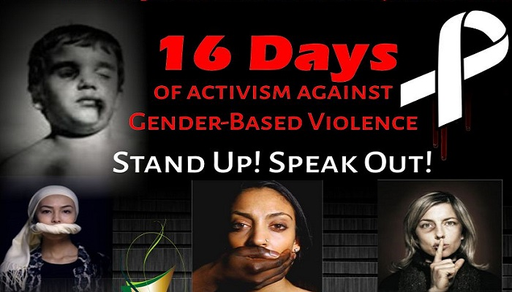

[Adapted from: https://www.vocfm.co.za Accessed on 06 May 2021]

Write paragraphs on 16 days of activism and Gender Based Violence (GBV).

Use the following as a guideline:

- Define the term ‘femicide’ and provide THREE social norms that may contribute to increased rates of femicide in South Africa. (1+3) (4)
(Lower Order)

- Analyse how bursaries dedicated for empowerment of abused woman could decrease incidents of GBV. (2x4) (8)
(Middle Order)

- Critically discuss strategies with which Faith-Based Organisation (FBO) could mobilise the community against GBV. (2x4) (8)
(Higher Order)

(20)
Question 6
Study the following cartoon and answer the questions that follow.

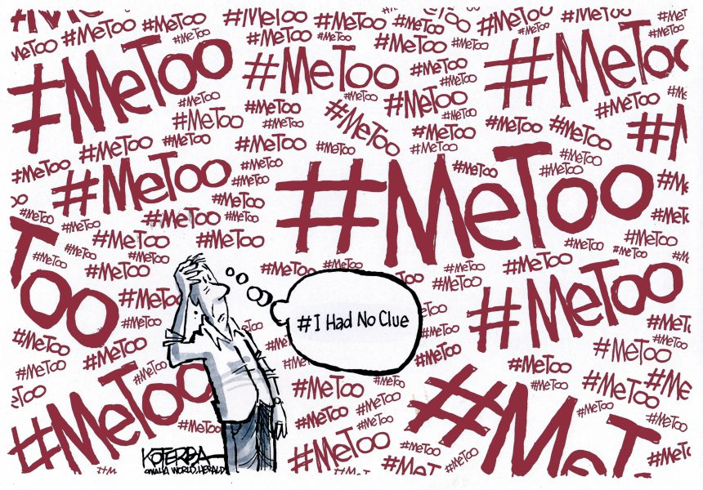

[Accessed from: https://www.cartooningforpeace.org on 09 May 2021]

Write paragraphs on sexual harassment.

Use the following as a guideline.

- Define the term ‘violence’ and provide THREE examples of the type of violence known as sexual harassment in the school grounds. (1+3) (4)
(Lower Order)

- Analyse TWO ways in which the anti-sexual harassment law could
effectively be used to successfully discourage sexual harassment in
South Africa. (2x4) (8)
(Middle Order)

- Critically discuss why boys and men might fail to realise the extent of the damage caused by sexual harassment. (2x4) (8)
(Higher Order)
(20)

[TOTAL SECTION C: 40 MARKS]
TOTAL = 40 + 40 = 80

