[INSERT SCHOOL’S NAME AND LOGO]
GRADE 11 LIFE ORIENTATION 2021

Term 1 – Group Written Task

Weighting (suggested) | Weighting (Actual) | Cognitive level | Bloom’s taxonomy
30% (27 marks) | 27 marks | Lower Order | Level 1&2
40% (36 marks) | 36 marks | Middle Order | Level 3&4
30% (27 marks) | 27 marks | Higher Order | Level 5&6

Due: Hand Out:
Topic: Democracy and Human Rights Marks: 90

Learner Information:
NAME AND SURNAME
GRADE 11 REGISTER CLASS
LO TEACHER

Activity | Description | Possible Mark | Mark Obtained | Moderated Mark
Question 1 | Effect of Covid-19 on the Public | 20
Question 2 | Governmental structures and Procedures during Covid 19 | 25
Question 3 | Sports During the Covid-19 Pandemic | 40
Referencing | Harvard Referencing | 5
TOTAL |  | 90

Learner Reflection on task and their performance:
________________________________________________________________________________________________________________________________________________________________________________________________________________________________________________________________________________________________________________________________________________

Feedback to learner (please check feedback inside task as well)
________________________________________________________________________________________________________________________________________________________________________________________________________________________________________________________________________________________________________________________________________________

INSTRUCTIONS
- Get into groups of no more than THREE and complete the following project.
- Each group member MUST have their own copy of the written task for their portfolio.
- A completed group participation form must be completed and attached to each member’s task. This should be completed privately and kept confidential.
- Group members should divide this task into parts which each member is responsible for. Be reasonable and don’t just take mark allocation into account when dividing the task. Also look at amount of research required.
- This written task must be handed in on the ______________
- You will need to manage your time effectively in order to complete this task in time.
- The task should be well-structured, by including the following aspects:
- Use the cover page provided on the front of this task.
- The text of your assignment must be divided into paragraphs/sections as indicated in the instructions/criteria of the assignment.
- Start each section on a new page.
- This task must be stapled together.
- Relevant pictures, photos, diagrams and graphs may be included. (These should include captions underneath and references in your reference list).
- Include a contents page as well as page numbers.
- The use of proper spelling and grammar with count in your favour.
- Read through the assignment carefully, paying special attention to mark allocations so that you know what is expected of you.
- Include a reference list (bibliography) in the Harvard referencing style. Notes will be attached to help you.
- Consult at least five sources (excluding pictures) so that you have a well-rounded assignment. More sources will influence your mark positively.
- Each group member must cut out the following plagiarism declaration, sign and attach to their project. Please see plagiarism declaration on the next page.

PLEASE NOTE:
Plagiarism (to pass off someone else’s work as your own) is an act of fraud involving stealing someone else’s hard work and lying about it afterwards. Plagiarism is a serious and illegal offence. The following constitutes as plagiarism:
- Copying from a friend
- Copy pasting from a website or other source. All work MUST be in your own words.
- Using a source without crediting (referencing) the source
  - Friends and teachers are not considered sources
Plagiarism will not be tolerated at _[INSERT SCHOOL’S NAME]__ School.
I, _________________________________, hereby acknowledge that I understand the definition of plagiarism and to the best of my knowledge have not plagiarised any part of this project. I declare that all work contained in this project is my own work and I have acknowledged all sources that I used through the Harvard Referencing system.
Sign:____________________________ Date:_____________________

Question 1: Businesses as Democratic Structures during Covid-19
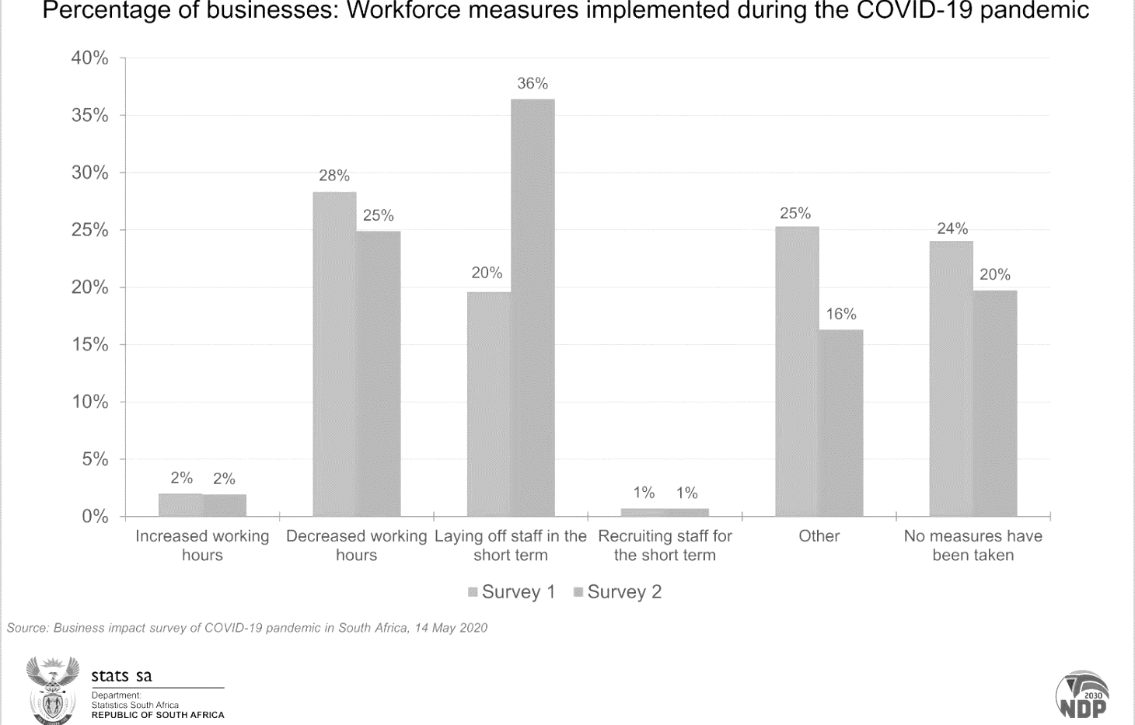
One-way businesses can contribute to democracy is by challenging the government to build better infrastructure to grow. They have the resources to ensure democracy through job opportunities and influence on the economy. Study the graph on measures taken by South African businesses during Covid-19 below and answer the questions that follow.
Accessed from: http://www.statssa.gov.za on 15 January 2021

- Give THREE interpretations from the data on the graph about the measures that South African businesses deemed necessary during Covid-19. (3x1)(3)
(Lower Order)
- Mention THREE ways how the data from the graph could negatively affect civil society. (3x1)(3)
(Lower Order)
- List THREE options for financial assistance available to those school leavers whose primary caregivers lost their jobs. (3x1)(3)
(Lower Order)
- Explain TWO ways that goal setting can help learners of the individuals who have lost their income due to Covid-19 positively change their situation. (2x2)(4)
(Middle Order)
- Discuss TWO reasons why public participation is important in a democratic society during the pandemic. (2x2)(4)
(Middle Order)
- Suggest ONE strategy that families can put into place to help improve the well-being of their family member who lost their job. In your answer, also indicate how the strategy will help to put the family member in a more positive mindset. (1x3)(3)
(Higher Order)
[20]
Question 2: Governmental Structures and Procedures During covid-19
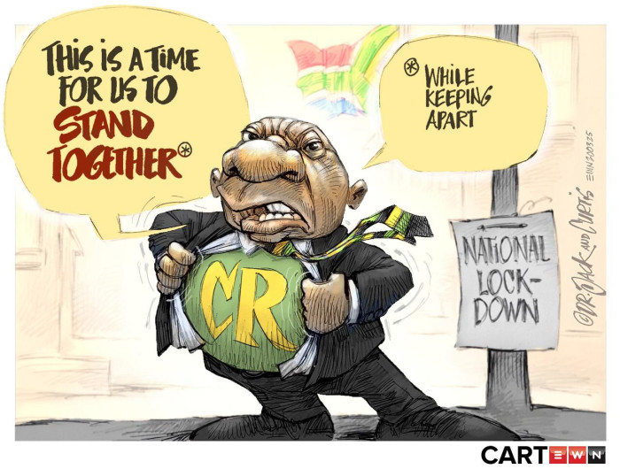
Read the extract from a study conducted by SABC news and the corresponding graph, then answer the questions that follow.
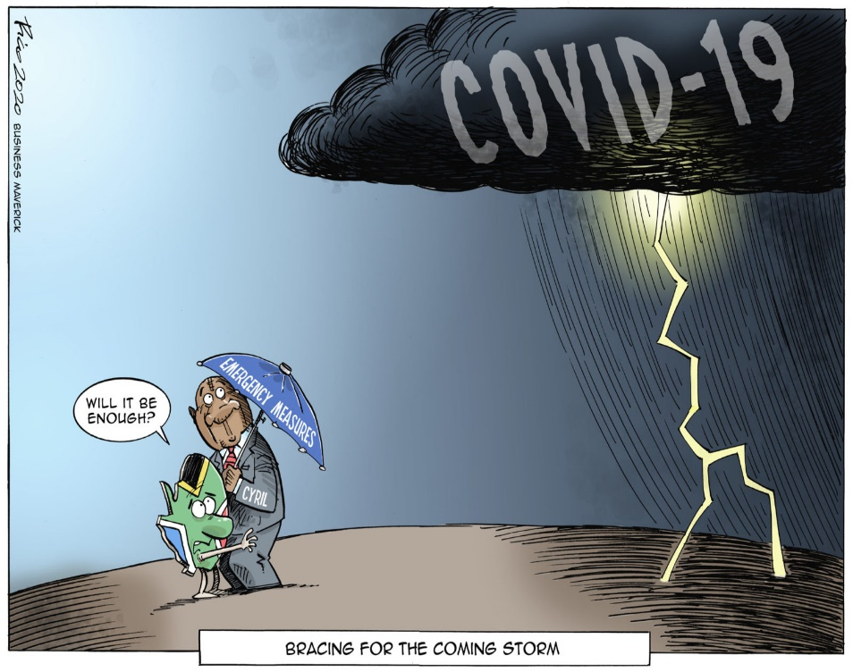
Accessed from: https://www.dailymaverick.co.za on 05 January 2021
- Define the term ‘governance’ and state the importance of cooperative governance. (1+1)(2)
(Lower Order)
- List the FIVE pillars that fall under the rule of law. (5x1)(5)
(Lower Order)
- Describe TWO ways how the rule of law may not have been carried out during lockdown. (2x2)(4)
(Middle Order)
- Discuss TWO ways how South Africa has received good governance during the Covid-19 pandemic (2x2)(4)
(Middle Order)
- Explain how a lack of the following could be detrimental to our country during this time of crisis.
  - Transparency
  - Representation of the diverse South African population (2x2)(4)
(Middle Order)
- Suggest TWO possible strategies that the government could put into place to ensure greater accountability within their ranks during the pandemic. In EACH of your answers, also indicate how this could lead to better governance overall. (2x3)(6)
(Higher Order)

[25]
Question 3: Sports During the Covid 19 Pandemic
England’s tour of South Africa lurched back into crisis on Sunday when the first one-day international was cancelled and two members of Eoin Morgan’s touring party tested positive for Covid-19.

The match in Paarl had officially become the series-opener after a positive case in the South African camp on Friday – their third since England’s arrival on 17 November – led to the initial fixture at Newlands being called off and a fresh round of testing ordered for the home squad. But an hour before the start of play it became apparent this game was in doubt when neither team appeared at the ground.

The announcement of a delayed start was then followed by the match’s full cancellation. Monday’s second ODI will not take place until Tuesday at the earliest, and the entire tour is in jeopardy. England still have an enlarged 18-man squad here – down from 23 during their 3-0 series win in the Twenty20s – and the new “best-case” scenario is described as two back-to-back 50-over matches at Newlands on Tuesday and Wednesday.

Accessed from: https://www.theguardian.com on 25 January 2021

- Define the term ‘good sportsmanship’ and mention THREE ways that national sports teams can display good sportsmanship during their matches. (1+3)(4)
(Lower Order)
- Mention TWO ways that spectators can display good sportsmanship when supporting live matches. (2x1)(2)
(Lower Order)

- Discuss THREE triggers that could cause negative spectator behaviour during live matches. (3x2)(6)
(Middle Order)

- Explain THREE reasons why sports professionals should avoid negative behaviour on the field during live matches. (3x2)(6)
(Middle Order)

- Describe TWO ways that sports players could keep themselves safe from Covid-19 during practices and matches. (2x2)(4)
(Middle Order)
- Analyse how nation building through sports could help the country heal financially after the Covid-19 pandemic has passed. In your answer, also indicate how the country would be in a better financial state because of sports. (1x3)(3)
(Higher Order)
- Evaluate TWO ways how the reopening of national sports matches could help relieve the stress from lock down and the Covid-19 pandemic. In EACH of your answers, also indicate the this could lead to a more positive mental state. (2x3)(6)
(Higher Order)
- Recommend THREE practical strategies how sports professionals could inspire the nation to stay safe and take the necessary Covid-19 precautions. In your answers, also indicate how EACH of these recommendations could lead to a safer South African community. (3x3)(9)
(Higher Order)
[40]
Referencing:
You will be marked for your referencing for both Section A and Section B so be sure to follow the instructions regarding the Harvard Referencing Format, attached to this task. You will need to create a reference list (bibliography) according to the Harvard Referencing Style. All pictures will need to have a reference in your reference list as well as a caption underneath each picture. Please see rubric below for further guidance. (5)
(Lower Order)
 | 0 - 1 | 2-3 | 4 | 5
Referencing, Presentation and editing | No reference list = 0  Just URLs/ titles listed = Max 1  Layout Instructions were not followed. Little or no effort went into making the reference list. Fewer than FIVE sources. | An attempted reference list with referencing techniques only partially adhered to.  Important aspects such as name, date and URL are present, but it lacks finer details such as publisher or name of website, etc. | Complete Harvard Reference List. Use of correct referencing techniques. No more than 3 minor errors or 1 major error. There is clear effort made to ensure that Harvard formatting instructions were followed. One or two extra sources were included. | A proper and complete bibliography. All sources perfectly referenced and listed alphabetically. Fantastic overall impression. Learner went over and above to ensure that the assignment was thoroughly referenced and included many extra sources.

No reference list = ZERO for this section.

Addendum A - Group Participation Form:
Each group member must give feedback on themselves as well as their fellow group members. Be honest about everyone’s participation, attitude and work ethic during the whole task.
- Please complete this privately and keep your feedback confidential.
- You should attach this form to the back of your personal copy of the task.
When rating your group members, consider their circumstances and what they could reasonably do. A 1 would mean that they did nothing or close to nothing and a 5 would mean that they worked hard within the group and completed their part of the project to the best of their abilities and up to the standard of the group.
The comment section should help you to validate why you gave the rating to your group mate.

Name of Group Member: | Part of project they were responsible for: | Comment on work ethic, attitude and participation: | Rating out of five:
1.

2.

3.

Addendum B - Referencing: Harvard Style
Referencing means that you give credit to the various sources you have used when writing your assignment/report. All sources should be arranged alphabetically according to the surname of the first author.
1. Books
Author's surname and initials, year of publication, title (underlined), edition, place of publication, publisher.
Example:
Marais, B.V.C. and Horne, K.W.W. 2011. The influence of the media on public opinion, Pretoria: Juta
2. Journals
Author's surname and initials, year of publication of the journal, title of article, title of journal (underlines), volume, pages.
Example:
Wobbe, T. 2001. How to organise the unorganised, Human Resource Management, 12(8), 8-9.
3. Chapters in books
Author’s surname and initials, title of the chapter, title of the book (underlined), editor of book, place of publication, publisher, pages.
Example:
Gericke, H.B. The place democracy has in our country, in South Africa, the democratic ideal edited by J.J. Matthews. London: Benton: 44-45.
4. Newspaper articles
Author surname and initials, year, title, newspaper (underlined), date and month, page.
Example:
Louw, S.2002. Water crisis, what’s next. Daily news. 29 January: 7
5. Internet Referencing
Author surname and initials, year, title (on-line) Available: (full web address) Date accessed:
Example:
Unknown (2004) Sentient microfilaments: A tempest in a tubule (On-line). Available:
http:somecomputer.printer.edu/pub/harnad/psyc.95.3.26/consciousness/11/bixley
Date accessed: 5 May 2011.
6. Personal Interview
Surname and initials. Year. Personal Interview. Date, Place.
Example:
Malan, B.D. 2011. Personal Interview. 5 May, Stellenbosch.

