GRADE 10 LIFE ORIENTATION
TOPIC:
INTEGRATED
(DSS, DHR, SER, CCC)
Term 1 & 2
2022
2 HOURS 100 MARKS

NOTE TO TEACHERS: This Teenactiv paper should be considered as a bank of questions for (SECTIONS B AND C ONLY) from which teachers can choose when creating their own paper. Remember, this is a bank of questions and therefore may contain some overlap. Please keep this in mind when selecting questions for your paper.
Ensure your paper covers EACH topic covered in terms 1 & 2.
The controlled test will comprehensively address the content, knowledge and skills covered during the first and second term and in the Recovery ATP.
Use the table below to help you when choosing your questions.
Weighting (suggested) | Weighting (Actual) | Cognitive level | Bloom’s taxonomy
30% (30 marks) | 30 marks | Lower Order | Level 1&2
40% (40 marks) | 40 marks | Middle Order | Level 3&4
30% (30 marks) | 30 marks | Higher Order | Level 5&6
Paper is aligned with the 2021 Grade 12 Examination Guideline
______________________________________________________________
INSTRUCTIONS AND INFORMATION
- The question paper consists of TWO sections, namely SECTION B and SECTION C.
- The questions in SECTION B are compulsory.
- Answer any TWO questions in SECTION C.
- Read ALL the questions carefully.
- Number the answers correctly according to the numbering system used in this question paper. Start each question on a new page.
- Write neatly and legibly.
- This paper consists of 7 pages and 5 questions. (26 pages including Memo)

SECTION B (Compulsory)
Answer all the questions in this section.
Write your answer in full sentences.

Question 2
Read the extract below and answer the questions that follow.

Crossing the Divide: A parent’s guide to understanding our transgender children

Diversity, discrimination and violation of human rights

As a mother, all I really want is for my kids to have a life that is ‘normal’ as possible. What I mean is that I want my kids to have a simple life, free of challenges and obstacles like bullying, peer pressure and social isolation. What is considered to be normal is different for every family, community and society.

As a fellow human being who knows children will one day be required to be self-reliant adults, I know that overcoming hurdles and finding their own strength is critical to developing their self-awareness and self-esteem. Assuming your self-identity comes as a result of your ability to reach a certain degree of self-awareness.

In my experience, questions and concerns about children expressing a different gender to the one they were assigned at birth are coming up more and more frequently. Parents are learning terms such as "non-binary", "gender dysphoria" and "transgender".

Through the media, parents are discovering that schools are moving towards gender-neutral uniforms and shared bathrooms. However, there is more to this than the pros and cons of ¹hormone blockers and whether schools should have shared bathrooms.

Although those conversations must be entertained – our children's physical and mental health is more important. It is our social responsibility to explore how we can help all children navigate this diverse and inclusive new world. We need to ask, how we, as their parents, can guide them to discover their true selves, so that they grow into the people they are meant to be, no matter their gender.

Glossary:
¹hormone blockers - shut down the hormonal process in a developing tween/teen.

[Adapted from https://https://www.news24.com/. Accessed: 31 March 2022]

- Define the term ‘transgender’ and mention THREE reasons why parents may have difficulty understanding the concept of being transgender. (1+3) (4)
(Lower Order - DHR)

- Provide TWO self-awareness techniques that parents could suggest to their children so that they may discover their true selves. (2x1) (2)
(Lower Order - DSS)

- Discuss TWO ways in which positive and accurate portrayals of transgender in the media could enhance the self-esteem of transgender teens. (2x2) (4)
(Middle Order - DSS)

- Explain TWO reasons why parents should fulfil their social responsibility by gaining more knowledge surrounding transgender. (2x2) (4)
(Middle Order - SER)

- Suggest THREE ways in which parents could support their children who identify themselves as transgenders to deal with the consequences of bullying. (3x2) (6)
(Higher Order - DHR)
\
(20)

Question 3
SA’s egg dance on war in Europe
Human rights violations in SA and globall

This week Archbishop Thabo Makgoba of Cape Town called on South Africa to condemn “loudly and clearly those who bomb health centres and places of refuge” in Ukraine. Russia’s war against Ukraine is a social issue that we as South Africans cannot ignore. It is a human rights violation that impacts more than just Europe; it affects the entire globe.

New York, Ukraine and other Western nations, question the implication of calling for humanitarian aid to be delivered to Ukraine – without mentioning Russia as the cause of the humanitarian crisis. At an exhibition dedicated to the work of the late Archbishop Desmond Tutu, Makgoba said that he was distressed by South Africa’s “silence on the horrific bombing of health facilities and civilians in Ukraine”.

In a battle for their lives, refugees from Ukraine are struggling to find safety. We are bombarded with stories of families getting separated and lives being lost. Those who survive are looking at a life of poverty. “Where is our ubuntu, our humanity?” he asked. “We Africans complain of the appalling indifference of many others to the suffering of Africans when there is conflict on our continent. Are we seeking to mimic this indifference?” [Adapted from https://www.thedailyvox.co.za/ Accessed: 25 March 2022]
Read the extract below and answer the questions that follow.

- Give a definition for the term “social issues” and state
THREE examples of social issues that communities could face as a result of war, like it is happening in Ukraine. (1+3) (4)
(Lower Order - SER)
- Describe TWO negative impacts that a social issue like the war in Ukraine could have on global communities. (2x2) (4)
(Middle Order - DHR)

- Discuss THREE impacts that poverty could have on refugees fleeing a
war-torn country like Ukraine. (3x2) (6)
(Middle Order - SER)

- Suggest TWO strategies which South African citizens could consider to support the call made by reputable people like Archbishop Thabo Makgoba against bombing of places of refuge as is the case in Ukraine. In your answer, also indicate how EACH strategy could make their views loud and clear.
(2x3) (6)
(Higher Order - DHR)
(20)
[TOTAL SECTION B: 40 MARKS]
SECTION C (Choice)
Answer any TWO questions in this section.
Your responses must consist of paragraphs.
Marks will only be allocated for responses written in full sentences.

Question 4

Study the cartoon below and answer the questions that follow.

The most forgotten route for the youth to secure employment!!!!
Occupation, career and job

[Adapted from: https://za.pinterest.com Accessed:25 March 2022]

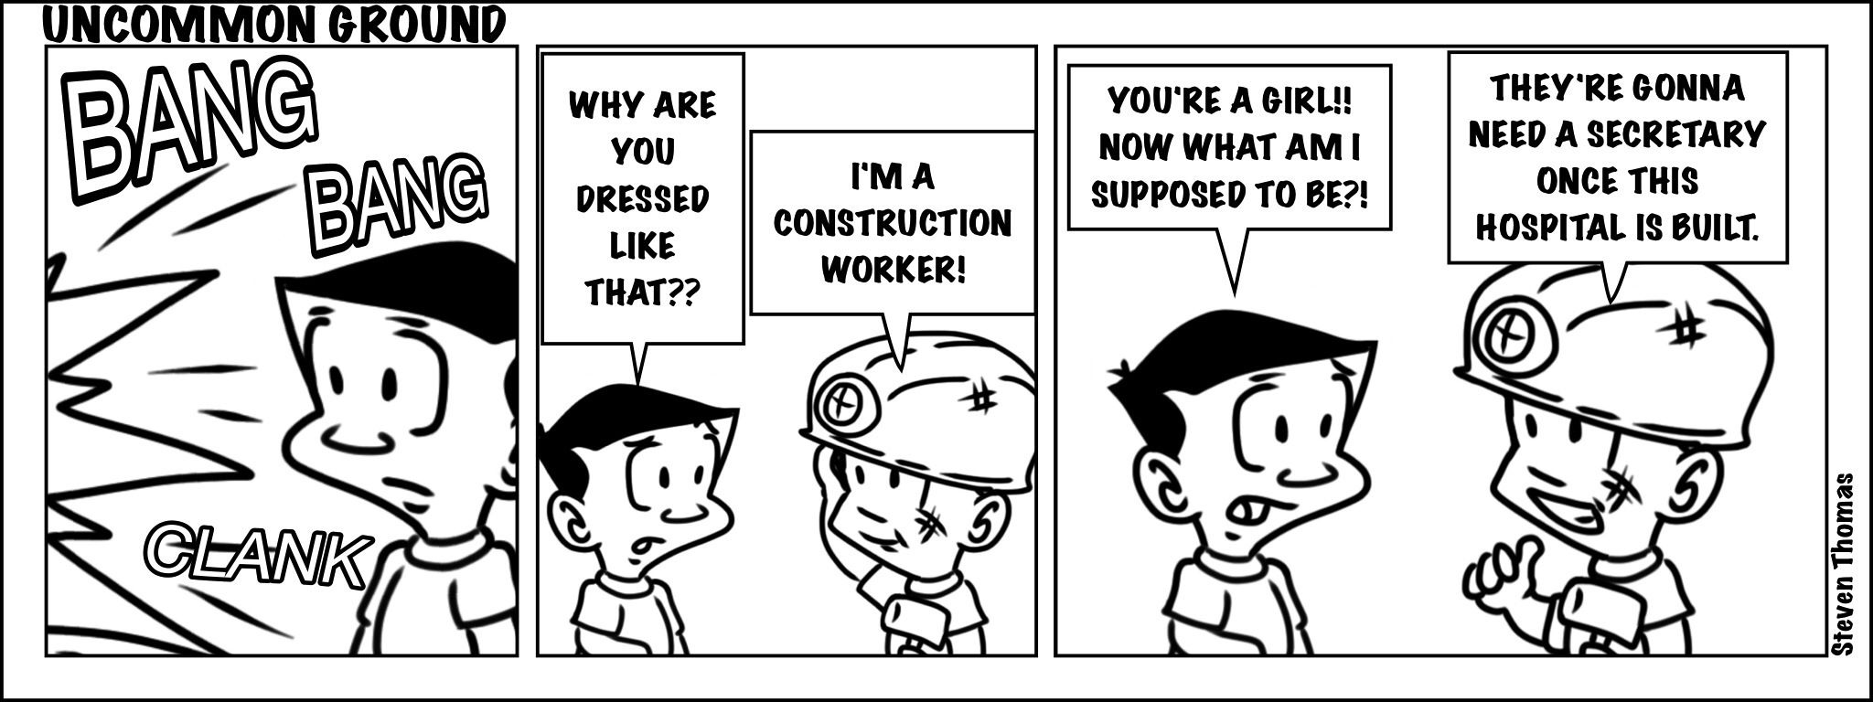

Write paragraphs on stereotyping in the workplace.
Use the following as a guideline:

- Define the term ‘occupation’ and give THREE reasons why some teenagers may be more drawn towards more practical occupations. (1+3) (4)
(Lower Order - CCC)

- Analyse how gender stereotypes could negatively affect a woman’s career. (2x4) (8)
(Middle Order – CCC/ DSS)

- Suggest how an employee who witnesses discrimination in the workplace could make their colleagues more aware of the Bill of Rights. In your answer also indicate how EACH suggestion could lead to less discrimination in future. (2x4) (8)
(Higher Order - DHR)
(20)
Question 5

Study the cartoon below and answer the questions that follow.

[Accessed from: https://www.dailymail.co.uk. Accessed: 31 March 2022]
Influence of gender inequality and its effects on teenage pregnancy
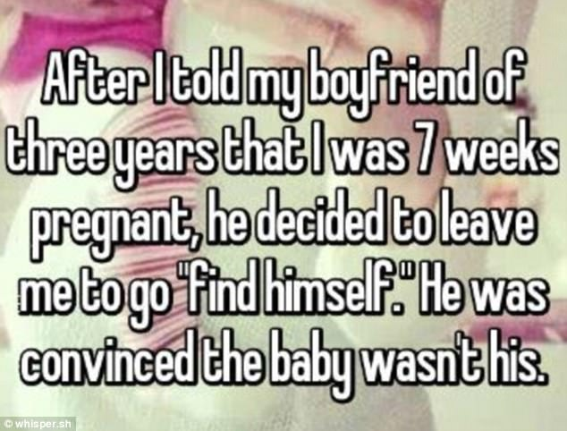

Write paragraphs on the influence of gender inequality on teenage pregnancy.
Use the following as a guideline.

- Define the term ‘teenage pregnancy’ and state THREE ways in which teen pregnancy could affect the mother’s study choices. (1+3) (4)
(Lower Order – DSS/ CCC)

- Analyse how poverty could lead to a higher number of teenage pregnancies in a community. (2x4) (8)
(Middle Order - SER)
- Critically discuss the effectiveness of a school campaign to decrease the number of teenage fathers abandoning teenage mothers as a result of gender inequality. (2x4) (8)
(Higher Order - DSS)
(20)

Question 6

Study the infographic below and answer the questions that follow.

[Accessed from: https://letabaherald.co.za Accessed: 31 March 2022]

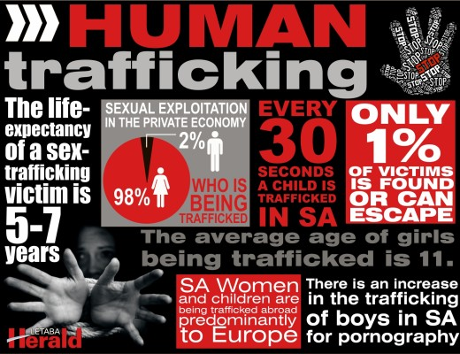
Violation of human rights: Human trafficking!!!!

Write paragraphs on human trafficking.
Use the following as a guideline.

- Define the term ‘human trafficking’ and state THREE negative health effects that could be caused by human trafficking. (1+3) (4)
(Lower Order - DHR)

- Analyse how the high number of human trafficking cases could negatively affect the safety and security within a community. (2x4) (8)
(Middle Order - SER)
- Critically discuss the influence that gender inequality has on the sexually abusive practice of human trafficking. (2x4) (8)
(Higher Order - DSS)
(20)
[TOTAL SECTION C: 40 MARKS]
TOTAL = 40 + 40 = 80

