Self-Concept and Self-Motivation

Instructions:
- This worksheet is based on Examination Type questions.
- Read and examine the source carefully.
- Make sure you look at mark allocation and make sure your answers are enough.
- Answer all questions, neatly in your workbook.

Question 1
Study the below cartoon featuring Charlie Brown and his friend, Lucy van Pelt and answer the questions that follow.
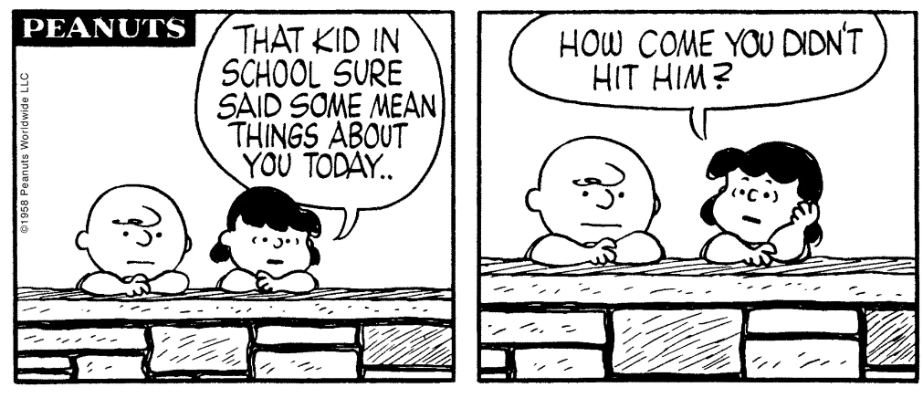

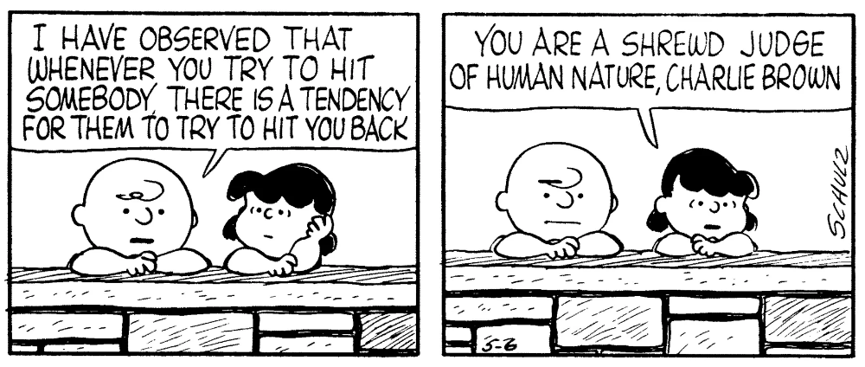

Accessed from: https://www.newyorker.com on 30 January 2021

  - Define the term ‘self-concept’ and give TWO reasons why a positive self-concept could
help you in relationships. (1 + 2) (3)

  - Mention FIVE factors that could influence a teenager’s self-concept. (5 x 1) (5)
  - List TWO ways that positive self-talk can boost an individual’s self-worth when they have been bullied. (2 x 1) (2)
(10)

