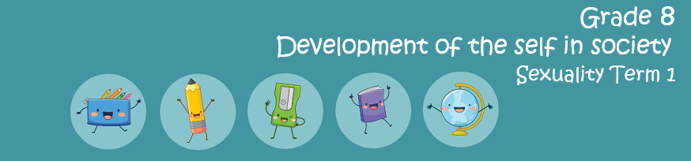
Content Summary
Lesson 1:
- Concept: sexuality
  - Understanding one’s sexuality: personal feelings that impact on sexuality
  - Influence on friends and peers on one’s sexuality

Sexuality can be described as:
- How we feel about ourselves and our bodies.
- Our sexual thoughts and feelings towards other people.
- The way we behave towards other people.
- The changes in our bodies to prepare us to reproduce one day.
- It is the lifelong journey from birth until death as all people are sexual beings.
Sex: is the act of intercourse and a celebration of one’s sexuality.

It is important to set up rules or rights that you intend to stick to when it comes to your sexuality.
Why do friends and peers have so much influence on your ideas around sex and sexuality in your teen years?
- You feel like you need to fit in with your peers so you would rather listen to them and do things they think are cool.
- You don’t seem to get along with your parents anymore.
- They are easy to talk to and quick to tell you about what they have done.

How do your friends use peer pressure to influence your choices about sex and sexuality?
- They tell us about their own sexual experiences and put pressure on us to do the same.
- They make us feel like we have to do this to fit in and be accepted.
- Their opinions influence us, this can also be positive.
Lesson 2:
  - Family and community norms that impact on sexuality
  - Social pressures including media that impact on sexuality
  - Problem-solving skills: identity formation and development

This lesson focussed on the impact on your sexuality from the people around you. When people in your community or family follow a series of rules, we call these norms.
Often these norms will become laws in certain societies. These norms are ‘acceptable standards of behaviour’. For example: Stealing clothing from a store is unacceptable and illegal.
Some norms are more informal and instituted by a family or even a certain culture. For example: You are only allowed to date when you turn 16yrs old.

The media influences your own views on sexuality.
The media is not only social media but it also includes all kinds of mass communication like music, movies, magazines, radio, newspapers and TV.
These different platforms make you believe that there is an ideal way that you should look to be acceptable. The media can also present different values to what your parents or community express.

Sexting refers to sending inappropriate pics over cell phones. This could include sending pictures over social media to friends or partners….
- being partly or completely naked or in your underwear
- posing in a sexual position, or
- sending ‘nudes’

Sexting is illegal in South Africa – as it infringes on the human right of dignity. A person can be prosecuted for sharing nude photos of anyone.
Five Facts on Sexting:
In an article where research was done amongst thousands of teenagers in America, the following was discovered:
- Teenage girls have a few reasons for why they participate in sexting: 40 percent do it as a joke, 34 percent do it to feel sexy, and 12 percent feel pressured to do it.^{[1]}
- Who will see your sext? 17% of sexters share the messages they receive with others, and 55% of those share them with more than one person.^{[2]}
- 15% of teens who have sent or posted nude/semi-nude images of themselves send these messages to people they have never met, but know from the Internet.^{[6]}
- Sending or receiving a sexually suggestive text or image under the age of 18 is considered child pornography and can result in criminal charges.^{[7]}
- 24% of high-school age teens (ages 14 to 17) and 33% of college-age students (ages 18 to 24) have been involved in a form of nude sexting.^{[8]}

Who am I?
The combination of physical, mental and social challenges and the serious choices can impact your identity. During this time you explore your values (what’s important to you) about things like religion, ethics, sexuality and gender.
Sometimes teenagers feel insecure and lack self-confidence. In these times it can be difficult to be amongst friends or peers that try to pressure you into doing things you actually don’t want to do.
Peer Pressure: a feeling that one must do the same things as other people of one's age and social group are doing, in order to be liked or respected by one’s peers.
Sometimes when you are trying to work through all these questions, it would be a good idea to work through your thoughts and emotions by writing in a journal. If that thought feels overwhelming, reach out to a teacher you trust or the school counsellor (if your school has one).

Problem Solving Strategy:
When its difficult to say NO, remember the following technique:
A- Ask yourself questions like: Is this against my beliefs, the law, parents rules?
Can this be harmful to me or others? Will I regret doing this later? How will
my friends & family feel when they find out?
S- Say NO to negative pressures- something like (No- I have thought about
what you have asked and I dont want to do it.
K- Know positive options- something like” I’d rather listen to music/ I’d rather
hang out with my friends and play sport.

Sometimes you find yourself in a difficult situation where a simple NO won’t solve the problem. In this situation, you would need to know how to
SOLVE IT!
To do so, use the following steps:

1) Dont make the decision when you feel emotional. Wait!
2) Define the problem
3) What are the possible solutions?
4) What are the consequences of each solution?
5) Choose a suitable solution
6) DO IT! Implement your chosen solution
7) Evaluate later if the problem was solved.

