
Lesson 2:

Activity 1: In the spaces below makes notes in the following areas in response to the information on the PowerPoint and website.
Where to get advice:
Career advice counsellors. There is even advice on subject choices in Grade 9 in relation to careers that you are considering as well as dates of the various open days to attend.

Admission Requirements:
Each university has their own admission requirements for the different courses they offer. As a matric learner you will need to meet these requirements in order to be considered for this institution.

Fee/ Bursaries/ loans/ scholarships:
- Parents pay for your fees
- Take out a student loan from an institution like FNB/ ABSA that requires you pay the money back when you are qualified and have a job. In this case you would need someone willing to pay the insurance and interest on the loan monthly.
- Loan through the university is similar to the bank
- Bursaries- this would be money provided for all you would need without the requirement to pay it back. An example would be NASFAS- a bursary for learners who come from a household where parents earn a low income or are unemployed.
- Scholarships- an amount towards study fees but not necessarily the entire amount based on academic achievement.

Accommodation & Traveling:
Universities have both residences in the form of hostels and then offer advice on private accommodation near the university. It’s necessary to make arrangements for more than one option as not all learners are placed in accommodation.

Activity 2: Study the following summary of admission requirements and then answer the questions that follow:

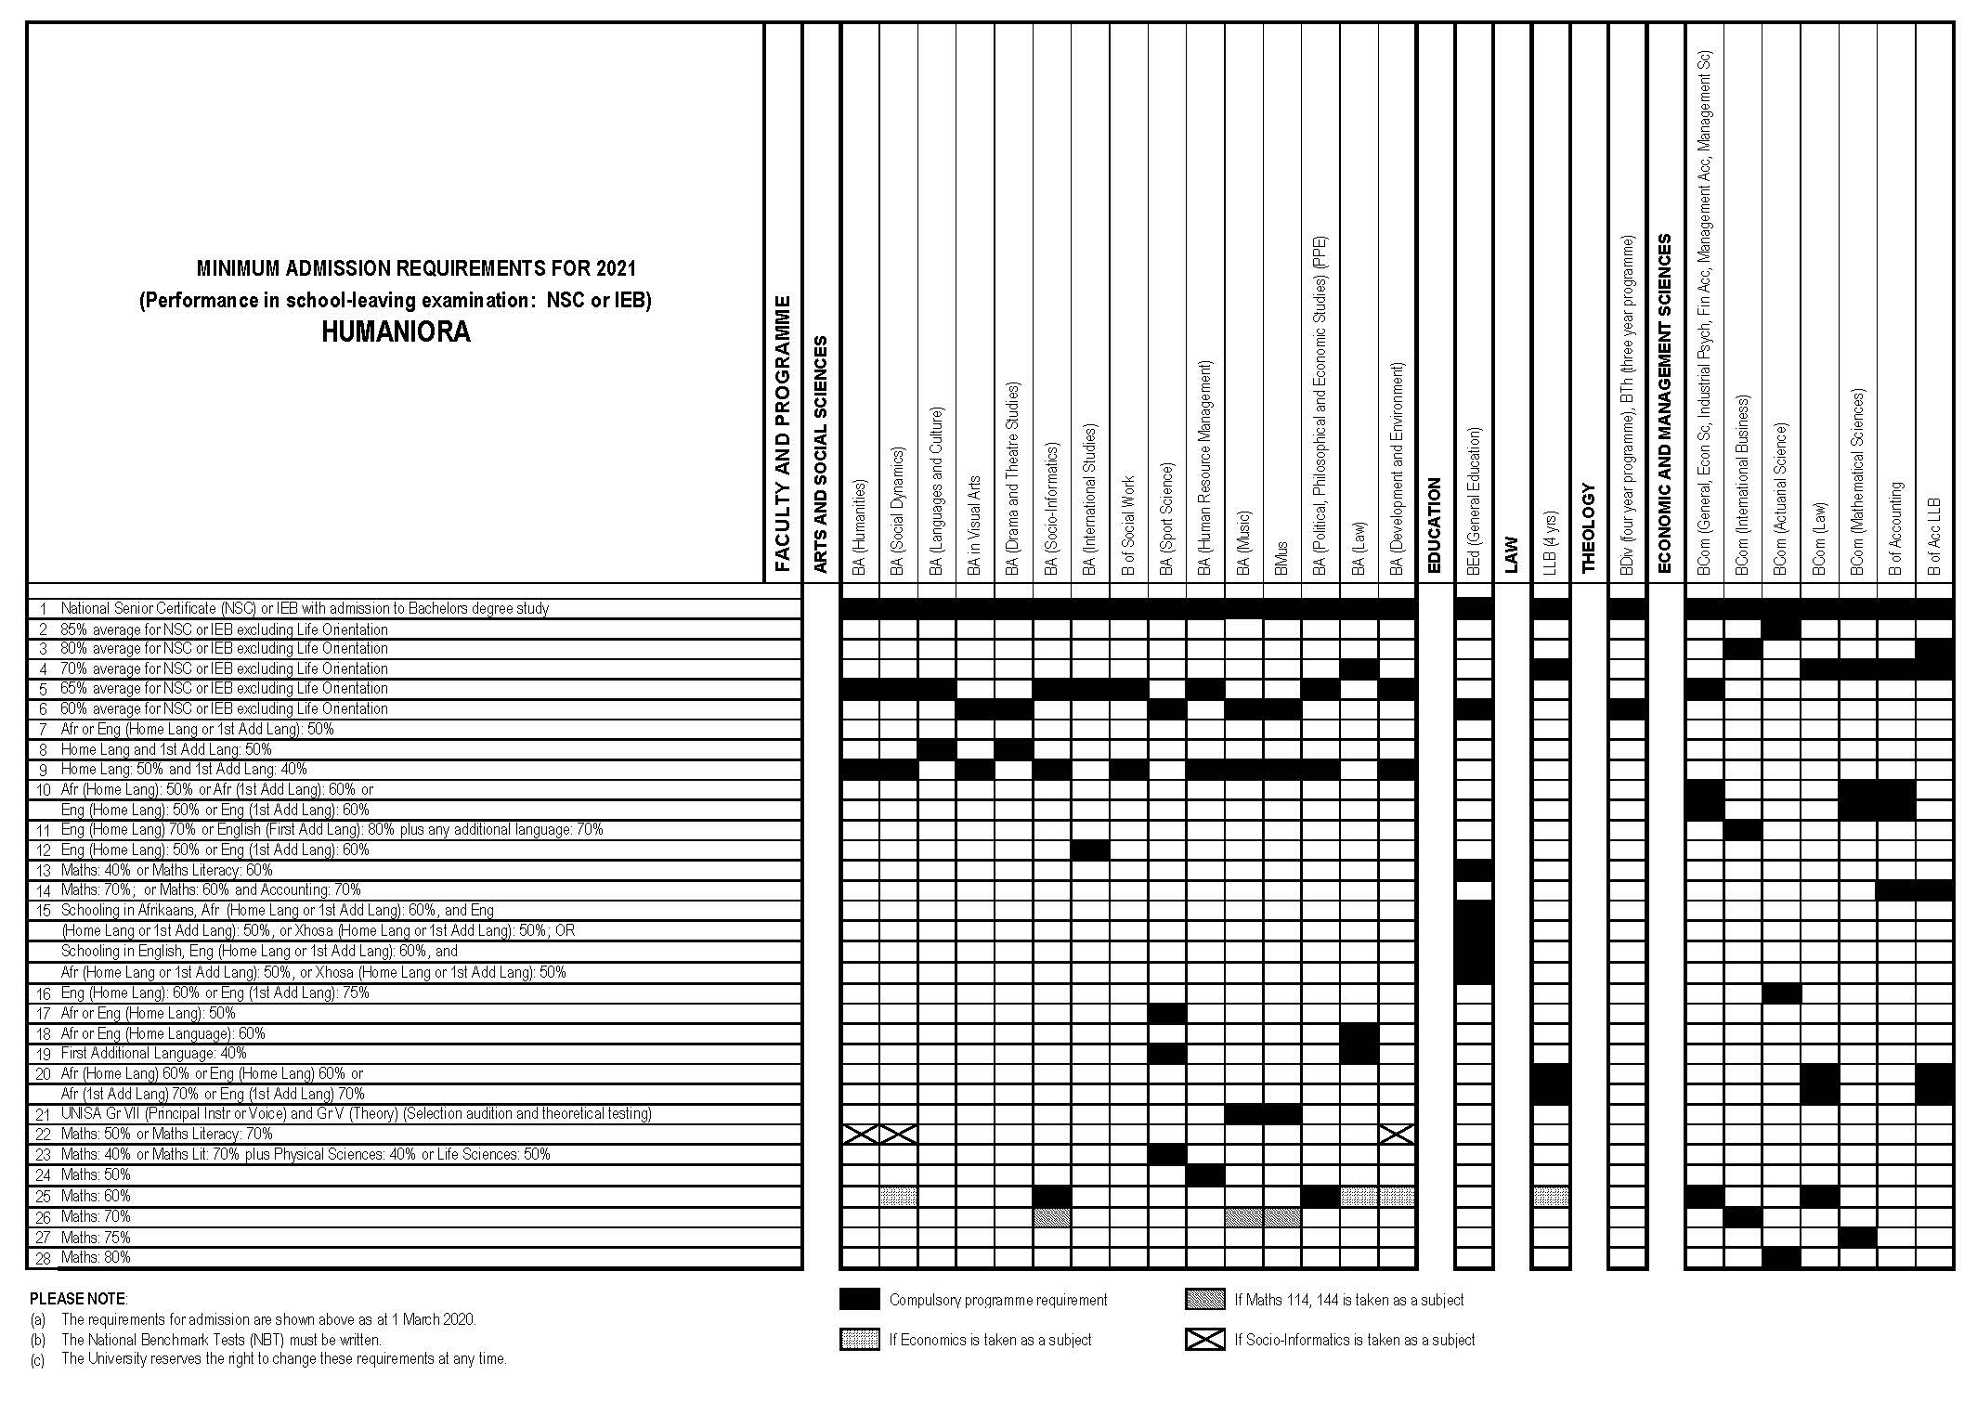
1) Should you choose to study a BCom (law), what subjects do you have to have in matric? | A) English 1st language 60% or Afrikaans 60% 1st language OR  English 2nd additional at 70% OR Afrikaans 2nd Additional at 70%  B) Maths 60%
2) Of all the courses, which appears to have the most difficult  entry requirements? Motivate your answer | Actuarial Science
3) Based on your present subjects and your grades at the end of  Grade 11, which courses do you qualify to apply for? | (own response per learner’s own academics)
4) Should you not meet the requirements for your chosen course,  recommend TWO strategies to improve your chances. | Extra lessons with a tutor, ask a teacher if there is additional work you can do to improve, work though past papers in each subject to get familiar with the content set in papers.

Activity 3: Read the following article and then answer the questions

How Can Facebook and LinkedIn Get You a New Job?
By Guest
Facebook and LinkedIn are great places to find your next job, more so than you would think. Recruiters use social networks to post jobs, to source for candidates and to network with talent.

Research shows that nearly 75% of companies check out potential candidates on social networks. And they’re not just digging for dirt. More and more, HR execs and recruiters are turning to social networks to scout out promising job candidates, and with good reason.

One recent study by Northern Illinois University professors found study participants could more accurately predict a candidate’s likelihood to succeed in a particular job by browsing their Facebook profile than by evaluating detailed personality surveys.

Another study by professors at Cornell University found that job applicants were less likely to lie about past work experience on their LinkedIn profile than they were on a traditional resume.

Our friends at OnlineDegrees.com have created a useful infographic about how companies are integrating social media more than ever in the job search – and how you can use that to your advantage.

Most recruiters hire through LinkedIn (94.5%), and some use Twitter and Facebook as well (42% and 33%, respectively). See more at How Recruiters Use Facebook, LinkedIn and Twitter.

So, can your social networks help you land a job? In this infographic, learn how recruiters are using social sites and how you can optimize your online presence.
https://theundercoverrecruiter.com/infographic-how-can-facebook-and-linkedin-get-you-new-job/ Accessed: 08 March 2021

1) State ONE reason why recruiters use social media platforms more often today than in the past?

- More and more people have access to the internet on their cell phones, laptops or tablets than ever before.
- Recruiters know that they will reach more people on social media platforms as there is a wider, international audience vs local magazines or newspapers.
- Recruiters might reach those that are not actively (passive) looking for jobs too, and not just those that are actively looking for jobs.

2) Provide TWO ways how you can best prepare yourself now to enter the job market on social media platforms?

Keep a clean profile! Don’t post racist/ sexist/ illegal content.
Your social media profile provides an inside view to your character for a future employer. Be aware that what you post builds a profile of the person they will consider for a job.

3) Give a short explanation how you would describe LinkedIn to someone.
This is a social media platform where individuals can promote themselves as working individuals and look for work.
4) When creating a profile on LinkedIn, you are required to tell “your story” in other words sell yourself as the person that the recruiter wishes to employ. In the space below, write a 10 line “story” that you could use as your profile.
OWN REPONSE- Could be interesting to ask learners to share if you have time in the next lesson.

Activity 4: Take a moment to reflect on what you have learnt about yourself today.
- With the knowledge that you have gained about studying after school, reflect on how you feel about your options for the future.

- What advice would you give to a friend who would like to study but cannot comprehend where the finances would come from to study.

- Certain responsibilities would change leaving home.
Rate yourself in your ability to complete the following skilfully.
(i.e. 1 = needs work and 5 = very capable.)
* cooking for yourself.
* doing your own washing.
* managing your money to buy groceries, petrol toiletries.
* cleaning your room/ apartment or accommodation.
* driving to and from work/ university.
For all the 1’s, write a plan on how you intend to improve these skills while still living at home.

Learners will have different responses to the reflection and therefore there is no memo for this section.

