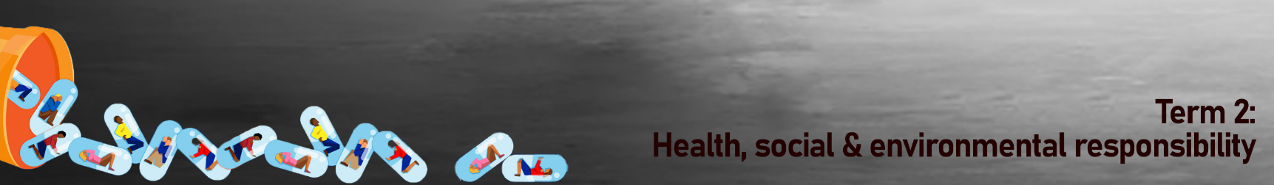
Kwartaal 2:
Gesondheids-, Sosiale en Omgewingsverantwoordelikheid
Gevallestudie 4:  In hierdie ballade demonstreer Amy Winehouse hoe gevaarlik 'n negatiewe siening van behandeling kan wees. Sy sing dat sy nie na rehabilitasiesentrums wil gaan nie en dat sy nie tyd het om te gaan nie. Haar pa dink ook nie dat sy rehabilitasie benodig nie. Ongelukkig het Winehouse in 2011 voor alkoholverslawing geswig en aan alkoholvergiftiging gesterf.  “Rehab”  Geskryf deur Amy Winehouse | 
Just try to make me go to Rehab  But I won't go, go, go  I'd rather be at home with Ray  I ain't got seventy days  'Cause there's nothing  There's nothing you can teach me  That I can't learn from Mr. Hathaway  I didn't get a lot in class  But I know it don't come in a shot glass  They tried to make me go to Rehab  But I said no, no, no  Yes I've been black but when I come back  You'll know, know, know  I ain't got the time  And if my daddy thinks I'm fine  Just try to make me go to Rehab  But I won't go, go, go  The man said "Why you think you here?"  I said "I got no idea"  "I'm gonna, I'm gonna lose my baby"  "So I always keep a bottle near"  He said "I just think you're depressed"  "This me, yeah baby, and the rest" | They tried to make me go to Rehab  But I said no, no, no  Yes I've been black but when I come back  You'll know, know, know  I ain't got the time  And if my daddy thinks I'm fine  They tried to make me go to Rehab  But I said no, no, no  Yes I've been black but when I come back  You'll know, know, know  I don't ever want to drink again  I just, ooh I just need a friend  I'm not gonna spend ten weeks  And have everyone think I'm on the mend  And it's not just my pride  It's just 'til these tears have dried  They tried to make me go to Rehab  But I said no, no, no  Yes I've been black but when I come back  You'll know, know, know  I ain't got the time  And if my daddy thinks I'm fine  Just try to make me go to Rehab  But I won't go, go, go!

