LESSON 1 & 3 WORKSHEET MEMO

LESSON 1
Worksheet (in Workbook)

Answer the following questions in your workbook

- State whether the following are TRUE or FALSE, give a reason for your answer:
- Prioritising tasks and allocating a time for the completion thereof is an effective time management strategy. (2)
- If you are accountable, you often miss important deadlines. (2)

- Answer the following questions by writing the answer next to the question number:
- Provide the term used to describe postponing doing something. (1)
- Give an example to explain the term above. (1)
- What does it mean to summarise something? (2)
- What does it mean to be accountable for one's actions? (2)

- Study the Madam and Eve cartoon below and answer the questions that follow:
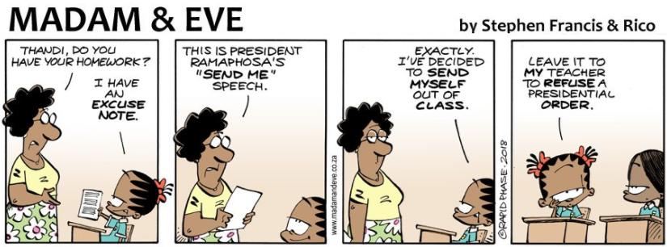

Taken from https://twitter.com/madamevecartoon/status/507056289374285825 on 08.04.2018
- List TWO benefits of good time management. (2)
- Critically examine how procrastination and poor time management may have been the root of Thandi’s poor work ethic. (2 x 2) (4)
- Suggest TWO pieces of advice on how to manage her schoolwork and time better. (2 x 2) (4) [20]

MEMORANDUM
1 a) True
By doing so you stay on track and do not fall behind. (2)
b) False ✓
If you are accountable, you almost never miss important deadlines (2)

2 a) Procrastination (1)
b) Saying that you will do something later, and when later comes saying later until there is no time left and you are rushing to complete something under immense pleasure. ✓ (1)
c) Summarising involves taking the (main ideas) from a piece of text and rewriting them (in your own words)
OR to shorten/condense information in key words or phrases (2)
d) Being willing to provide an answer for queries regarding one’s actions (2)

3 a) You will reduce stress in your life.
You will lead a more balanced life.
You will be able to focus better on each of the things you do.
You will become more reliable.
You will experience less pressure and feel more in control. ✓✓
Any TWO of the above or any relevant answer for ONE mark each (2)

b) Procrastinating means putting things off and wasting time
While Thandi cannot control time, she must take responsibility for how she spends her time and not put things off.
The only way in which she can control time is by managing the way in which she chooses to spend it. She has to become selective about what she takes on. ✓✓+✓✓
Any TWO of the above or any relevant answer for TWO marks each (4)

c) Put together a small Home Study Kit. This kit can be a neat box or plastic container.
Have paper, pens, pencils, books and a dictionary ready to use at homework time.
Find a quiet place that you can use daily to do your work.
Be focused, so that she does not get easily distracted
She does not have a career yet, but being a learner is your most important job now.
Studying needs to come first when scheduling time and planning activities.
Calendars, diaries and to-do lists are useful tools for making schoolwork the top priority and helping you to stay focused.
Try to hang a large calendar in a central place, for example, in the kitchen, your bedroom or the area where you study. ✓✓+✓✓
Any TWO of the above or any relevant answer for TWO marks each (4)

LESSON 3
Worksheet (in Workbook)

- Study the following scenarios and state the reading or writing technique that is the best applicable:
- A personal record of events, experiences, and reflections kept on a regular basis.
- Reading specific sections of work in order to understand the content, and to recall it at a later date, or apply it to solve a problem.
- Reading lightly over something to understand the main points. (3 x 1) (3)

- Explain the importance of:
- reading effectively. (2)
- writing effectively. (2)

- Evaluate the positive influence that journaling can have on teenagers. (2 x 2) (4)

- Read the case study about Sovuya and answer the following questions.

She is normally shy and reserved, but 17-year-old Sovuya Jack, a Grade 11 pupil at Nqweba Secondary School in Graaff-Reinet, beat her peers from eight schools when she was crowned Eastern Cape National Library Week winner last week. Sovuya faced stiff competition from her peers, but she excelled in summarising and reviewing former president Nelson Mandela’s autobiography, Long Walk To Freedom.
“I cried tears of joy when they announced me as the winner. It felt good to know that my review of the book was the best,” said Sovuya. “It was a lot of work and took a long time because I had to summarise the book before reviewing it”.
Her isiXhosa teacher, Nombeko Sontlaba, described Sovuya as a pupil who normally keeps to herself in class. “I am so proud of Sovuya. She is normally shy and reserved but she has become more accountable and learnt to open up and address a crowd with confidence,” she said.
Adapted from http://www.dispatchlive.co.za/news/school-news/2018/03/28/teen-scoops-top-prize-at-library-week/

- State ONE purpose for writing. (1)
- For what purpose did Sovuya read Mandela’s A Long Walk to Freedom? (1)
- Provide a reason for your answer. (1)
- Distinguish between scanning a text and skimming a text. (2)
- Recommend ONE strategy Sovuya may have used to summarise the book. (2)
[18]

MEMORANDUM
1 a) Journalingü (1)
b) Studyingü (1)
c) Skimmingü (1)

2 a) Reading exposes you to alternative opinions, which broadens your mind; exposes you to language structures and vocabulary, which benefits your writing ability; There are signs and words everywhere, so reading allows you access to messages all around you; Allows you to understand what is being taught at the time. üü (2)

b) Writing allows you to communicate important ideas to others when it is not possible to speak to them in person; is a mechanism for people to express aspects of their personality; is a reflection of professionality and work ethic.üü (2)

3 As you read and re-write your goals daily, they’ll become forged into your subconscious mind. Eventually, your dreams and vision will consume your inner world and quickly become your physical reality. üü
Helps you to stay motivated when you journal your goals and dreams üü
Allows you to develop key writing and thinking skills (description, reflection, evaluation)üü
Helps you to have better memories of each phase of your lifeüü
It allows you to express yourself without fear of someone judging you and it helps to organise thoughtsüü
To journal increases self-awareness and enhances your interaction with othersüü
The expressive writing (journaling) helps teens to release pent-up negative emotions, helps them to build buffer between negative thoughts and sense of well-being / helps to manage emotionsüü
To journal helps to review and improve your daily to-do list, and this can help to improve your big picture goalsüü
Re-writing your goals may help that they become part of you and eventually become a realityüü
(4)

4 a) ANY ONE (1)
for pleasure
to convey messages
to make notes
to express yourself
to complete assignments
to make summaries

b) To win a competition (1)
OR
To review the book

c) Skim: read something quickly to take note of the important points
Scan: read over something quickly to identify specifics (2)

d) ANY ONE (1)
capture the most important parts of the original text in a shorter space
use keywords and/ or phrases as well as your own words where possible
read the original text carefully to understand the main ideas – underline them
read it again to identify the ideas supporting the main idea – circle them
make notes as you read along – considering what you have underlined and circled
revise your notes and add or take away where necessary

