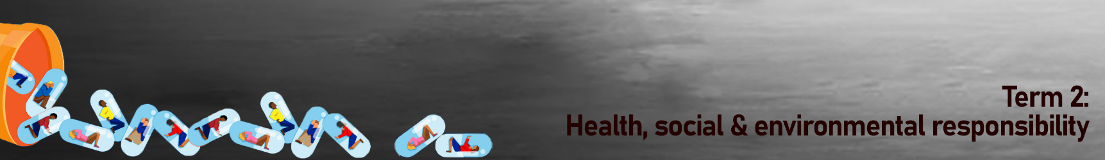
Kwartaal 2:
Gesondheids-, Sosiale en Omgewingsverantwoordelikheid
Gevallestudie 3:  In "Not an Addict," toon K's Choice die ontkenning wat met verslawing gepaard gaan. Die liedjie begin met 'n beskrywing van die pynverligting wat ervaar word wanneer dwelms diep in die are gespuit word en verklaar dat dit nie 'n gewoonte is nie.  Die liedjie bespreek verder die donker kant van verslawing en beskryf hoe die persoon wat dwelms gebruik, "koud en alleen" voel nadat die gevoel van “hoog-wees” hom verlaat het. Die liedjie eindig met die sanger wat herhaal, "I’m not an addict." Dit toon die emosionele onrus en ontkenning wat gepaard gaan met die aanvaarding van hulp vir verslawing.  “Not an Addict”  Geskryf deur K's Choice | 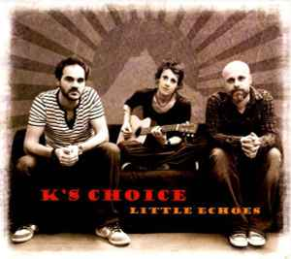
Breathe it in and breathe it out  And pass it on, it's almost out  We're so creative, so much more  We're high above, but on the floor  It's not a habit, it's cool, I feel alive  If you don't have it, you're on the other side  The deeper you stick it in your vein  The deeper the thoughts, there's no more pain  I'm in heaven, I'm a god  I'm everywhere, I feel so hot  It's not ah habit, it's cool, I feel alive  If you don't have it, you're on the other side  I'm not an addict, maybe that's a lie  It's over now, I'm cold, alone  I'm just a person on my own  Nothing means a thing to me  Oh, nothing means a thing to me | It's not a habit, it's cool, I feel alive  If you don't have it, you're on the other side  I'm not an addict, maybe that's a lie  Free me, leave me  Watch me as I'm goin' down  And free me, see me  Look at me, I'm fallin' and I'm fallin'  It is not a habit, it is cool, I feel alive, I feel  It is not a habit, it is cool, I feel alive  It's not a habit, it's cool, I feel alive  If you don't have it, you're on the other side  I'm not an addict, maybe that's a lie  I'm not an addict  I'm not an addict  I'm not an addict  Bron: Musixmatch  Liedjieskrywers: Bettens Gert / Bettens Sarah

