
CONTENT SUMMARY
VAK Learning Styles
refers to three learning styles: visual, auditory and kinesthetic:
Visual: a visually-dominant learner absorbs and retains information better when it is presented in pictures, diagrams and charts.
Auditory: an auditory-dominant learner prefers listening to what is being presented. He or she responds best to voices, for example, in a lecture or group discussion.
Kinesthetic: a kinesthetic-dominant learner prefers a physical experience. She/ he likes a "hands-on" approach and responds well to being able to touch or feel an object or learning prop.
VARK Learning Styles is variation on the VAK acronym. It refers to four styles: visual, auditory, reading/writing, and kinesthetic.
Reading/Writing: a reading- or writing-dominant learner uses repetition of words and writing. Clearly, there is an overlap with visual and auditory styles, as words and writing can be both, but, commonly, a person who prefers to learn this way remembers or organizes things best in his mind by taking down notes.


Tips for VISUAL Learners to remember things better:
- Utilize graphic organizers such as charts, graphs, and diagrams.
- Redraw your pages from memory.
- Replace important words with symbols or initials.
- Highlight/ underline important key terms in corresponding colors.
- Study using pictures, videos, posters, slides, flowcharts
- Get textbooks with diagrams and pictures
- Use symbols @, #, & and white space
- Reconstruct the images in different ways … try different spatial arrangements.
- Look at your pages and see any patterns.

Tips for AUDITORY Learners to remember things better:
- Record your summarized notes and listen to them again
- Talk it out. Have a discussion with others to expand upon your understanding of a topic.

- Reread your notes and/or assignment out loud.
- Explain your notes to your peers
- Attend classes, discussions and tutorials (and pay attention)
- Ask your teachers questions
- Use a recording device (if you have permission)
- Remember the interesting spoken examples, stories, jokes…
- Describe the overheads, pictures and other visuals to somebody who was not there
- Leave spaces in your notes for later recall and ‘filling.’

Tips for KINAESTHETIC Learners to remember things better:
- Redo lab experiments or projects.
- Utilize pictures and photographs that illustrate your idea.

- Put plenty of examples into your summary. Use case studies and applications to help with principles and abstract concepts.
- Talk about your notes with another “K” person.
- Make use of all your senses – sight, touch, taste, smell, hearing …
- Collect related items, e.g. rock types, plants, shells, grasses, etc.
- Work through previous exam papers
- Try to organize a field trip on the relevant topic.
- Walk around or play with a stress ball whilst studying.


Tips for READ and WRITE Learners to remember things better:
- Re-write your notes and re-read your notes
- Write out summaries of key concepts and ideas
- Use subheadings, bullets and lists when organizing notes
- Use colored pens and highlighters to focus in on key ideas
- Translate into words key information on diagrams, graphs, charts
- Study alone and in quiet areas to avoid distractions
- Print out your notes for later review
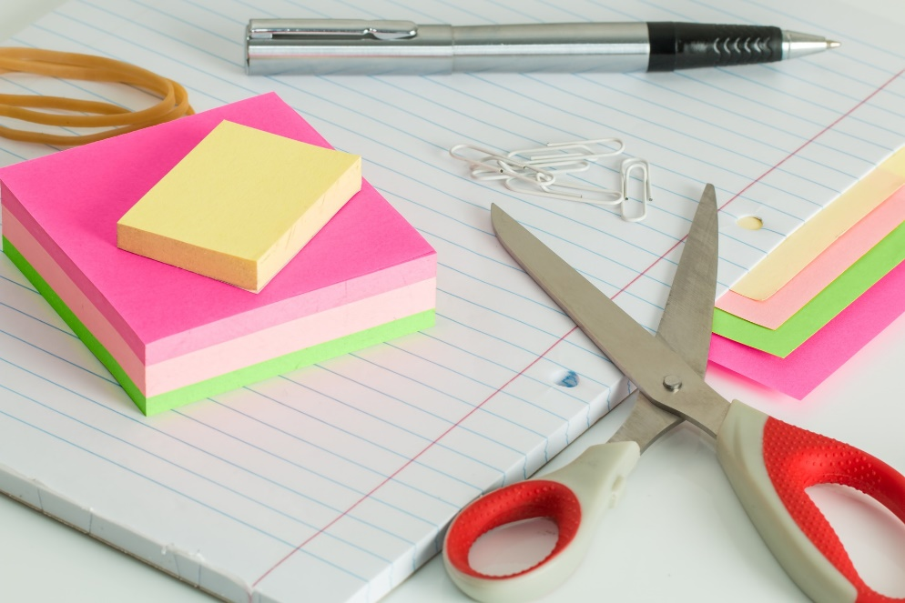

- Stick cards / post-it summaries of your notes in visible places (on the fridge, cupboard) to view regularly

