
Y
T
I
L
A
U
X
E
S

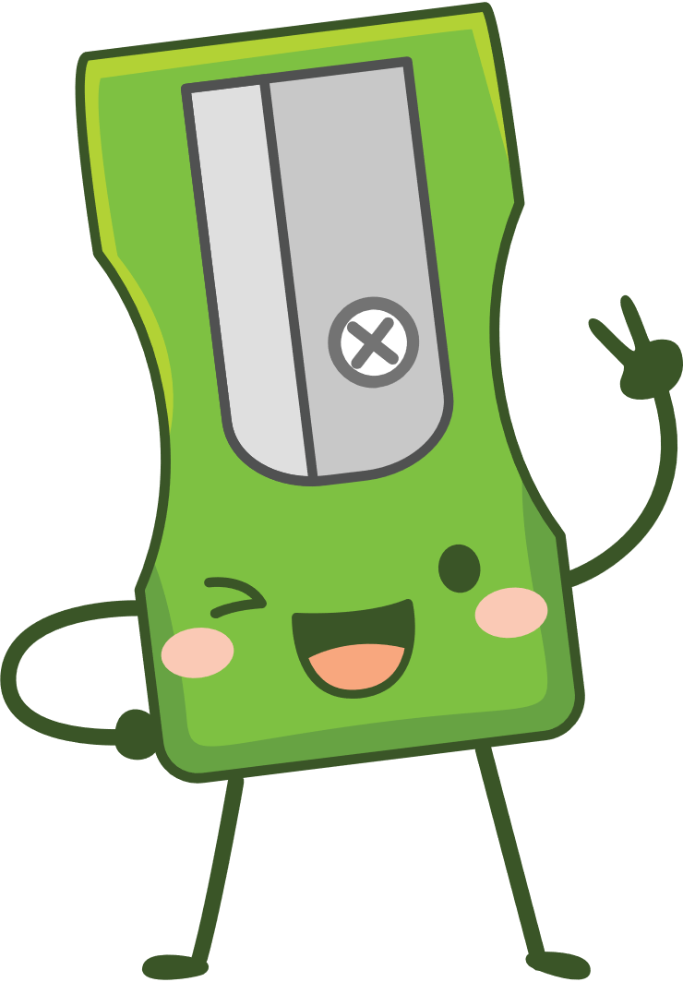
Lesson 1 – Worksheet MEMO

Activity 1: Complete the risk factors / choices that teenagers believe.

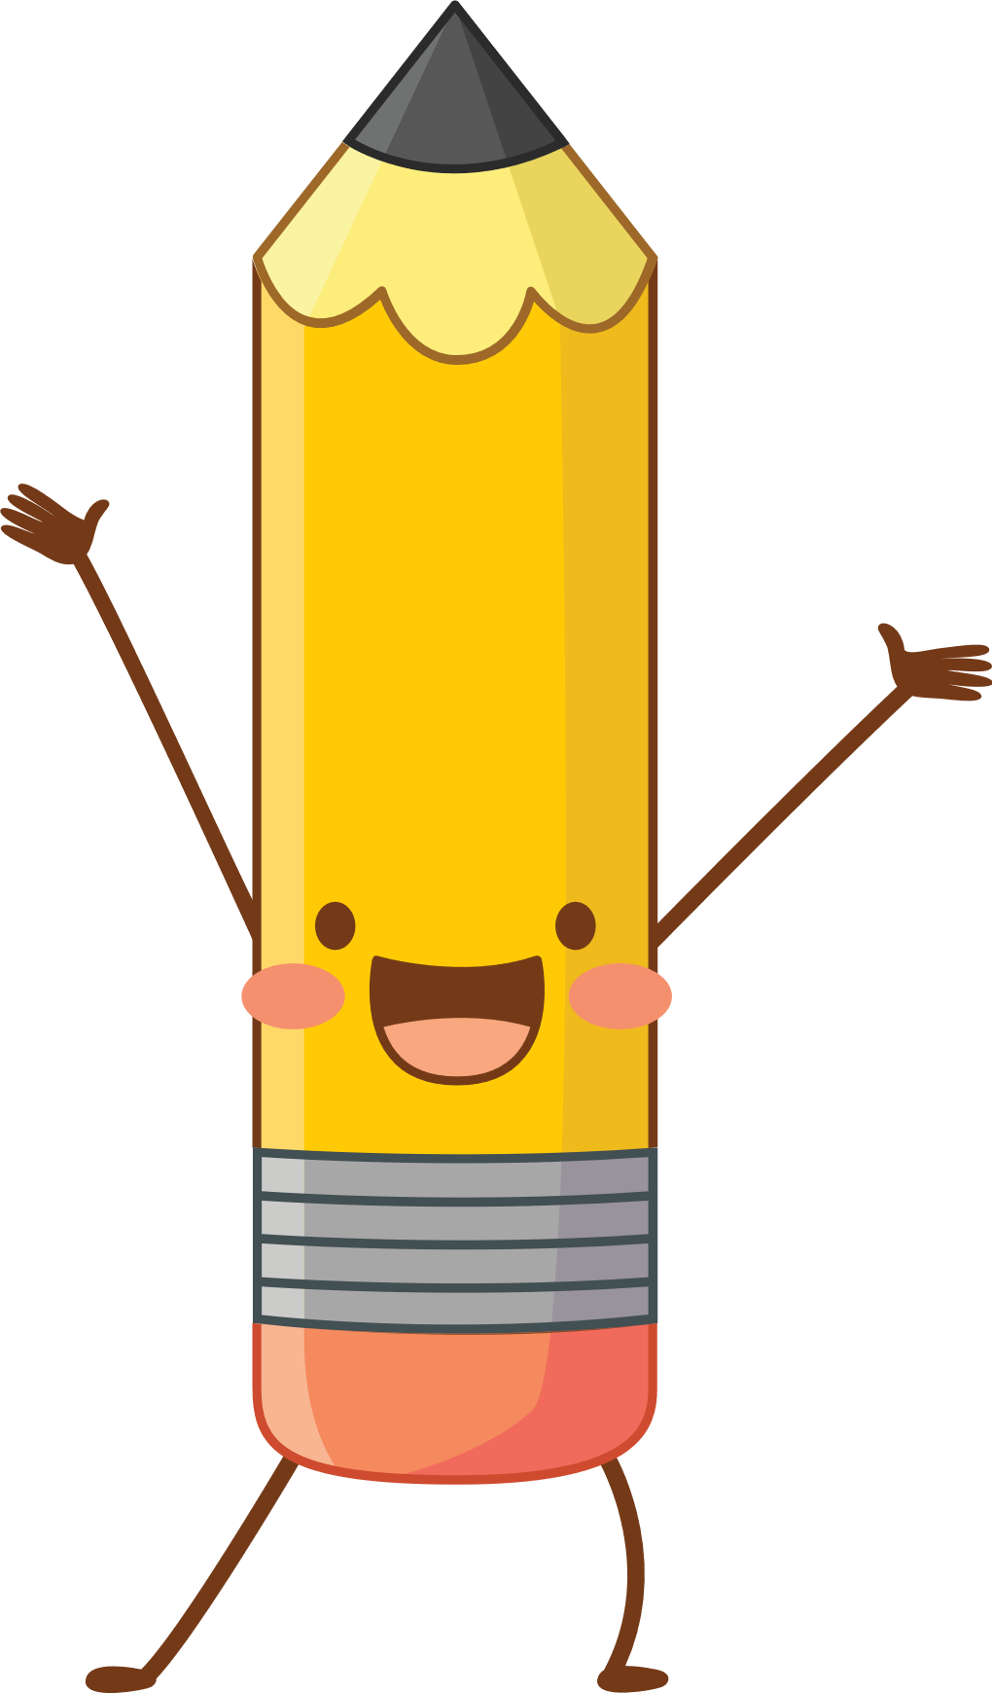
Believing that nothing bad will happen to you even if you take risks. E.g. Having sex without contraception and believing that pregnancy wont happen to them.

Believing you need to do something to be accepted by your peers. E.g. Eg boys that believe to be accepted and “cool” amongst their peers they must have sex with a girl.

Believing you have no control or say over what happens to you E.g feeling so insecure in yourself that you can’t say no to unhealthy sexual attention.

Living in poverty often feels like you have no choice. And choices are made to survive.

The use of drugs/and alcohol inhibits your ability to make wise decisions.

Activity 2: Read the following extract of known symptoms and then respond by
answering Question 1
Sexually transmitted infections (STIs)
If you're worried because you think you've got an STI, go for a check-up at a sexual health clinic as soon as you can. Do not have sex, including oral sex, without using a condom until you've had a check-up.

You can have an STI without knowing it and infect your partner during sex. Call a sexual health clinic if you need help or advice.

STI symptoms include the following:
- an unusual discharge from the vagina, penis or anus pain when urinating
- lumps or skin growths around the genitals or bottom (anus)
- a rash
- unusual vaginal bleeding
- itchy genitals or anus
- blisters and sores around your genitals or anus
- warts around your genitals or anus
- warts in your mouth or throat, but this is very rare

Go to a clinic / doctor if:
- you have symptoms of an STI
- a sexual partner has symptoms of an STI
- you're worried after having sex without a condom
- you're pregnant with symptoms of an STI
Many STIs have no symptoms at all, like HIV. The only way to know for sure is to get tested.

If tests show you have an STI, you should tell your sexual partner and any ex-partners so they can get tested and treated as well.

Common types of STI include:

Chlamydia
Gonorrhoea
Trichomoniasis
Genital warts
Genital herpes
Pubic lice
Scabies
Syphilis
Human papillomavirus (HPV)

Question 1:
Write a letter to your best friend, where they have written to you asking for advice. They have had sex with someone and now they are scared they have an STI. In your letter, provide advice on where they can go and who they can talk to. Also include your knowledge of what symptoms your friend needs to look out for.

This is a sample of a letter a learner could write:

Good day Sam
I’m sorry to hear that you arefeeling so scared about catching an STI. I don think its important that you take action soon rather than imagine nothing happened and just hope for the best.
If you had to contact a local clinic where you could go privately, I’m sure they would be able to give you some advice. I’m sure your school also has a counselor. You could chat to her and ask for information on where you could find a clinic. The counselor could even help you deal with your fears as well. I’m not a counselor, I think you need to speak to someone who knows how to help you.
I’ve heard of some of the symptoms to look out for but I still think go to the clinic. You might have a discharge when urinating, there might be a rash around your privates and it could be really itchy. Sometimes even sores develop if you leave it too long.

Let me know what you decide. I’ll even go with you to the clinic if you are scared.

Your friend
…..

Activity 3: Reflection activity
- Circle THREE emotions you experienced during this lesson.
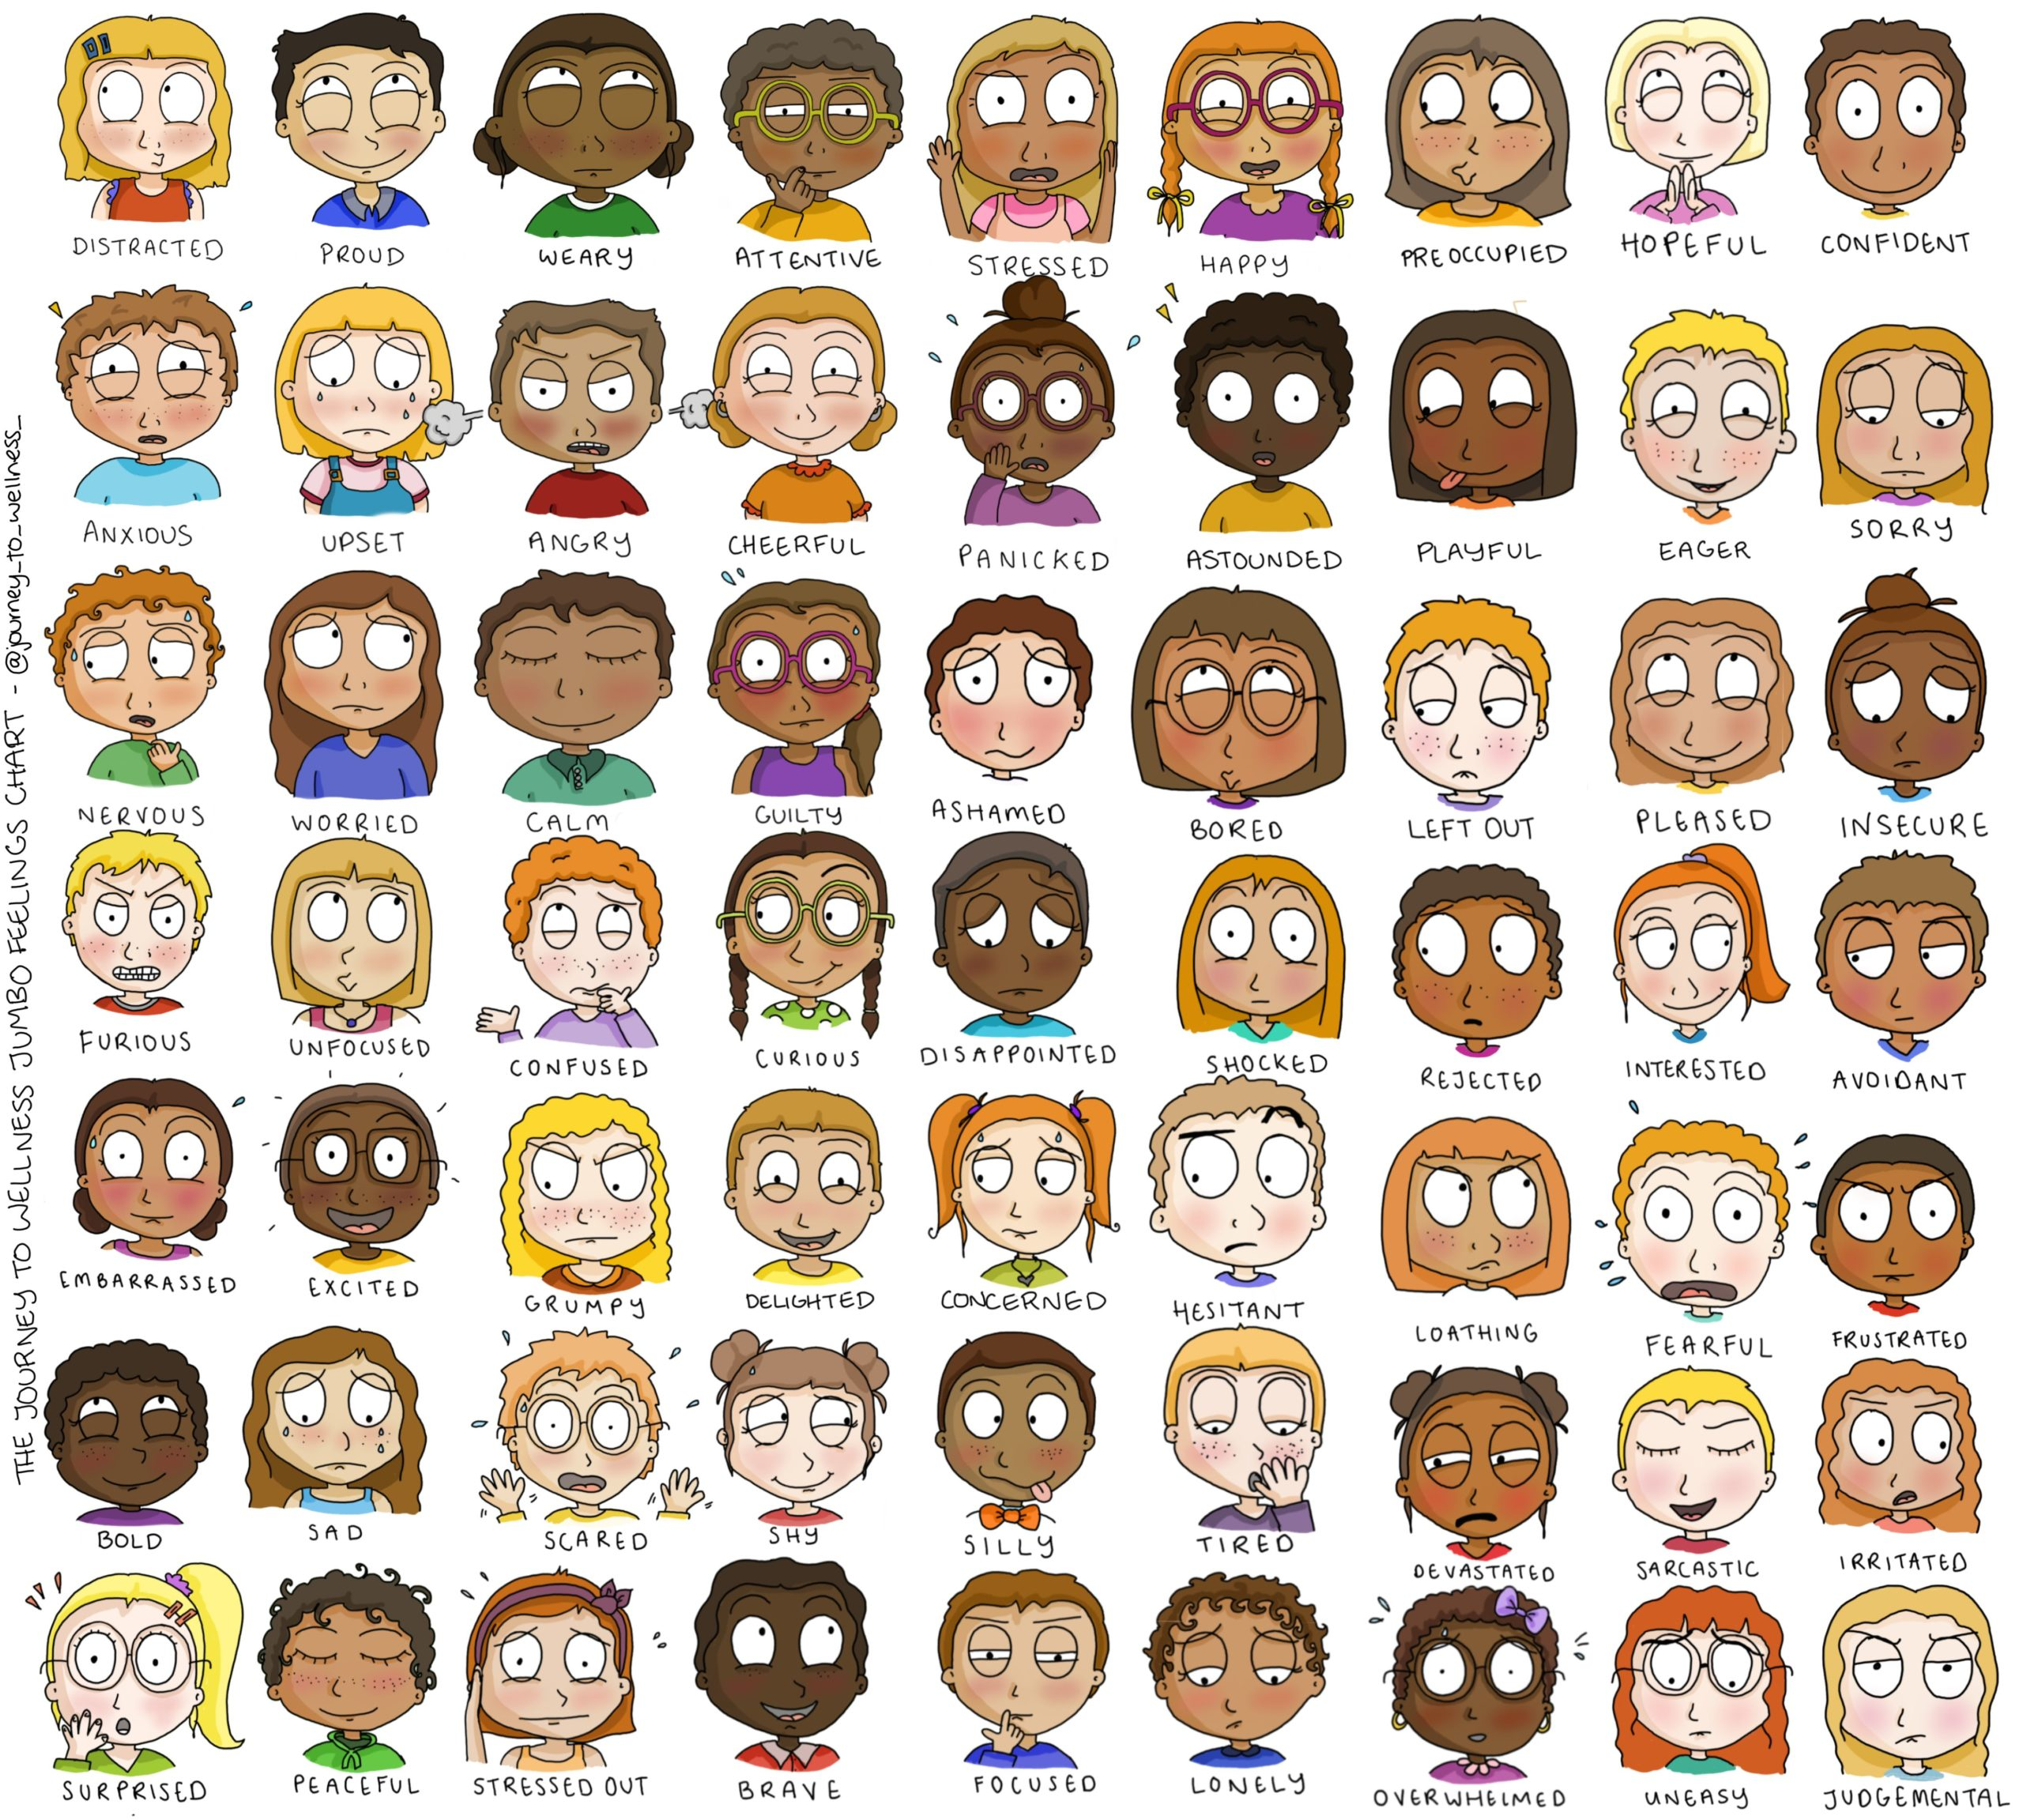
- What content was the most challenging to accept and you feel would need to do more research on for homework?
________________________________________________________________________________________________________________________________________________________________________________________________________________________________________________________________________________________________

- Are there any questions that you would like answered and want to email / post for the next lesson?
________________________________________________________________________________________________________________________________________________________________________________________________
Learners will give personal responses to this activity.

