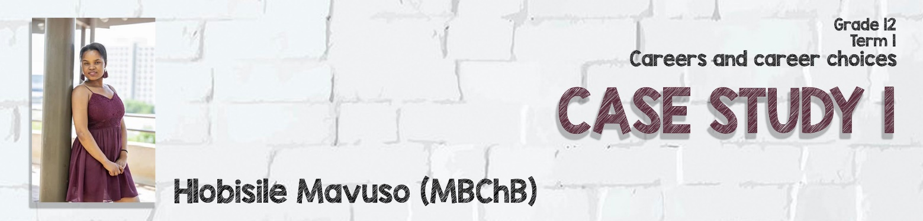
https://www.up.ac.za/teaching-and-learning/article/2748899/success-stories

I am a first-year medical student and I come from KwaZulu Natal. My success story which I wouldn`t refer to it as just a story, it is a never-ending journey that started when I came to UP to do a self-application. I couldn’t finish my application the previous year due to network problems and having insufficient access to facilities needed to assist learners with the university application process.
When I told the assistants, who helped with applications and registrations that I actually want to do Medicine, they explained to me that the applications for medicine were closed long time ago, I was so sad to hear that but I didn’t really know what to expect. I just didn’t want to stay at home and do nothing and more importantly I just wanted to help my community which is poverty stricken with poor health services. Luckily UP gave me a chance.
I got admitted, for BSc not medicine. I didn’t really know what BSc was about but just because I was told that if I do BSc and get good grades, I would put myself in a position to be selected for medicine after the first semester. I told myself that I just have to work hard and everything would be fine, but in reality, things were not as easy as I thought they would be, mind you, I didn’t even know how to use a computer nor did I have a laptop.
When I arrived, I was told that if I have NSFAS, I will be given money to buy a laptop and get a monthly food allowance, but here at Tuks it was a different story. My parents are both not working and I came here all alone. It would hurt me so much. As time went by, we started writing tests, I would try to study as much as can and give it my all, but the marks would come back telling a different story and looking at the way other students who wanted to also do medicine were passing made it so difficult to keep hope alive.
As I was staying at res, I depended on the computers at the IT labs and others available on campus but the disadvantage was that although there were computers, you are never sure that you will get one available. A lot of students were also using the computers and at times all of them were occupied so when you want to write online assignments, and there is nothing available and had no option but to leave.
When the time came for second semester tests, I saw that I was improving but it was not good enough, I wanted to give up. I felt like it was just taking more from me than giving back, I was tired of always being forced to study at the IT lab as it was cold, twice as cold that a fridge could ever be. I also had to go to the library at night which eventually closed at 9. I remember a day when I was crying at the IT lab, complaining to myself that I no longer want to try anymore, I am just tired of everything. Then I went to my room and slept. The next day I couldn’t wake up, I just didn’t have the motivation anymore and at that time a lot of people were dropping their modules. They didn’t want to do medicine anymore, I also thought of doing so, then I thought to myself that " am I just going to give up just because I don’t have a laptop nor a fat bank balance?
I asked myself “would I just allow myself to fail and set an example to younger kids that Varsity is all about struggling and failing?” How sure am I that I won’t give up like this even when I get a laptop which was my main excuse??" From then I had to change my mindset and start seeing things differently, I started to study at the IT lab with a smile, I realised how lucky I am to at least have computers to use for my work, to be given an opportunity to study, I started consulting with other students and lecturers regarding things that I did not understand, and yes it was not all easy but I had to try and hope for the best.
I had to believe that I am capable of making it into medicine. I started making jokes of me being a doctor, talk to my roommate as one of my patients when she was not feeling well. I believe success starts in one’s mind, if you can just change the way you think of something you will be able to use it to your advantage. Today I am a medical student, I got accepted. You have to believe in a dream that no one sees, work hard, dress up, show up, and never give up. Through Christ all things are possible.

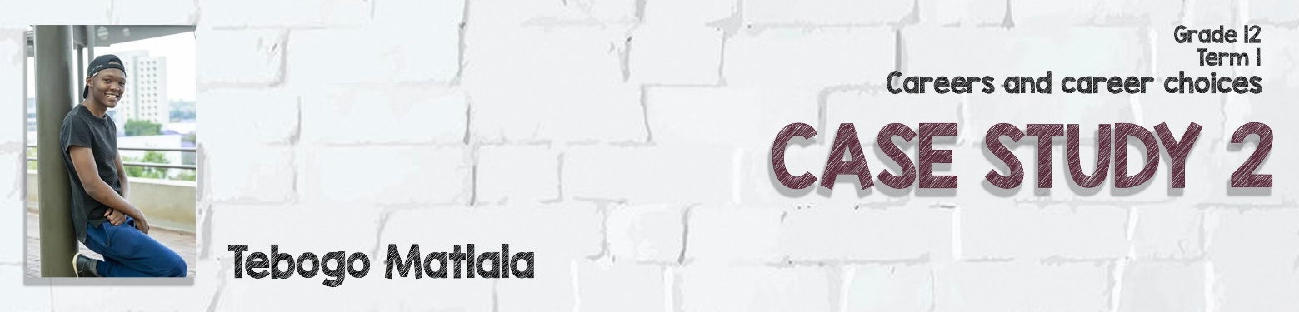
https://www.up.ac.za/teaching-and-learning/article/2748899/success-stories

I grew up in a family where education was just a dream, especially furthering my education to obtain a University degree. I never believed I would end up where am I today. English was a problem for me because I was taught in my home language at school and I felt demoralized because this would be a barrier for good communication. I didn't have a place to stay during my first semester so I had to travel every day from Hammanskraal and had to stand in a bus which was always full. When I got to University, I would be tired already.
When I attended lectures, the language barrier added to my problems because I was not used to being taught in English. During semester tests, I stayed up all night in the library because I would miss the bus after writing and the security would not allow us to sleep in the library. When I told my friends about my language barrier, they referred me to tutors, at that stage I didn't know what a tutor was. I just had to agree with them because I didn't want to feel embarrassed by disclosing that.
I wrote my semester tests and not even one mark was above 40%, that really demotivated me because the township people at home believed in me. But I finally accepted my defeat and tried to ask around about consultations with lecturers, I started consultations with them hoping that something would improve. unfortunately, when I did, it seemed as if the lecturers were speaking a language which was foreign to me. I stopped attending classes for a week because I was demotivated.
A week later, I received a message from TukRes saying that I have been placed at MAROELA. I immediately packed my stuff and came to University. I made sure that I associated with people who spoke English at res and read a lot of books. I managed to survive my first semester without a supplementary exam. I persevered and kept on stretching myself out of my comfort zone and during second semester I managed to get distinctions for all my modules. I didn't understand the quote "it always seems impossible until its done" by Nelson Mandela until now. I am currently a Bcom Accounting Sciences final year student and I always have that goal in mind.
This is my story. Thank you.

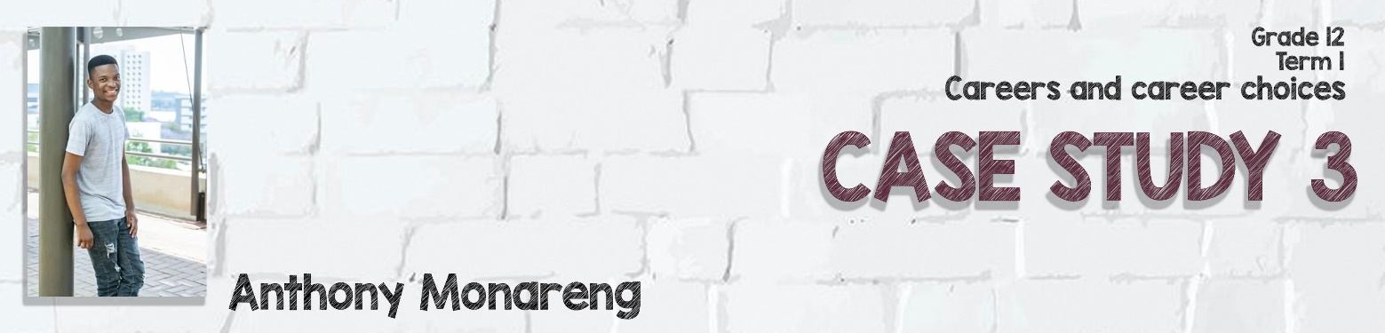
https://www.up.ac.za/teaching-and-learning/article/2748899/success-stories

The first semester was really tough on me as it was my first year at university. The anxiety was there and anticipation as well. In my residence many people who do teaching do not do mathematics, physics and chemistry as electives as they say that they are difficult modules.
I enrolled for them since I have the love for them. As the semester went by, I started feeling a lot of pressure doing these modules. The results for the first semester test for Calculus I got 44% which was the first fail in my whole mathematics school life.
During the same week we got results for our Chemistry semester test as well and it was even worse at a percentage of 38%. I felt like University of Pretoria is not made for me and I wanted to drop these electives but told myself that it is still the first tests. After some time, there came examination periods, I qualified for all my examinations but my Chemistry and Calculus semester marks were very low. After the first examinations I got informed that I would have a supplementary for both these modules on the same day which was the 26th of June 2018 to be exact.
At this time, I was so stressed to the extent I thought of dropping out immediately but my mind kept telling me that no road to success is easy. I pulled myself up and wrote the supp exams and managed to pass one of them. At the beginning of the second semester I figured out that I have to consult with the student adviser of the faculty and she gave me many possible solutions to my problems.
She told me that I have poor time management skills and I need to work on them. Due to the help of the UPO 109 module I managed to sort out my time management skills and now I can actually cope very well. The lecturer consultations also helped me with many things that I struggle with academically. Of course, praying to God also helped me in a great way. I am currently waiting for the Chemistry summer school as it is the last chance for me to pass the module. I am now confident enough that the finish line is mine and that I am going to graduate on time! I really hope that my story will be a motivation to other first years who are coming to this university next year and other UP university students at large.

