
Kwartaal 2:
Gesondheids-, Sosiale en Omgewingsverantwoordelikheid
Gevallestudie 1:  Currington het die koor vir "Walk a Little Straighter" geskryf toe hy twaalf jaar oud was. Die lied gaan oor die getuienis van sy eie pa se alkoholisme en hoe hy nie daardie eienskap aan sy eie kinders wil oordra nie  "Walk a Little Straighter"- lirieke |  | 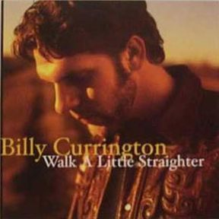
 | I remember looking up  To look up to him  And I remember most the time  He wasn't there  I'd be waiting at the door  When he got home at night  He'd pass me by to go to pass out in his chair  [Chorus]  And I'd say  "Walk a little straighter daddy  You're swaying side to side  Your footsteps make me dizzy  And no matter how I try  I keep tripping and stumbling  If you'd look down here you'd see  Walk a little straighter daddy  You're leading me"  [Verse 2]  He stumbled in the gym  On graduation day  And I couldn't help but feel  So ashamed  And I wasn't surprised a bit  When he didn't stay  He stumbled out before they called my name |  | [Chorus]  And I thought  "Walk a little straighter daddy  You're swaying side to side  It's not just me who's watching  You've caught everybody's eye  And you're tripping and stumbling  And even though I've turned eighteen  Walk a little straighter daddy  You're still leading me"  [Verse 3]  The old mans still like he always was  But I love him anyway  If I've learned one thing from him  Its my kids will never have to say  [Chorus]  And I'd say  "Walk a little straighter daddy  You're swaying side to side  Your footsteps make me dizzy  And no matter how I try  I keep tripping and stumbling  If you'd look down here you'd see  Walk a little straighter daddy  You're leading me"  [Outro]  Yeah walk a little straighter daddy  You're leading me.

