

Lesson 1 – Worksheet


Activity 1:
The three study methods / learning techniques that I use most often (in class or when studying) are:
1. ______________________________________
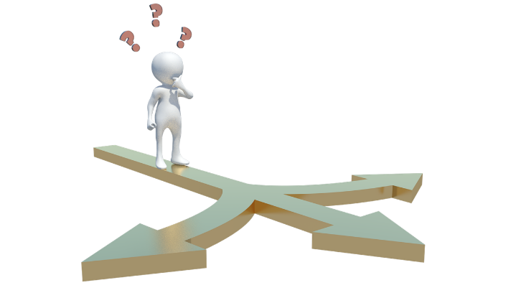
2. ______________________________________
3. ______________________________________

Activity 2:
My response / answer to
Scenario 1: _____________________________
Scenario 2: _____________________________
Scenario 3: ______________________________


Activity 3:
9.1.2.5
Based on the Learning Styles Questionnaire, my learning style is _____________________

Activity 4:
Reflect on the study methods you mentioned in Activity 1 and your learning style (Activity 3).
Refer also to the Content Summary as you answer the following.
- Where could I improve on my studying and learning?
_______________________________________
- Which studying ideas / tips would work best for me in my circumstances?
_______________________________________

 Activity 5:
Question 1

Choose the correct answer and write only the letter (A–D) next to the question number
(1.1 – 1.8), for example 1.9.D.

  - Visual learners …
A) learn best when they can see what they need to learn.
B) learn best when they are actively or physically involved in the learning process.
C) learn best when they can summarize what they have learned.
D) learn best when they can discuss or listen to what they need to learn.

  - Reading and writing learners …
A) learn best when they can see what they need to learn.
B) learn best when they are actively or physically involved in the learning process.
C) learn best when they can summarize what they have learned.
D) learn best when they can discuss or listen to what they need to learn.

  - Auditory learners …
A) learn best when they can see what they need to learn.
B) learn best when they are actively or physically involved in the learning process.
C) learn best when they can summarize what they have learned.
D) learn best when they can discuss or listen to what they need to learn.
  - Using colour, pictures, maps and diagrams while studying is a learning strategy that is most
suitable for a / an …
- auditory learner.
- visual learner.
- tactile / kinesthetic learner.
- reading and writing learner.

1.5 Chewing gum, walking around, taking frequent study breaks and squeezing an object in your hands
while studying is a learning style most suitable for a / an …
A) auditory learner.
B) visual learner.
C) tactile / kinesthetic learner.
D) reading and writing learner.

1.6 Repeating information out loud or making songs, jingles, rhymes and mnemonics while studying
is a learning style most suitable for a / an …
A) auditory learner.
B) visual learner.
C) tactile / kinesthetic learner.
D) reading and writing learner.

1.7 Engaging in research, reading over content repeatedly and making summaries of content to be memorized
is a learning style most suitable for a / an …
A) auditory learner.
B) visual learner.
C) tactile / kinesthetic learner.
D) reading and writing learner.

1.8 A learning style can be defined as …
A) the type of colours you like to use when making study notes.
B) the way a person prefers to internalise, organise, store and use information.
C) your approach to solving problems in relationships.
D) the way you relate to your teachers.
[8]

Question 2

Provide a definition for the following terms.

2.1. Visual learning style (1x2) (2)
________________________________________________________________
________________________________________________________________
________________________________________________________________

2.2. Aural learning style (1x2) (2)
________________________________________________________________
________________________________________________________________
________________________________________________________________

2.3. Kinesthetic/Kinaesthetic learning style (1x2) (2)
________________________________________________________________
________________________________________________________________
________________________________________________________________

2.4. Reading and Writing learning style (1x2) (2)
________________________________________________________________
________________________________________________________________
________________________________________________________________

[8]

Question 3
Study the illustration below and answer the questions that follow.
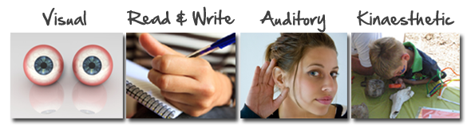

  - Explain what a learning style is (1x2)( 2)

________________________________________________________________
________________________________________________________________
________________________________________________________________

3.2 Identify and briefly describe TWO of the learning styles depicted (2x2) (4)
________________________________________________________________
________________________________________________________________
________________________________________________________________
________________________________________________________________
[6]

