Lesson – Worksheet

Before we delve into this topic, take a minute, and think about what the word RELATIONSHIP means to you. Write a few sentences in the space below:


Activity 1: Your RELATIONSHIP Mind Map
Use the space below to draw a mind map of your relationships and friendships at home,
school and in your community. Under each heading, write the names of people who you
have relationships with. If you don't know the names of some of the people, you may use
descriptors.
At HOME:

At SCHOOL:

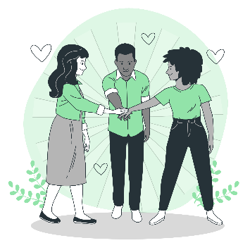
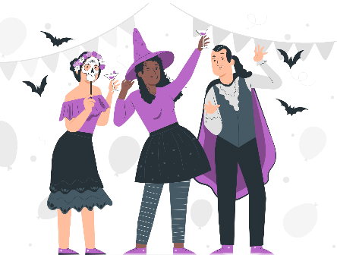

My Relationships & Friendships

In the COMMUNITY:
OTHER:

Activity 2:

Starting a Conversation
(Adapted from https://www.dalecarnegie.com/en/winpeopleover/how-to-start-a-conversation)
Use the following question types when needing to start a conversation.
Order should be Factual, followed by Causative and finally Value-based.
Step 1: Ask a Factual Question
Factual questions that are typically conversational in nature and revolve around factual information. Factual questions are great for conversation starters. Here are some examples:
- What was your favorite sport or activity in Grade 7?
- Where did you grow up?
- How long have you been living in this community / area?
Step 2: Ask a Causative Question in response to the answer to Step 1 (i.e. the Factual Question)
Causative Questions determine the motives or causative factors behind the answer to the factual question. They are typically the “why” and “what questions”. Causative questions build on the conversation starters allowing you to engage on a deeper level. Here are some examples:
- Why did you choose that sport or activity?
- How then did you happen to come to our school?
Step 3: Ask a Value-based Question in response to the answer to Step 2 (i.e. the Causative Question).
Value-based Questions help determine a person’s value system. They are designed to help understand the “worth” that an individual places on certain things. These are questions that people are probably rarely asked and give a greater view of the inner person. Value-based questions allow you to deeply understand the other person. Here are some examples:
- If you had to do it over again, would you have chosen a different sport or activity?
- How did that youth hobby or activity end up serving you now at high school?
- Tell me about a person that had a major impact on your life.

Try practice this three-step strategy by asking someone in your class these types of questions.

Think about and write down your three questions that you would use:
1
2
3

Activity 3:

Sustaining a Relationship:
The How to initiate and sustain relationships article you read on page 6 of the
Content Summary – has quite a bit of information in it. Have a look at the following
questions:
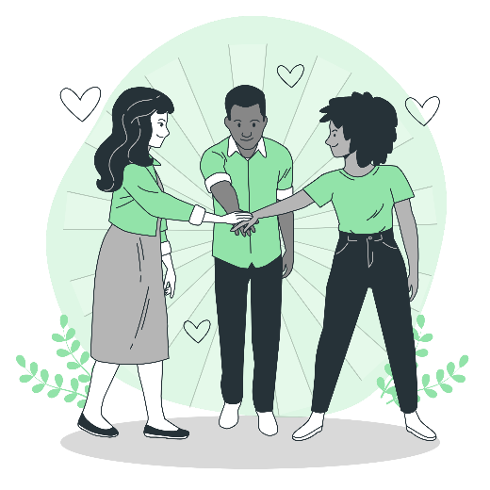
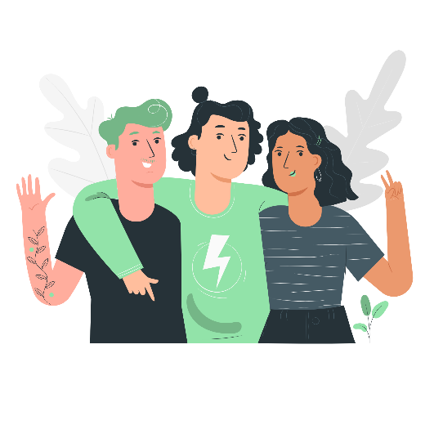
Which of the ideas from the article can I use?
So far, I have learnt:
My main takeaway from the article:

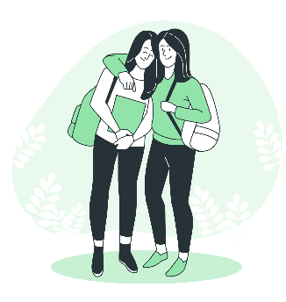

My questions so far:

Activity 4
Refusal Skills Worksheet (page 11 of Content Summary)
Making Excuses versus Assertively Refusing
Looking at the excuses below – complete the table taking into consideration your lesson so far.

If YOU were being offered DRUGS by a friend or acquaintance, how could you say no?

Excuse | Possible Negative Consequence to the Excuse | Assertive Alternative
Not today | They could ask me again tomorrow because they did not get the message. | “No thank you. I am not using anymore.”
Maybe another time
Maybe later

I don’t have any money on me

I have a drug test tomorrow

I am on Probation

I am an athlete

No thanks, not my thing

Activity 5
A few quick questions:
Answer the questions below as best you can:

- List three characteristics of a healthy relationship. ___________________________________
______________________________________
______________________________________
- List three examples of emotional abuse. ___________________________________
______________________________________
______________________________________
- List three examples of physical abuse. ___________________________________
______________________________________
______________________________________
- List three people or organizations you could turn to for help if you were in an unhealthy relationship.

_____________________________________________
_____________________________________________
_____________________________________________
- How could I support a friend who’s being bullied?
________________________________________________________________________________
________________________________________________________________________________
________________________________________________________________________________
________________________________________________________________________________
________________________________________________________________________________



Complete the reflection below now that you have covered this section. Use key words and short sentences to answer the questions.

What stood out for me was:
What have I learnt?
What do I need help with?

How well have I worked, and can I improve?
Did the lesson help to understand relationships more?
What skills can I apply?

