Content Summary
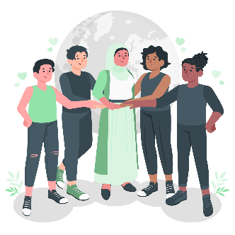
RELATIONSHIPS
Development of the Self in Society
Grade 8 Term 1 Week 6-7

As humans, the relationships we form with other people are vital to our mental and emotional well-being and even our survival.
Humans have an inherent desire to be close to other people — to connect and build relationships.
Social support is a very important part of being a human, and therefore when social relationships break down or are damaged, it can have a big impact on our mental health and well-being.
A positive relationship can be shared between any two people who support, encourage, and help each other practically as well as emotionally.
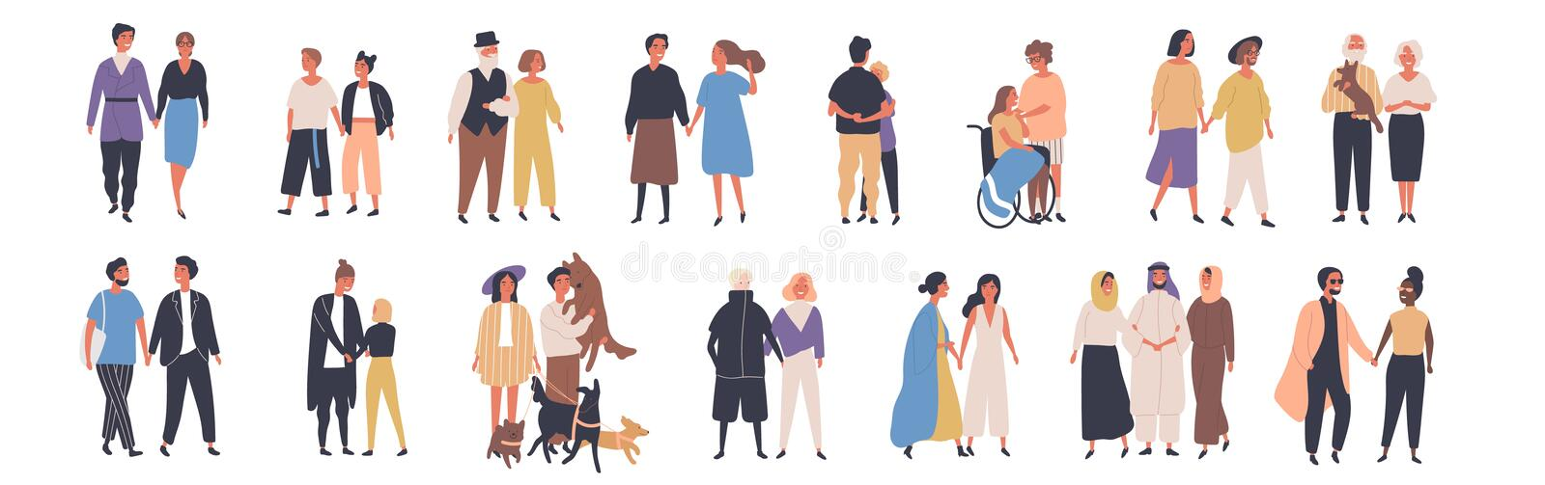

Relationships are connections between people. People need relationships at different stages in their lives, relationship needs will change as we grow up, mature and learn more about ourselves.
Our first relationships would be with our caregivers at home - whether they were our parents, grandparents’, or guardians. As you grew up, you developed relationships with your playmates. When you started school, you developed even more relationships. Now you have relationships with your peers, with friends and with your teachers.
As you grow up, your circle of friends and relationships widens to include people in your community. As a teenager going through adolescence, and you may find that your friendships are becoming increasingly important to you. In some ways you may even place more importance on your friends than what you do on your family relationships.

Family, Friend, Enemy or Stranger (but what about Acquaintance?)
Many of us would label or box our peers into Family, Friends (anyone that seems to like us), Enemy (someone who doesn’t seem to like us OR does not appear to like us enough to want to get to know us better) and Strangers (never met them before). But we are missing an important category of people called acquaintances.

An acquaintance is someone that you recognize by sight but don’t know well (positively or negatively). It might be that you don’t know each other well because you always only bump into them or see them briefly at a particular place (like shopping mall, at a bus stop, during the holidays away, at the local sports club, etc) or because when you see each other there is no time to talk long. It could also be that you met them long ago but forgot their name so now you need to keep the greetings short as don’t want them to find out. You might feel intimidated by them or them by you, as a result very few words are ever exchanged, but you recognize each other.
There are people in this class that you could probably label as acquaintances.

During this recent season of social distancing and mask wearing, we have all made far more acquaintances (someone you recognize by sight) than friends.

For the next two lessons, we are going to focus on acquaintances that are your peers at home, school and in the community.

We are going to learn some ways that will help us to potentially make some of these acquaintances (people we recognize by sight) into friends, but also how does one connect with someone you have met for the first time.
Thereafter we will look at what keeps friendships and relationships going? This means what sustains them and finally, we will be exploring problem solving and communication skills within relationships and how to handle things when they don’t work out.

APPROPRIATE WAYS TO INITIATE A RELATIONSHIP

(Making acquaintances into friends and meeting strangers)
To initiate something means to start or get something going. Some relationships you do not need to initiate – as you are born into them.
Many relationships begin naturally because there is a mutual need for that relationship.

The beginning of any relationship starts with a conversation. It often feels more difficult to initiate a conversation with an acquaintance than with a stranger - because of the apparent ‘history’ between you and them (i.e., where you always see each other / recognize each other but never chat).
But this could be used to your advantage, it is the thing that you have in common.
The first rule when initiating any conversation with someone is to try find something you:
a) have in common or
b) something that you can agree on.
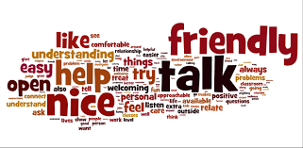
You can do this best by asking questions (while showing genuine interest) and getting the person to talk about themselves.
Things you may have in common could include:
You both enjoy a particular: sport, sports team / club / coach or athlete, movie / series, type of music or artist, book, game, app or website, community activity, pet(s), place to relax, shop / store or car.
Things you may agree on:
You both might discover you hold the same view regarding a current topical issue at your school or in your community.
Topics could range from favorite technology (for example: Apple phones vs Samsung vs Huawei), food preference (opinion on fast foods, dietary constraints e.g., vegetarian, vegan, etc.), views regarding a certain celebrity, opinion regarding a social issue such as climate change or a local community project.
Let’s practice initiating conversations, refer to Activity 2 in your Lesson - Worksheet.
Identify someone in class that you don’t know well and ask them one Factual Question, followed by one Causative Question (Why, How or What Questions) and finally one Value Based Question (Worth person places on things). Listen carefully!! Because after the three questions, you will need to repeat their answers to the person – to show you listened and paid attention.

PRACTICAL Example:
Factual Question: What was your favorite sport or activity in Grade 7?
Answer: Enjoyed playing soccer
Causative Question: Why did you choose soccer over rugby / netball?
Answer: My family are big soccer fans and my older brother made me practice with him. So, I had little choice.
Value Based Question: If you had to do it over again, would you have chosen a different sport?
Answer: It was easy to get sucked in with all the family hype. But now that I know the game better, I really enjoy the tactical play and find I’m actually pretty good at spotting gaps and passing well. So no, I’m glad that soccer is my favorite sport.

Progressing from Factual, to Causative to a Value Based Questions within a conversation, allows you to understand someone better. More than just obtaining a fact about them but also understanding why they do what they do and where they place value.
This is a great starting point for initiating a relationship!



When initiating friendships, it's important to actively listen so what the other person is saying and to also tell the person a little bit about yourself. Express interest in the other person and be authentic, try not to have expectations and accept that person for who he or she is.
You can't force a friendship; you will come across people that you will automatically click with. This may be because of a shared passion for something, similar personalities, or sense of humor. Maybe your differences will be what pulled you towards one another. Friends can learn from each other and it's important to appreciate our friends and peers for their individual qualities. And with some people, you might just stay acquaintances, and that's okay too. You don't have to be friends with everyone you meet, but it's still very important to respect people even if they are just acquaintances.

APPROPRIATE WAYS TO SUSTAIN A RELATIONSHIP
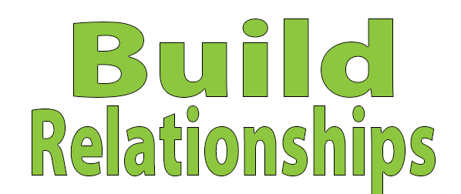
Once we have made a friend, we started a new relationship. The next important part of the relationship is to sustain it.
To sustain something means to keep it going or to strengthen it. Any relationship whether it is friends, classmates, peers, or acquaintances will require some effort on both parties.
Once you've established a connection - you have crossed the first hurdle of navigating a relationship.

Work on the basics: The basis of any good relationship is communication, sharing, caring mutual respect, trust, and honesty as well as fairness. For a relationship to continue to grow, we need to keep all of the above intact. Clear and honest communication is essential in sustaining a relationship - as it helps us avoid hurting the other person’s feelings or any misunderstandings.

Make the time and effort: All relationships take time, energy and care to keep them going. Being committed to a friendship - means that you are both willing to put in the time and effort into sustaining it. Taking time to connect with each other and making a continued effort, will help to strengthen your relationship. Make sure that your friendship is mutual, everyone must work at making relationships work.

Trust each other: In any relationship, trust is crucial. This means keeping your promises and not doing anything to hurt one another. Being there for one another is also part of that trust.

Have fun together: As much as a friendship requires work – the best part of them is that you will have someone to laugh with and have a good time with.

Support each other through good times and bad: A true friendship is unconditional; it is not based on popularity or looks. Friends also don't run away when things are tough or challenging. Saying things like “I will be your friend IF…” or “I’ll be your friend UNTIL…” should not even be a consideration.

Understanding that sometimes friends will disagree: everyone disagrees at some point or another – we all have different viewpoints, ideas, or opinions. But just because you disagree on something does not mean that a friendship is over – its important to respect one another and forgive when necessary.

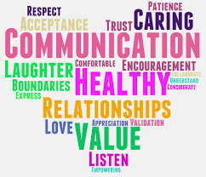
Have look at the article that follows and then, refer to Activity 3 in
Lesson – Worksheet page 4.

HOW TO INITIATE and SUSTAIN RELATIONSHIPS

Adapted from 10 Ways to make people like you
https://www.forbes.com/sites/francesbridges/2018/02/07/10-ways-to-make-people-like-you-from-how-to-make-friends-and-influence-people/?sh=6280b28e4bb4

1. Do Not Criticize, Condemn or Complain
Carnegie writes, "Any fool can criticize, condemn or complain- and most fools do." He continues to say that it takes character and self-control to be forgiving, this discipline will pay major dividends in your relationships with people.
2. Be Generous with Praise
Carnegie uses Schwab as an example throughout the book, as someone who exemplifies all the principles Carnegie preaches. Schwab used praise as the foundation of all of his relationships, "In my wide association in life, meeting with many and great people in various parts of the world," Schwab declared, "I have yet to find the person, however great or exalted in their station who did not do better work and put forth greater effort under a spirit of approval than they would ever do under a spirit of criticism."
3. Remember Their Name
Remembering people's names when you meet them is difficult. You casually meet a lot of people so it's challenging, but if you can train yourself to remember people's names, it makes them feel special and important. Carnegie writes, "Remember that a person's name is to that person the sweetest and most important sound in any language."
4. Be Genuinely Interested in Other People
Remembering a person's name, asking them questions that encourage them to talk about themselves, so you discover their interests and passions are what make people believe you like them, so they in turn like you. Carnegie writes, "You make more friends in two months by becoming genuinely interested in other people than you can in two years by trying to get other people interested in you." If you break it down, you should listen 75% and only speak 25% of the time.
5. Be Quick to Acknowledge Your Own Mistakes
Nothing will make people less defensive and more agreeable than you are being humble and reasonable enough to admit your own mistakes. Having strong and stable personal and professional relationships relies on you taking responsibility for your actions, especially your mistakes. Nothing will help end tension or a disagreement more than a swift acknowledgment and apology on your part.
6. Don't Attempt To "Win" An Argument
The best way to win any argument, Carnegie writes, is to avoid it. Even if you completely dismantle someone's argument with objective facts, you won't be any closer to reaching an agreement than if you made personal arguments.
7. Begin on Common Ground
If you are having a disagreement with someone, you start on common ground and ease your way into the difficult subjects. If you begin on polarizing ground, you'll never be able to recover, and may lose ground with subjects on which you agree.
8. Make People Feel Important
Smiling, knowing people's names, praising people, trying to know their interests and chat about them make people feel important. That is the underlying point of all the above principles. If you make people feel important, how you walk through the world will be an exponentially more pleasant and incredible experience.


CHARACTERISTICS OF HEALTHY RELATIONSHIPS:

In a positive relationship, a person can still be their own person, as well as being part of a couple.
A healthy relationship makes a person feel good about themselves and their partner. They can have fun together and still be themselves. All relationships are different, but healthy relationships share at least five things in common - the S.H.A.R.E. qualities.

- Safety: In a healthy relationship, a person feels safe. They do not have to worry that their partner will harm them physically or emotionally, and they are not tempted to harm them. A person can change their mind about something - without being afraid of how their friend will respond.
- Honesty: A person does not hide anything important from their friend and can say what they think without fear of being ridiculed. They can admit to being wrong and working with their partner to resolve disagreements by talking honestly.
- Acceptance: They accept each other as they are. They appreciate their friends’ unique qualities, such as shyness or outgoing, and do not try to “fix” them. If there are qualities a person does not like about their partner, then maybe they should not be with that person.
- Respect: Both partners think highly of each other. They do not feel superior or inferior to their partner in important ways. They respect each other’s right to have separate opinions and ideas.
- Enjoyment: A good relationship is not just about how two people treat each other - it also must be enjoyable. In a healthy relationship, they can play, laugh together, and have fun.

What POSITIVE words do YOU associate with a HEALTHY Relationship?

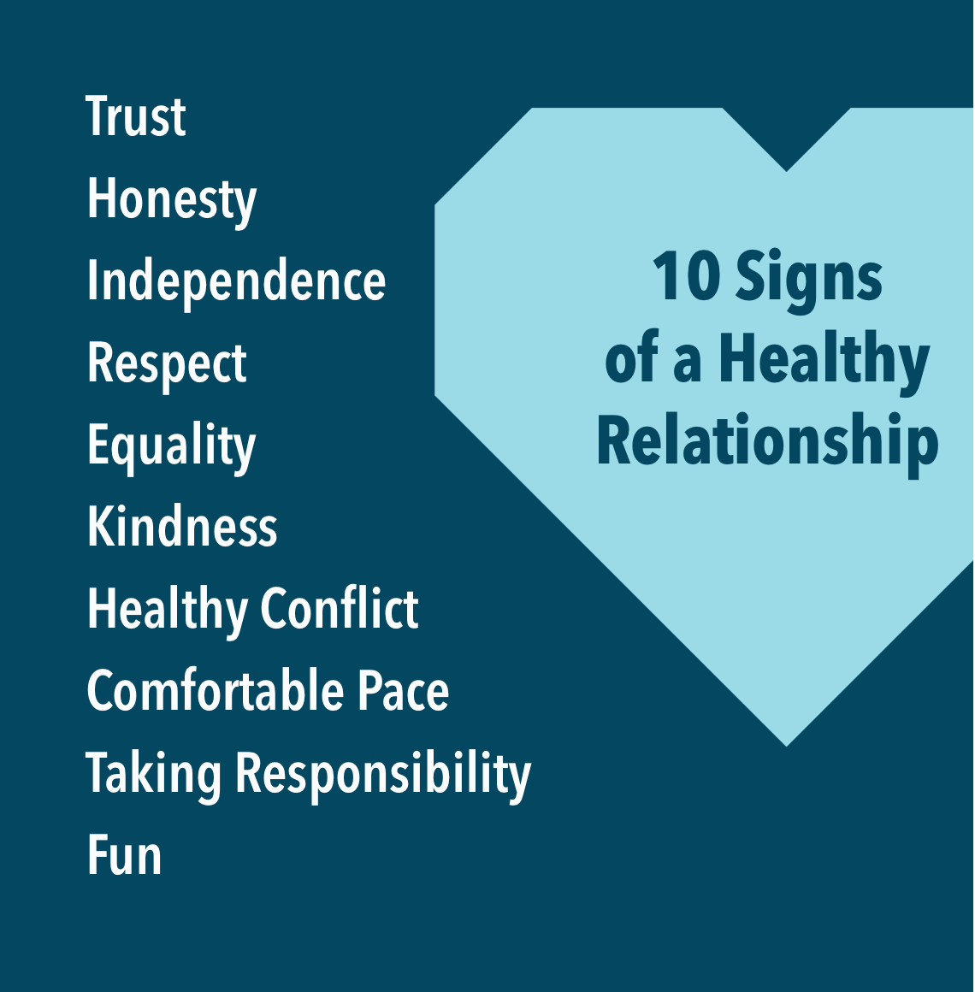

CHARACTERISTICS OF UNHEALTHY RELATIONSHIPS:
It is important to recognize signs of unhealthy relationships before they escalate, unhealthy characteristics may include the following:
- Control: one person makes all the decisions and tells the other what to do, what to wear, or who to spend time with. They are jealous, and/or try to isolate the other person from their friends and family.
- Dependence: one person feels that they “can’t live without” the other. Or they threaten to do something drastic if the relationship ends.
- Digital monitoring or “clocking”: one person uses social media sites like Instagram and Snapchat to keep tabs on the other person. They constantly message or text the other person and demand quick responses.
- Dishonesty: one person lies to, steals from, or keeps information from the other.
- Disrespect: one person makes fun of the other or talks about them behind their back.
- Hostility: one person picks a fight with the other. This may lead to one person changing their behaviour to avoid upsetting the other.
- Harassment: one person uses unwanted, unwelcome, and uninvited behaviour to make the other feel unsafe. They may use cat calls to make inappropriate comments about the other's body or make physical advances without consent.
- Intimidation: one person tries to control the other by making them fearful or timid. They may attempt to keep the other person from friends and family or threaten violence or a break-up.
- Physical violence: one person uses force to get their way (such as hitting, slapping, grabbing, or shoving).
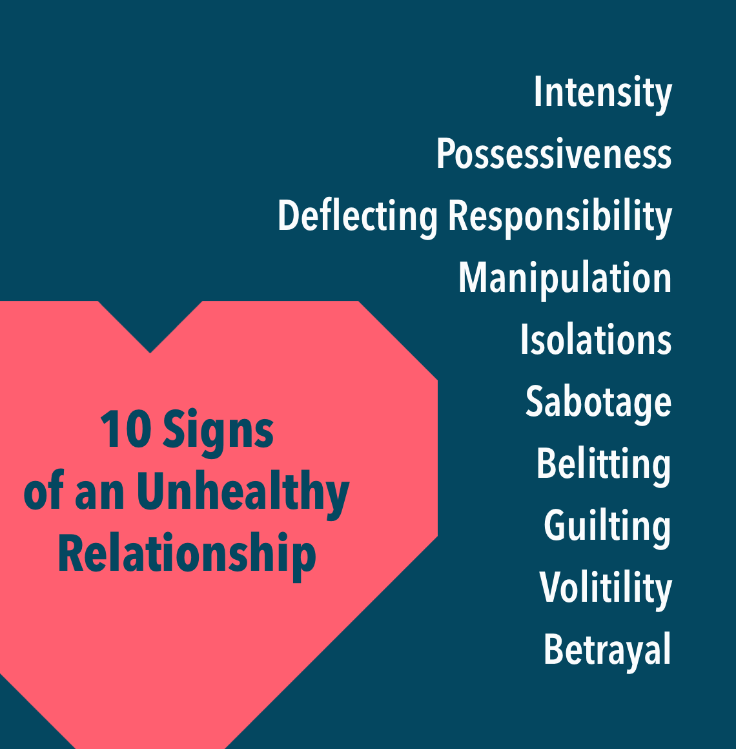

LESSON 2:
PROBLEM SOLVING SKILLS: APPROPRIATE BEHAVIOUR IN A RELATIONSHIP


As we've discussed, a good relationship is based on communication, sharing, caring, mutual respect and trust. As well as honesty and fairness.
But what do we do if our friends are behaving inappropriately? What do we do if they behave unfairly towards us or if they do something to hurt us and break our trust or are disrespectful?
Any of these would create problems in your relationship so we would need problem solving skills to deal with them. In previous lessons when you looked at Sexual Identity and Development (i.e. Term 1 Week 4-5), you started exploring problem solving skills. Let's look at a similar model to help solve problems within our relationships:

The IDEAL method
I Identify the problem
In order to know what we are dealing with; we need to break it down and figure out exactly what the problem is and pinpoint it.
D Describe possible solutions
Next, we need to look at what possible solutions there are to our problem, sometimes there may be more than one solution and in others some solutions will be a better fit than others.
E Evaluate each option
Looking at our possible solutions we need to figure out Which are suitable and, discard the solutions that are not.
A Act on the chosen strategy
Once we've made our decision, we can go ahead and put whatever we've decided in place.
L Look back and learn
Lastly, we can evaluate our decision and decide if it was the best course of action.

ASSERTIVE REFUSAL SKILLS – ALCOHOL & DRUGS

Being able to refuse requests from others is an important part of being assertive and standing up for yourself. Sometimes you may run into old friends who don’t know or don’t care that you don’t do drugs or drink, they may offer or push you to use. It may sound simple but turning down an offer to use can be difficult – as some people are very skilled and persuasive when offering drugs or alcohol! Practicing assertive refusal skills will help you be more successful at saying ‘no’ and abstaining from use! Assertive refusal skills are skills that allow you to be effective at saying no to drug or alcohol offers.
(NOTE: we will be looking at Substance Abuse in more detail in Term 2)

Different Assertive Refusal Skills / Techniques:
- Respond Rapidly: the faster you can say no to offers of drugs and alcohol, the less likely you are to give in. If you hesitate, it allows time to think of excuses to go along.
- Respond with a clear and firm ‘no’ that does not leave the door open to future offers for alcohol or other drugs. Leave out any excuses or qualifiers – state:
- ‘no’ or
- ‘no, thank you’ or
- ‘no, I don’t drink or do drugs’

‘No’ can be followed by:
Changing the subject:
‘No thanks, but talk more about what’s been going on in your life’
‘No thank you, I don’t drink – but can you tell me more about your holiday’
‘No, I don’t use drugs – instead, can you tell how the new school is going?’
Suggesting alternative activities:
’No thank you, but I would love a coffee/soda/tea/or something to eat’
’No thanks, but would you like to head over to the coffee shop’
’No, I don’t drink, but I do know of a great pizza joint’
Clearly requesting that the individual not offer alcohol and other drugs again
’No thank you and I don’t want to be asked again’
’No’ (leave out the thank you if you have to repeat it a second time)
’No (one more time) and I need to leave now’

- Broken Record: Continue to say no. You may feel uncomfortable at first but reminding yourself that they are also trying to make you uncomfortable enough to drink or use, will be a helpful tool.

- Pay attention to body language and non-verbal cues:
- Good eye contact – don’t take your eyes off the other person’s eyes
- Standing squarely towards the other person
- Appear confident
- Use a calm, even voice tone and volume
- Keep your ‘body language’ consistent with your statements
- Maintain a posture and attitude of equality
- Speak firmly, positively, and loud enough to be heard easily
- Use clear, concise speech
- Leave only after you have said no a second or third time

- If all else fails, leave the situation
Examining the above skills more closely:
The first two skills (responding rapidly and with a clear, firm no) focus on leaving out excuses that leave the door open for using. Sometimes it can feel more comfortable to blame your refusal to use on an outside force. It may even be easier early on in recovery to have external motivators (e.g., drug tests) influence you to abstain; however, this leaves future offers on the table. To decrease the likelihood of future offers, the above assertive refusal skills will be more effective.

Let’s practice assertive refusals, refer to Activity 4 in your Lesson - Worksheet page 5

BULLYING (INAPPROPRIATE BEHAVIOUR IN A RELATIONSHIP)
Bullying is very difficult for anyone, to deal with. No matter who you are or where you come from, Bullying is a terrible thing to go through. It makes you feel afraid and degraded and often it makes a person feel like they are worthless. Unfortunately, bullying also makes you stop wanting to go out because you are scared you might see the person bullying you. Many people who are bullied even start asking themselves if they can do anything right?

BULLYING IS UNACCEPTABLE and these are the ways you can be bullied:
- People calling you names
- Making things up to get you into trouble
- Hitting, pinching, biting, pushing, and shoving
- Taking things away from you
- Damaging your belongings
- Stealing your money
- Taking your friends away from you
- Spreading rumours
- Threats and intimidation

What to do if you are being bullied
You have to tell someone. You may not want to do this because it means showing that you are vulnerable, that you are letting someone get the better of you. But really, it is very important to tell someone otherwise, it may not stop. Speak to a friend, parent, brother or sister, uncle, or aunt and most importantly, if it happens at school, speak to your teacher.
In the meantime...
Try to stay in safe areas of the school at break and lunchtime where there are plenty of other people. Bullies don’t like anyone seeing what they are doing. If you are hurt at school, tell a teacher immediately and ask for it to be written down. Make sure you tell your parents.
On the school bus, try to sit near the driver, or if it’s an ordinary bus, by other adults. If you must walk part of the way, and you’re afraid of the bully finding you, then change your route, try to leave home and school a bit later or a bit earlier, or see if you can walk with other people who live near you, even if they’re older or younger.

If you have a cell phone, be careful who you give your number to. If you receive threatening phone calls or emails, then tell your parents. It is against the law for anyone to send offensive or threatening phone messages and if it continues, it can also amount to harassment. The police can, and do, take action.
If you see anyone else being bullied at your school, please tell someone about it. But don’t get into trouble with the bullies, do it without anyone noticing. Tell a teacher when you get a chance and there isn’t anyone else around. People who are being bullied need friends so if you can help someone who is so unhappy, please do so.

There are many different types of bullying that can be experienced by children and adults alike, some are obvious to spot while others can be more subtle. The different types of bullying that we look at below are some of the ways that bullying could be happening.
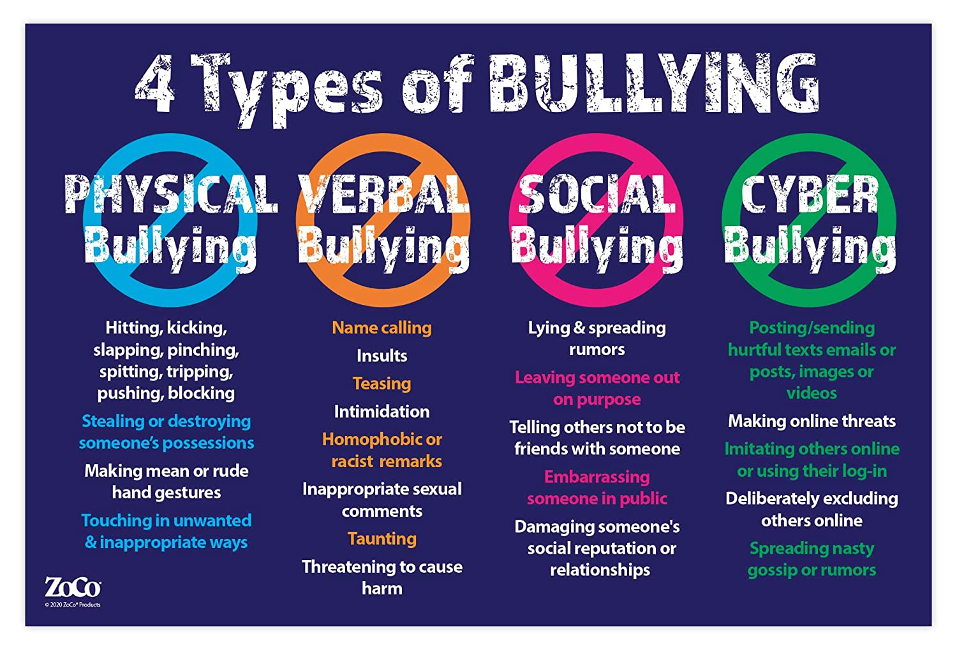

Physical bullying
Physical bullying includes hitting, kicking, tripping, pinching, and pushing or damaging property. Physical bullying causes both short term and long-term damage.
Verbal bullying
Verbal bulling includes name calling, insults, teasing, intimidation, homophobic or racist remarks, or verbal abuse. While verbal bullying can start off harmless, it can escalate to levels which start affecting the individual target.
Social bullying
Social bullying, sometimes referred to as covert bullying, is often harder to recognise and can be carried out behind the bullied person’s back. It is designed to harm someone’s social reputation and / or cause humiliation.
Social bullying can include:
- lying and spreading rumours
- negative facial or physical gestures, menacing or contemptuous looks
- playing nasty jokes to embarrass and humiliate
- mimicking unkindly
- encouraging others to social exclude someone
- damaging someone’s social reputation or social acceptance.
Cyber bullying
The Cyber Bullying Research Centre defines cyber bullying as: Intentional and repeated harm inflicted through the use of computers, phones, and other electronic devices.
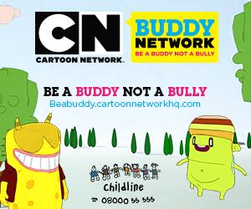
Cyber bullying can be overt or covert bullying behaviours using digital technologies including hardware such as computers and smartphones, and software such as social media, instant messaging, texts, websites, and other online platforms.
Cyber bullying can happen at any time. It can be in public or in private and sometimes only known to the target and the person bullying.
Cyber bullying can include:
- abusive or hurtful texts, emails or posts, images, or videos
- deliberately excluding others online
- nasty gossip or rumours
- imitating others online or using their log-in.

COMMUNICATION SKILLS: ABILITY TO DISAGREE IN CONSTRUCTIVE WAYS AND APPROPRIATE WAYS TO END A RELATIONSHIP.

How to disagree in a constructive way:
By using constructive communication skills, we can build and strengthen our relationships. Disagreements happen in all relationships, how we deal with them will determine the strength of our relationships.

Here are some pointers to remember:
- Think about the disagreement and how you may feel about it
- Talk to the other person, discuss the problem and see if you can't find a solution together
- It is important to take turns to speak and listen never cut each other off
- Actively listening means not interrupting and making sure that you understand what your friend is saying
- Try and understand your friend’s point of view
- Stay calm, talk clearly and be honest about your point of view
- Be reasonable and not overly emotional, this is not the time for threats attacks or being rude
- Focus on constructive solutions and not blaming each other and trying to be right
- If it comes to it and you can't find a solution - sometimes, we need to agree to disagree

How to end a relationship:
There can be many reasons why a relationship may come to an end. You may end a relationship because you've had a disagreement and you're unable to find resolution, maybe you have to move away or maybe you feel that you have both changed and you no longer get on.
We would all like to believe that every relationship lasts forever, but unfortunately not all relationships can.

When it comes to ending a relationship it's best to be honest and straight forward with the other person – there is no need to be rude or start ignoring them. We've talked about how important communication is and even when you're ending a relationship – it is still a very important factor

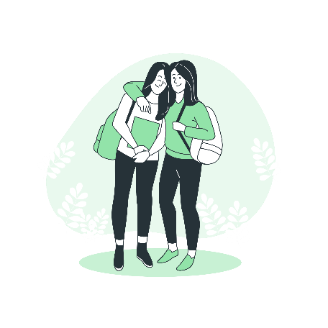
The end of a relationship can be very painful and it is upsetting whether you are the one that ends it, or the other person is. There are many emotions that come with ending our relationship, turn to your friends for support and allow yourself to feel the emotions that come with it.

Here is something to consider when ending a relationship:
1) Plan
What you want to say
Try to explain what you are feeling but remember to clearly say that you want to end the relationship.
Where you'll meet
Pick a neutral place to meet where there are other people around.
How you’ll get home safely after meeting
Let a friend or family member know where you’re going & when they can expect you back.

2) Look after yourself
After a breakup, make sure you spend time doing things that make you feel good like your favourite hobbies, or seeing your best friends!

3) Remember it’s not your fault.
The other person should respect your decision.
If you feel pressured or threatened talk to a trusted adult.
Remember:
- A positive relationship is based on open and honest communication, trust, respect, and compassion.
- It has healthy boundaries that allow you to be who you are, do what you like and spend time with your friends and family.
- Pay attention to unhealthy behaviours in your relationships - such as power and control, disrespect and the use of physical force and ask for help if needed.
- Always remember that a relationship should make you happy and everyone deserves to have positive relationships.
NOTES

