
Y
T
I
L
A
U
X
E
S

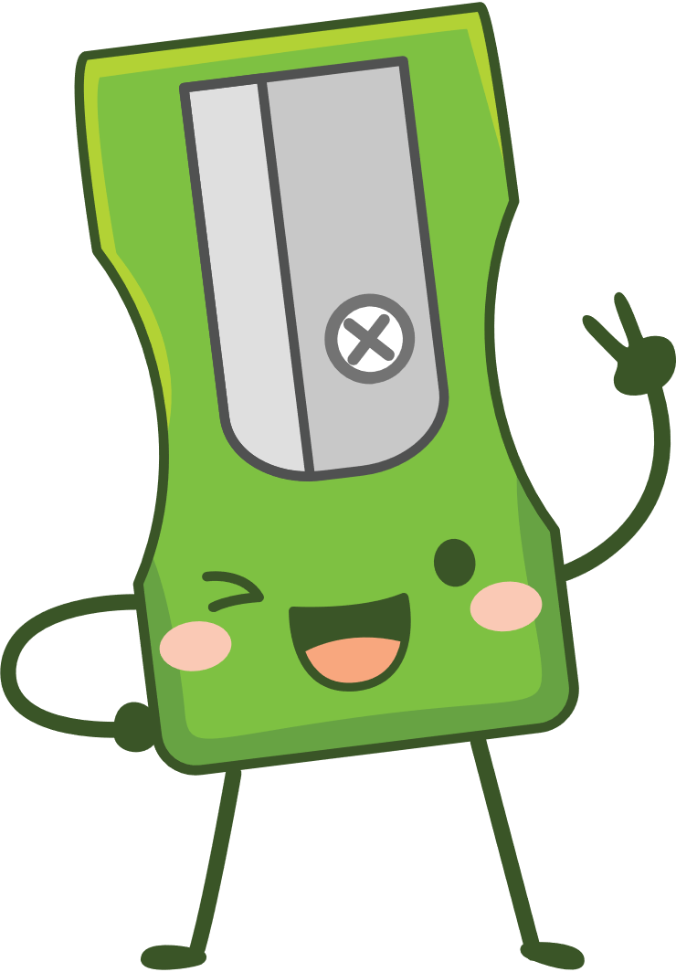
CONTENT SUMMARY
Lesson 1: Sexual behaviour and sexual health
Last year in Life Orientation we looked at understanding what sexuality is compared to sex. This year we are going to look at how to look after your sexual health. You are a young adult now and some of you might find that you are experiencing feelings of attraction toward someone else. Remember that all choices have consequences. They could have a positive impact when making a healthy choice or a negative impact by making an unhealthy choice. e.g. choosing to hang out drinking alcohol with friends lowers inhibitions and you could do something physically with someone you would normally not do when sober. Then you’ll have to deal with the embarrassment and possible pregnancy from that choice. You need to develop standards for yourself by which you will live your life that protects your physical, emotional and sexual health. These standards are influenced by you physical health, self-image, quality of the relationships you have with others and your values.
Risk factors are those things that impact you to making poor choices about your sexual behaviour. These choices could place you at risk and lead to unhealthy sexual behaviour.
Here are some common beliefs of teenagers:
- Believing that nothing bad will happen to you even if you take risks. E.g. Having sex without contraception and believing that pregnancy wont happen to them.
- Believing you need to do something to be accepted by your peers. E.g. Eg boys that believe to be accepted and “cool” amongst their peers they must have sex with a girl.
- Believing you have no control or say over what happens to you E.g feeling so insecure in yourself that you can’t say no to unhealthy sexual attention.
- Living in poverty often feels like you have no choice. And choices are made to survive.
- The use of drugs/and alcohol inhibits your ability to make wise decisions.
Unhealthy sexual behaviour will results in a serious outcome that you DONT want. These could include:
- TEEN PREGNANCY : As you can see teen pregnancy is a huge problem in South Africa. Young people are sexually active and not using contraceptives. Some women feel that using the pill will make them fat or that it will stop them from falling pregnant as an adult. This is a myth. Some men think that women need to be responsible and prevent pregnancy. This is dangerous thinking, as STI’s can still be transmitted.
- SEXUALLY TRANSMITTED INFECTIONS (STIs) : Many of the STI’s have similar symptoms. STI symptoms include the following:

- An unusual discharge from the vagina, penis or anus pain when urinating
- lumps or skin growths around the genitals or bottom (anus)
- a rash
- unusual vaginal bleeding
- itchy genitals or anus
- blisters and sores around your genitals or anus
- warts around your genitals or anus
- warts in your mouth or throat, but this is very rare
- HIV and AIDS : HIV and AIDS is still very much a problem amongst teenagers. In the same way that an STI is transmitted, HIV infections are a result of unprotected sex. If you become infected, your immune system becomes weak and you cannot be protected by other infections or diseases.
- LOW SELF-IMAGE : It could make you feel bad about yourself and lower your self image. You could feel disappointed, ashamed, scared and blame yourself for making poor decisions. Having a low-self esteem could impact your decision making and be dangerous and damaging to yourself e.g. cutting or struggling with sever depression.
- EMOTIONAL SCARS: An emotional scar is a mental or emotional pain that you carry for a long time. For many it’s the rest of their lives without seeking help from counsellors to deal with the pain. Some teenagers struggle with this pain and find it difficult to go back to normal life. They pull away from friends and partners, often becoming depressed.
Maybe you’ve had an experience in your life that has caused you an emotional scar. Please reach out, either contact a counsellor or ask for advice from a trusted adult on what to do. You are still young, deal with your scars while you are young so you can move forward in life.
Lesson 2: Factors that influence personal behaviour
Our personal behaviour is greatly influenced by the people we spend time with. This influence could be negative or positive.
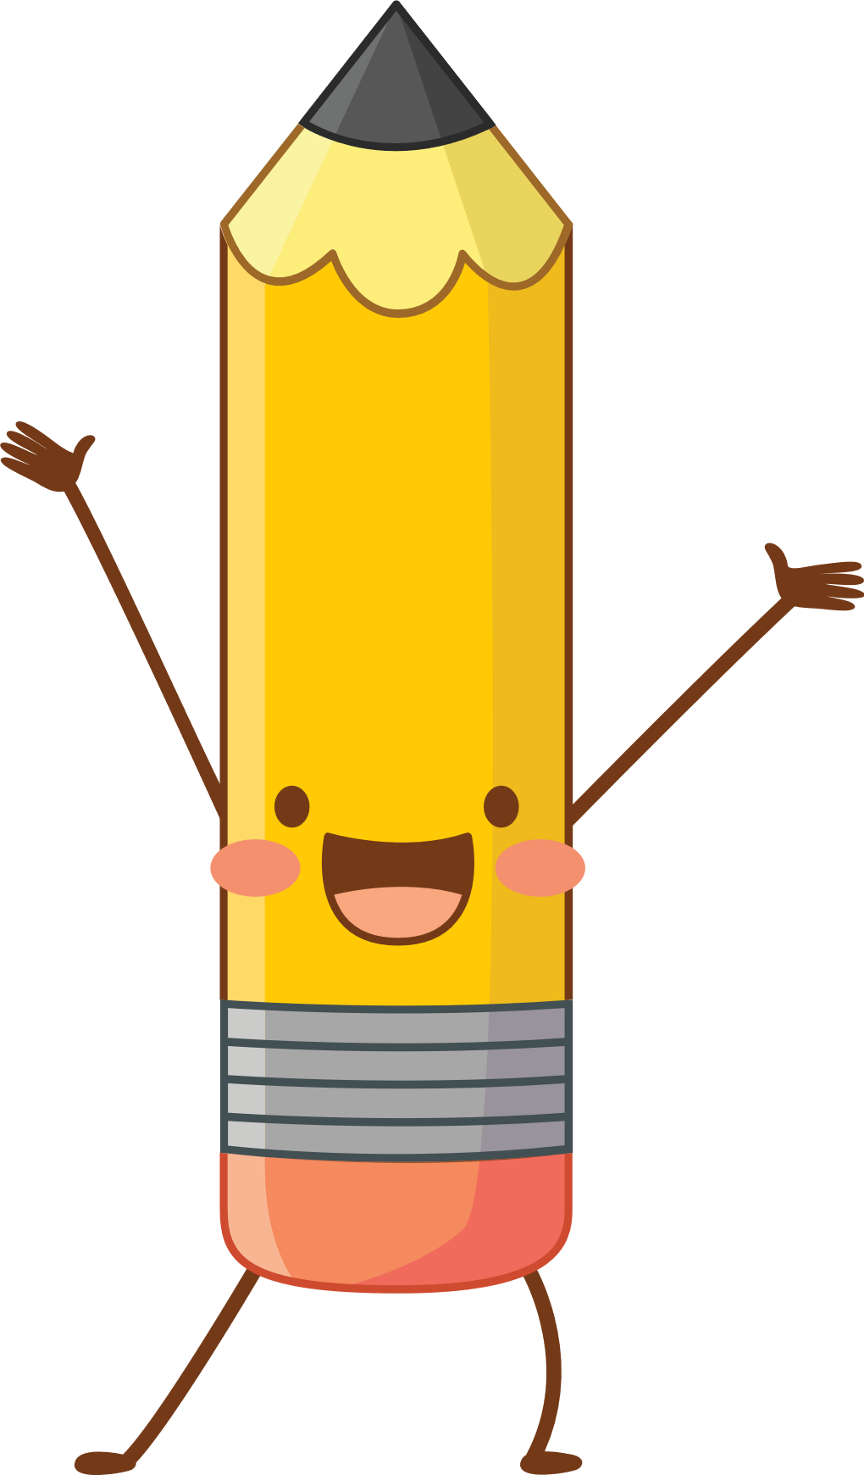
Family and Community Norms- (A norm is a standard that is acceptable to a group of people) The people in our lives impact our personal behaviour. Lets start by looking at the influence of the family and community:
When your parents enforce certain rules on you in your early teens for the sake of health e.g. No smoking- its unhealthy and results in lung cancer. In many instances you would then avoid smoking all together. This is an example of a positive influence.
However, a family could also have a negative influence e.g. A father who is an abusive alcoholic spends money on alcohol rather than buying food for the family. This results in a home with an absent father who portrays a negative image of what a father should be like.
Living in a community where learners have absent parents and many are on the streets rather than in school, we find an increase in crime and gang violence. The role that community members play affects the role you play in a community. In these communities we see increased teen prostitution, drugs and alcohol and more people are at a risk of contracted STI’s and HIV and AIDS. These are examples of a negative influence.
BUT a community could also have a positive influence. In some communities, the neighbours rally around to support and challenge learners to go to school and get an education because hey believe that education changes the future. In this community it is the norm to treat elders with respect regardless of whether they are family or not.
You need to consider these influences around you and as you grow up, make choices that line up with your own vision for your future.
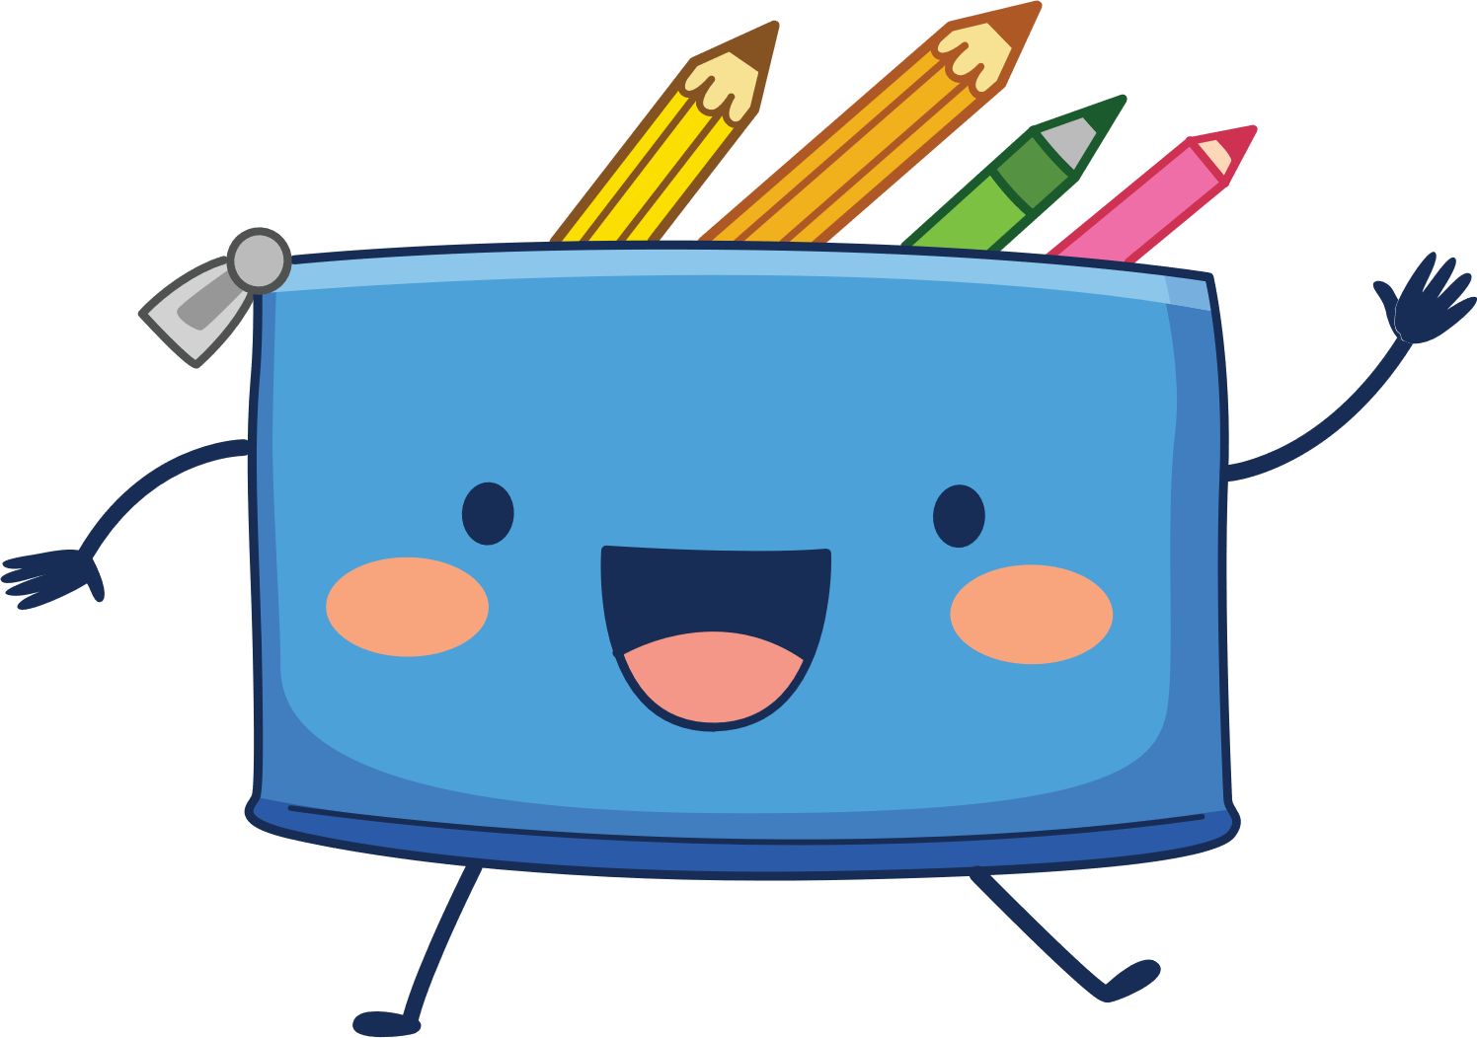
FRIENDS AND PEERS- One of the greatest influences during your teen years are your peers and friends. Teenagers are very protective of these friendships and value their relationships more than those with adults. Friends and peers can impact you positively to be focused and complete school work or to abstain from sex until you are married. But on the other end, they could have a tremendous impact if the influence is negative with drugs, drinking and reckless sexual behaviour.

Lesson 3: Developing Healthy Sexual Behaviour
Todays lesson we will focus on the different strategies you can use to change negative sexual health habits. To address a negative habit we need to replace it with a positive one.
Abstinence means to refrain from sex completely. This is the safest option. There is no chance of contracting an STI or getting pregnant if you are not having sex. When making a decision to be abstinent you need to communicate that this value is important to you when coming into a relationship. A person that really cares about you and respects you will NOT push your boundaries and try to change your mind. You could also look for online groups that support your ideas. This approach gives you the opportunity to focus on developing healthier relationships without the potential baggage of emotional scars.
Another approach to addressing negative sexual behaviour is to change your behaviour. This means making choices to stay safe. If you choose not to abstain, then always using a condom when having sex is vital. Be faithful to one partner. Females should use female contraception. Remember it is not going to be easy to implement these changes and you might find some friends will try to change your mind. Look for people in your community or join a group where you can be supported in these new choices you have made.
It is also good to find other forms of enjoyment like playing sport with a team or joining a cultural society like a choir. These changes will strengthen you and help with developing healthy relationships that are not of a sexual nature.
Friends can also have a positive influence and help you make these changes. This would be a good time to evaluate your friendships and see if their influence is toxic or helpful.
There are times that we know we need help. Protective factors refer to those aspects of yourself, your family or community that need help to cope with life’s challenges.
They include the following:
- Be assertive and believe you could have a good future. Use your negotiation skills and feel confident saying
NO! Stick to your decisions and beliefs.
- Discuss sexual behaviour in your family and talk about important / sensitive topics.
- Friends play a part in providing support of your decisions and helping you avoid sexual behaviour.
- Resists peer pressure by using the skills you have learnt at school to make wise choices and standing up for yourself.
- Choose healthy role models by looking for people in your school or community that could help you become the kind of adult you would be proud to be.
- If you don’t find the help you need in your local community like a clinic, you can call the national helpline numbers or make contact on their websites. There is assistance available for teen pregnancy, counselling for HIV and Aids as well as for Gender Based Violence and abuse.

Change comes when we reach out and partner with those who believe in us and want the best future for us.
You don’t have to do it alone!

Lesson 4: Teen pregnancy
We have already looked at some of the consequences of unhealthy sexual behaviour. Today we are going to look at teen pregnancy in South Africa and in schools in a little bit more detail. As a learner, your approach to this lesson should be NOT to say…”Oh that will never happen to me so I don’t need to know about teen pregnancy.” RATHER your attitude should be to listen…. to contribute….. and to learn, so that you can help by advising in the future – should one of your friends or peers fall pregnant. Be a part of the solution and not the problem!

The adverse consequences and implications of teenage pregnancy.
Becoming a parent as a teenager is extremely challenging. Having a child as a teenager not only affects you as the young parent but also your own family and that of the father / mother of the child. For a young girl, there are physical dangers when going through labour at a young age. The pregnancy could damage her bone structure, she could tear giving birth causing a lot of pain and she would need an operation.
Both the young mother and father would be affected emotionally with this new burden. They may suffer depression as they lose friends and respect from community members. They may feel depressed and sometimes the young father turns to alcohol or drugs to escape his reality.
This young couple would be confronted with choices on abortion (the termination of the child) or adoption (placing the child in another home). The outcome of these choices would have a lifelong impact on each of them in different ways.
Many young mothers drop out of school to have the baby and struggle to return to school because of the burden of responsibility of being a young mom.
Should a young mother choose to keep her child there are physical challenges the young baby will face. Often the baby is underweight when born due to a mother who did not eat nutritionally, trying to hide the fact she was pregnant for so long. The baby could experience health problems and may even be sick. Additionally as the child grows, they often experience further malnutrition and sometimes abuse as the young couple/mother struggles to handle the pressures of parenting. Sadly, for many children of these young teens, they will grow up in poverty and possibly repeat the cycle of falling pregnant in their teen years. This keeps these families in a constant cycle of poverty and lack of education.

