
Lesson 4:


Activity 1: Give a short definition for the following terminology:
A | Corruption | is the misuse of public power and money for private gain.
B | Cronyism | refers to the favouritism shown to friends regardless of their qualifications
C | Nepotism | the practice among those with power or influence of favouring relatives or friends, especially by giving them jobs.
D | Influence peddling | the illegal practice of using your influence in government or connections with persons in authority to receive information or benefits.
E | Fraud | refers to when someone steals money from others through a scam, cheating or deceiving them.
F | Bribery | is to pay for an illegal favour.
G | Extortion | is to obtain money or favours through threats.
H | Embezzlement | theft or misappropriation of funds placed in one's trust or belonging to one's employer.

Activity 2: Write the definition while working through the PowerPoint.

Individual: With the increase of corruption in society the cost of living increases as the cost of public services increase and the poor feel these increases the most.

Country: When a country is corrupt everyone is impacted, taxes increase, and service deliveries fall apart. Money that was set apart for infrastructure improvement is used for something else where individuals benefit rather than the country.

Companies: The company or government gets a bad name. The company might have to spend a lot of money just to put measures in place to stop corruption.

Communities: Many believe the only way to access services is through bribery or even threats. If bribery becomes common, others begin to believe this is a way of life and corruption is normal when you want to get something.

Activity 3: Study the images on the ppt and then answer the following questions:
South Africans experience of corruption in the public sector.

Slide 4:  1.2.1 | Identify the FIVE public sectors in which corruption was investigated:  Police  Public Schools  ID Services (Home Affairs)  Utilities (Municipalities/ Telkom)  Public clinics and hospitals
1.2.2 | Which public sector used bribery the most? Give TWO possible reasons why.  Policing  The public are more likely to give into bribery with the police as they fear being punished with fines.  Corrupt officials have found it easy to get money out of the public and continue to do so because they have never been caught or stopped.
1.2.3 | Give ONE example of a form of bribery in a school environment.  - A student paying a teacher with a treat like a chocolate or packet of chips to accept a written task that is handed in late. The learner is asking the teacher to ignore any late penalties in exchange for the bribe.  - Peers doing homework for their friends in exchange for money.  - Bribery between peers/friends?
1.2.4 | Discuss TWO strategies that government could implement to curb bribery in the public sector.  1) Government could educate the public by running campaigns on how they can recognize corruption and where to report it. Government can also protect people who come forward and report corruption.  2) Government could increase the penalties of using bribery. People could be fined extensively or go to jail for initiating or accepting a bribe.  3) Government could also positively affirm groups where there has been a decrease in corruption over time. Celebrate the victories publicly!  4) Awareness /petitions/ workshops to educate  (Any valid TWO strategies)
Slide 5:  1.2.6 | 120000 took part in this survey. Do you think this survey is an accurate reflection of the South African people? Give ONE reason to motivate your answer.  There are millions of people in South Africa from many different economic backgrounds. This survey is not accurate because it doesn’t not represent all South African people.
1.2.7 | Based on the barometer statistics below, which sector saw the least increase in corruption?  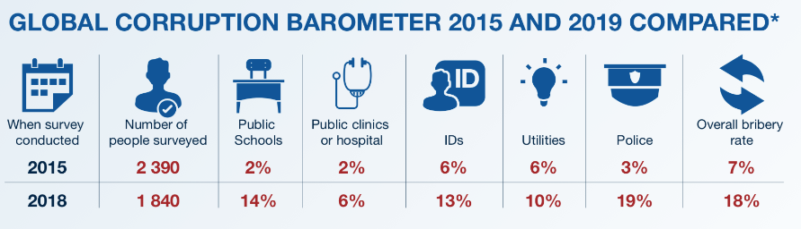  Public Schooling
Slide 6:  1.2.8 | There has been a noted decrease in ID document and Drivers licenses corruption since 2011. Discuss TWO strategies government implemented that lead to this decrease in corruption in these sectors?  1) Government implemented the ID card replacing the ID book where individuals had their licenses in. This has increased the national data base of residents and improved the system of managing large numbers.  2) This ID card is very difficult to forge. Greater penalties have been included for card fraud.  3) More companies and organisations require ID confirmation for everyday occurrences like parking and the card has become more convenient for the public.  (Any valid TWO strategies)

Activity 4: Take a moment to reflect on what you have learnt about yourself today.
- Why do you think teenagers avoid reporting corruption when they see it amongst their peers - like selling drugs?

- How could you become a leader /activist who says NO to corruption amongst his / her peers and people in the local community?

Learners will have different responses to the reflection and therefore there is no memo for this section.

