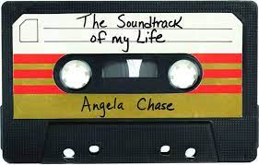
Activity 2:
Sound Track of My Life
Imagine that you are making a movie about your life and must oversee creating of the soundtrack and YouTube / CD cover art. You need to compile a soundtrack by picking 12 songs that would be on your playlist.
Name:
You then need to design the cover art to your soundtrack.
Use the template below to complete this task.

- Soundtrack
Choose the 12 songs that best represent YOU. Write each song and the artist in the spaces below:
1
2
3
4
5
6
7
8
9
10
11
12

- Briefly explain why you chose those songs, what makes them part of YOUR soundtrack:

- Design the cover art for your YouTube / CD in the space below, use colour pens or pencils, kokis. Make it as UNIQUE as YOU are.

