Lesson 4 - Articles

- GIRLCODE

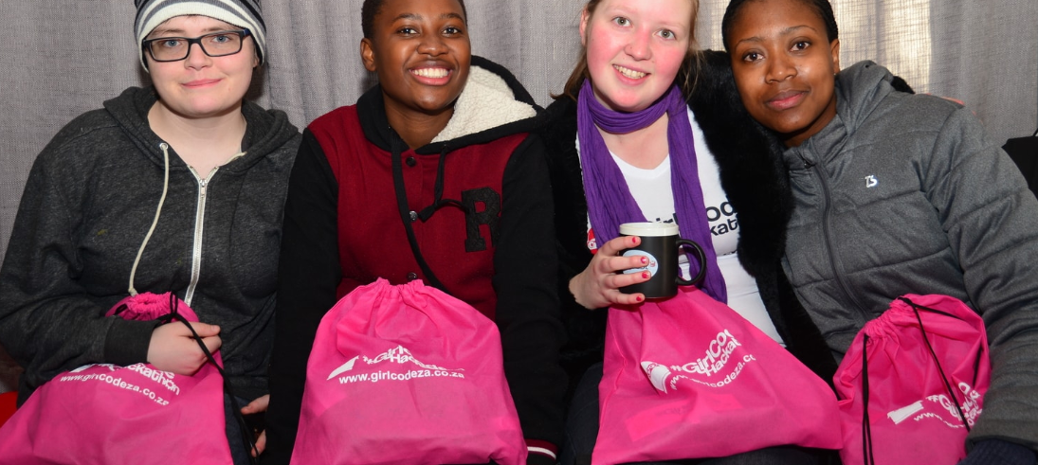
GirlCode is a social enterprise that empowers young girls and women in the field of technology and coding. They run various initiatives the first being GirlCoder, a programme which focuses on teaching coding and robotic skills to primary and high school girls.
They also offer workshops and vacation work where they teach coding skills to unemployed women and university/college female students. GirlCode has an annual hackathon that aims to spotlight female tech talent who are currently studying an IT related course.
Zandile Mkwanazi, chairwoman of GirlCode, “As challenging as this time has been for everyone, more so the youth of South Africa with unemployment expected to skyrocket. I encourage everyone to view this as an opportunity to reinvent themselves, re-skill themselves and take up the many opportunities available in the technological space.”

- DIGIFY AFRICA

Digify Africa is a digital skills training initiative that aims to create meaningful opportunities for young, disadvantaged individuals in South Africa and Africa as a whole.
In South Africa they have partnered with Facebook to give young people from disadvantaged backgrounds the opportunity to partake in a ten-week digital skills boot camp called DigifyPro, where they prepare the youth for a career in digital marketing.
They recently announced that DigifyPro is back and will be conducted online.

- THE STREET STORE
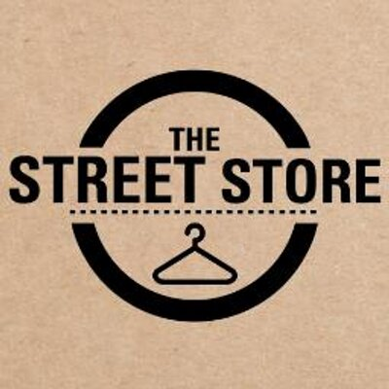
The Street Store was established in Cape Town in January 2014 to specifically help the homeless and has since spread from Canada to Brazil with over 580 stores functioning worldwide today. The Street Store is a pop-up store for the homeless that can be created in any community around the world where the homeless shop for free,” explains the organisation. “The pop-up [store] is made of posters on the sidewalk and runs entirely on donations. It’s pretty simple: you bring clothes and shoes you don’t wear and the homeless help themselves.”
One of the most important aspects of The Street Store is that it dignifies the receiving process for the homeless. The organisation explains that “instead of feeling like they’re having old clothing thrown at them, the homeless get to have a full shopping experience [where] they can browse through the clothes. We’ll help them find an outfit they like, it’s wrapped up, and off they go.”

- THE BLACK MAMBAS

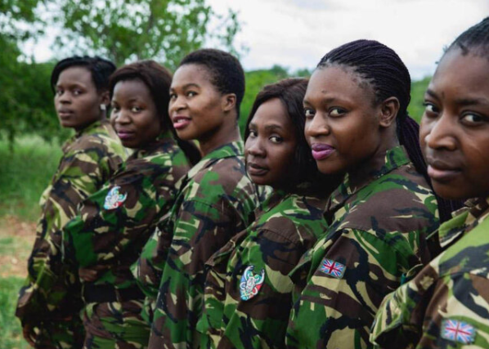
The Black Mamba Anti-Poaching Unit is an all-female ranger unit focused on protecting South African wildlife. Each day, they perform crucial duties that prevent poaching and poachers coming into the reserve. One of these is an intensive snare sweeping, where they search for the snares that poachers set up in the bush for animals to get trapped and eventually die. One of their biggest challenges is that they are driving very old Land Rovers that are largely unreliable given the roads the Mambas have to drive every day. They are currently engaged in a fundraising drive for repairs to the vehicles or even a new vehicle that would help them in their valuable anti-poaching work.

5. UNITED RELIGIOUS INITIATIVE

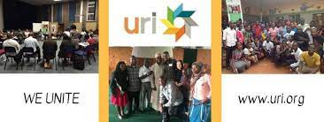
URI is a global grassroots interfaith network that cultivates peace and justice by engaging people to bridge religious and cultural differences and work together for the good of their communities and the world. We implement our mission through grassroots groups, called Cooperation Circles, which bring diverse people together to jointly engage in community actions such as conflict resolution and reconciliation, environmental sustainability, education, women’s and youth programs, and advocacy for human rights. Our purpose is to celebrate and share the richness of the religious and spiritual diversity in Cape Town, and to promote community interfaith understanding, harmony and cooperation, through both an awareness of universal spirituality and an honoring of the dignity of difference.

