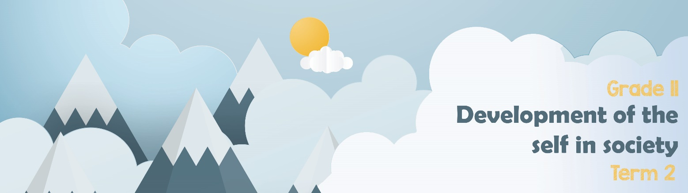

Lesson 3 - Worksheet
Activity 1: Complete the following from Lesson 3 - PowerPoint.
The psychological effects of GBV include:
- _____________
__________________________
- _____________
_____________
_____________
- PTSD- post traumatic stress disorder
- _____________
__________________________
- Increased anxiety

The emotional effects of GBV include:
- Fear of the other person
- __________
- Fear for your personal safety
- _____________
_____________
- Feelings of guilt because you think you may be responsible for the abuse.
- ___________
___________
- ___________
___________

_______
The physical effects of GBV include:
- ________
- Broken bones and teeth
- Rope or strap marks
- ____________
- Bald spots where your hair has been pulled out
- Burn marks from cigarettes, irons or hot water
- ______________________
- Death

Negative effects on individual health and well-being
Negative effects on the family
The effect and how it contributes to broken family structures:
- ________________________________________________________
________________________________________________________
- ________________________________________________________
- ________________________________________________________
________________________________________________________
- _________________________________________________________
- _________________________________________________________

Activity 2: Informal Assessment
You have had an opportunity to see the effect gender-based violence has had on individuals and families. In the space provided, brainstorm and explore how GBV contributes to the following sectors of society as a whole.
Refer to the following in your brainstorm:
- Inability to build trusting relationships

- Increase in social ills

- Increased burden on healthcare system

- Increased burden on judicial system.
SOCIAL
I LLS
BROKEN RELATIONSHIPS
JUDICIAL
SYSTEM
HEALTHCARE
IMPACT ON SOCIETY
Activity 3: HOMEWORK REFLECTION
Take a moment to reflect on your response to the trial between Amber Heard and Johnny Depp in class. Write a short essay in which you summarise what you have learnt. Include comments on the following:
- How GBV contributes to many broken family structures
- Financial impact on Heard and Depp.
- Psychological impact of GBV.
- Burdon on the judicial system.

