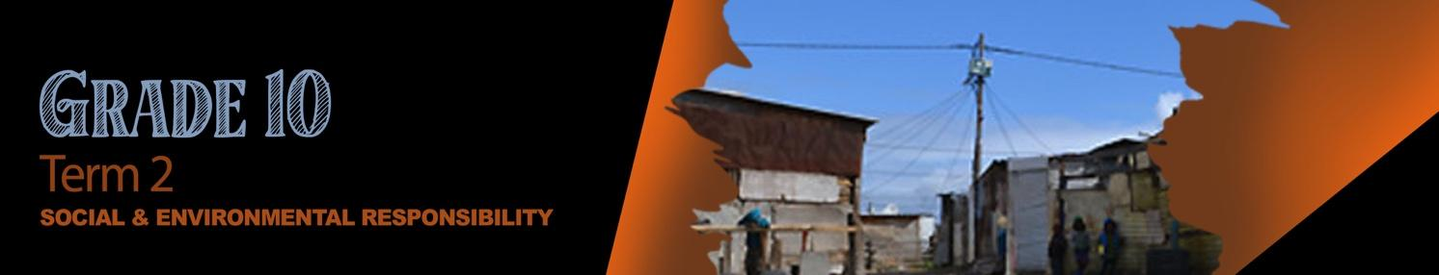


Lesson 2 - Worksheet MEMO

Activity 1: Flash Activity
In the last lesson we researched different instances of social injustice and the impact they had
on local communities. Can you remember some of the examples we looked at? List as many
examples from the last lesson that you can remember as quickly as you can.

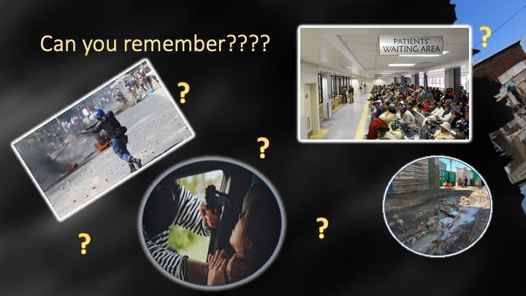
- violence

- crime

- poverty

- lack of basic services like water

5) lack of access like healthcare

6) safety and security

Activity 2:
In the last lesson we looked at these two case studies. I’m sure you could look at these same two case studies again and identify some of the harmful effects of crime (a social injustice) and pollution (an environmental injustice) on individuals and the community.
Choose ONE of these case studies when answering the question below:
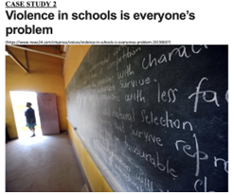 OR 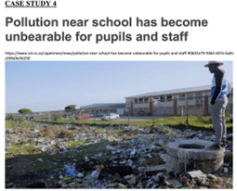
First list THREE harmful effects on the individuals and the community.

Because of your desire to see a positive change in this community, you have chosen to write a letter to the municipality of ONE of these case studies. You feel it’s very important that they know the impact this issue is having on the learners in the school. In your letter, describe TWO examples of how this issue is harmful to the individuals that attend the school as well as the school itself. Propose THREE suggestions in your letter of how the municipality could address this issue and prevent it from happening again in the future.
Lastly include a personal commitment on how you intend to “take action” and make a difference in your own community.

This question is open to the learner’s opinion and suggestions should be realistic and relevant.

Activity 3: Loadshedding challenge
Circle THREE that you are going to try out this week.

- Watch the stars with my mom/dad/ brother/ sister and tell them about my day.
- Drink a glass of water/juice together with a friend and share your favourite memories of your primary school years.
- Play a game of dominoes / thirty seconds or another game you loved with your family.
- Book an appointment to give your mom or dad a back massage or foot massage.
- Pick up that instrument you’ve always wanted to play and work through a tutorial book that will teach you to play.
- Write a poem for someone special in your life that will let them know how special they are to you.
- Find a quiet area, listen to music and make an artwork just for the fun of it.

Learners will give personal responses to this activity.

