


Lesson 2 - Worksheet

Activity 1:

Read the below article and then answer the questions that follow.

Action needed before overfishing depletes our waters
https://www.foodformzansi.co.za/action-needed-before-overfishing-depletes-our-waters/
by Coty Perry, 8th July 2022
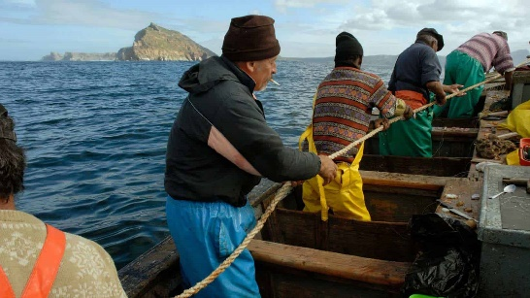
As with many other aspects of government policy, overfishing and other fishing-related environmental issues are a real problem, but it’s not clear that government intervention is the solution. As the ocean goes, so goes the planet, so it is of paramount importance for everyone to educate themselves on what is driving overfishing, what its consequences are, and what meaningful steps can be taken.

Indeed, over three billion people around the world rely on fish as their primary source of protein. There are 18.9 million fishermen in the world, with 90% of them falling under the same small-scale fisherman rubric discussed above.

Overfishing is, in some sense, a rational reaction to increasing market needs for fish. Most people consume approximately twice as much fish as they did 50 years ago and there are four times as many people on earth as there were at the close of the 1960s. This is one driver of the 30% of commercially fished waters being classified as “overfished.” This means that the stock of available fishing waters is being depleted faster than it can be replaced. Overfishing occurs when the breeding stock of an area becomes so depleted that the fish in the area cannot replenish themselves.

It’s not simply bad because it depletes the fish stocks of available resources, though that certainly is one reason why it’s bad.
The effects are felt by the marine ecosystem but also by the people whose livelihoods depend on fishing. Surely overfishing can’t be that bad, right? The seas are just filled with tons of fish and it would take us forever to overfish to the point that they began to disappear entirely, right? Think again. Overfishing is happening at biologically unsustainable levels.

When major protein sources are depleted forever, there will be intensified competition for the resources that remain. Even if you’re not concerned with overfishing and the problems it creates, it will soon be on your doorstep unless corrective measures are taken before it’s too late.

1.1 Define the term ‘environmental issue’ and mention TWO ways how the environmental issue of
overfishing could negatively impact people living in the surrounding areas. (1+2) (3)
(Lower Order)

1.2 Provide THREE ways how South African citizens could make a positive impact on preventing
overfishing. (3x1) (3)
(Lower Order)

1.3 Describe TWO irresponsible actions that could lead to depletion of our fishing resources. (2x2) (4)
(Middle Order)

1.4 Explain TWO ways how overfishing will harm the environment of the South African coastal towns.
(2x2) (4)
(Middle Order)

1.5 Suggest THREE ways how the government could ensure that the population is aware of the
dangers of “overfishing”. (3x2) (6)
(Higher Order)

[20]

Activity 2:
Based on the responses from the class, complete this activity by writing down THREE reasons from the group feedback that stood out for you.

THREE ways that the impact of the depletion of these resources would have on local communities.

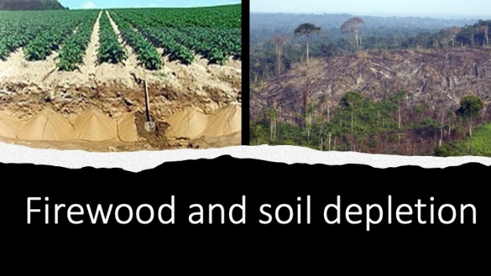

Activity 3:

For homework you need to create an infographic poster highlighting the FOUR main parts to your family action plan. Think of disasters that could occur in your home or community based on your location. Think of things like a fire outbreak or an earthquake or flooding. Your emergency action plan needs to include a focus on:
- Possible hazard in your area?
- Attitude? How to remain positive and calm?
- What to do when this emergency occurs? How to escape?
- Where to meet as a family in the case of an emergency?
- A list of what you should include in your home emergency kit.
- Who to contact in an emergency?

Paste your poster in your notebook. You will need it for the next lesson.

Activity 4: Reflection Questions
- Reflect on any content covered in the lesson today that you are still not sure of and will have to follow up on for homework.

- What advice would you give to your younger brother/ sister to preserve the environment for future generations?

