Lesson 2 - Worksheet

Activity 1 - Exam Practice:

Read the extract below and answer the questions that follow.
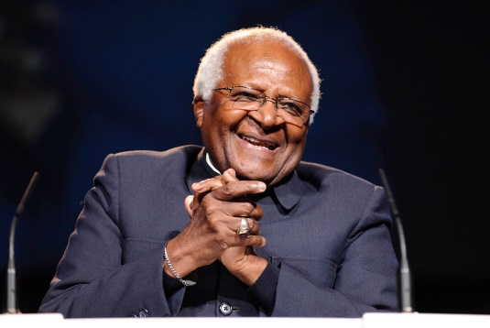
Archbishop Desmond Tutu died on 26 December 2021. He was a Nobel Peace Prize Winner, an international award given to those deemed to have done the most to encourage international peace and cooperation.

He is known for his work alongside the likes of Nelson Mandela and Albert Luthuli to bring apartheid to an end. Since then, he has worked on numerous human rights campaigns. He is seen as the moral compass of South Africa and someone who upheld our country's constitutional values.
Source: Anonymous

Write paragraphs on role models.

Use the following as a guideline.

- Define the term ‘role model’ and give an example of a role model in your community. (1 + 1) (2)
(Lower Order)

- Explain the difference between a positive and negative role model with an example of the
behaviour of each one. (2 + 2) (4)
(Lower Order)

- State ONE constitutional value. (1 x 1) (1)
(Lower Order)

- Discuss TWO ways in which a positive role model can uphold the constitutional values
of South Africa. (2 x 2) (4)
(Middle Order)

- Recommend TWO ways in which young people can become positive role models within their communities. (2 x 2) (4)
(Higher Order)

[15]

Activity 2 – Final Reflection:

What I have learnt in these lessons:

I can explain the difference between POSITIVE and NEGATIVE ROLE MODELS. | 
I understand the concept of THE CONSTITUTION.

I understand the concept of CONSTITUTIONAL VALUES.

Where I performed well and what I can do better:

My reasons to be a GOOD ROLE MODEL:

Questions I have:

