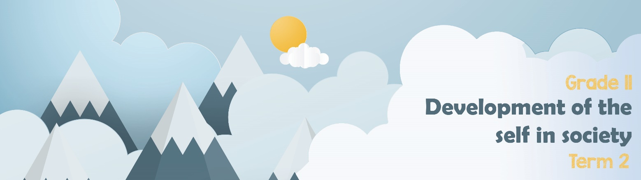

Lesson 2 - Worksheet
Activity 1: Provide an example for each of the following forms of the abuse of
power. You may use examples from the articles you have read.
- Physical:

- Family:

- Cultural:
- Sexual Harassment:

- Rape:

Activity 2: Study the images below. They refer to an issue around certain sexist
views in society in the 1950’s that were recently recreated by a high school
teacher in America to teach his students about sexism and gender
stereotyping. Answer these questions in your notebook.
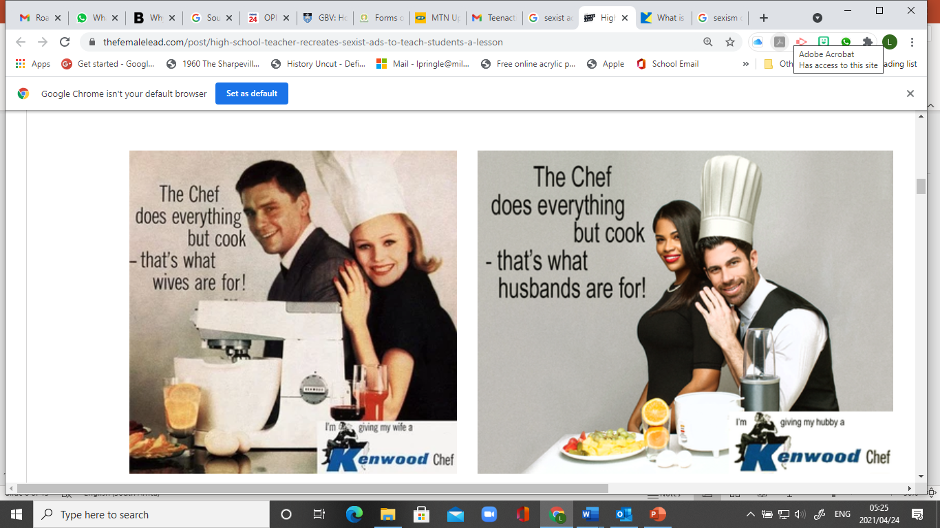
1) Identify the gender-role being challenged in this image.

2) Do you think the issue of sexism is still relevant today. Give TWO other examples of sexism in the home.
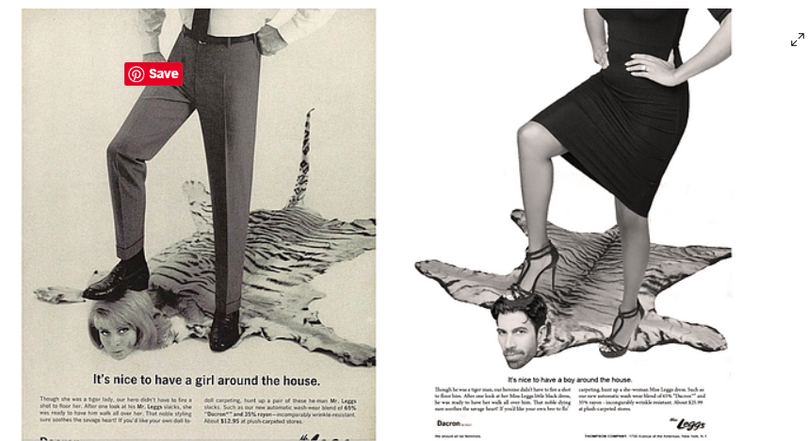
3) What do the images of a foot on the head communicate about power struggles in society?

4) How can these struggles lead to domestic gender violence?

DEFINITIONS:
LGBTQI+
SEXUAL ORIENTATION

“Why do people get uncomfortable talking about sexual orientation and race?”

“Why are more people from the LGBTQI+ community prejudiced against?

Activity 3:
Take a moment to reflect on what you have learnt about yourself today.
- What have you learnt about yourself and your opinions on gender equality?

- We have seen an increase in bullying around sexual orientation. What advice would you give a friend who has been bullied at school?

Activity 4: HOMEWORK
Complete this basic quiz about some of the concepts you have learnt during this lesson. Take note of what you might need to refer to in the lesson should you struggle.
- 1 | Explain the difference between incest and rape. | (2)
__________________________________________________________________________
2. | The following is an example of gender inequality:  - Men choosing to be nurses  - Male soccer players paid more than female soccer players.  - Woman working as a firefighter  - Woman becoming a wife and having to cook and clean all the time. | (1)
3. Explain the term “power struggles” in the context of gender abuse in your own words. (1)
__________________________________________________________________________

