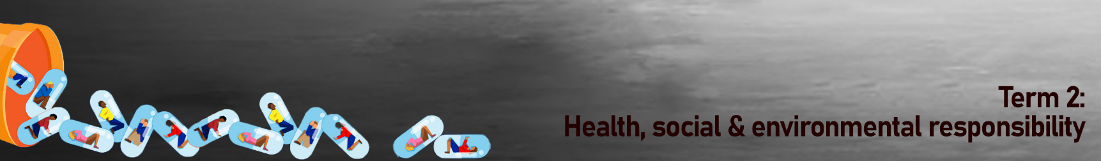
Case Study 2:  This song tells the story of a man making some bad decisions. Johnson commented on his website that he "believes this can happen when people are hurting and can go from bad to worse if they don't receive the help they need."  High Cost of Living  Song by Jamey Johnson | 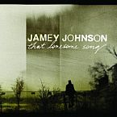
I was just a normal guy  Life was just a 9 to 5  With bills and pressure piled-up to the sky  She never asked, she knew I'd be  Hangin' with my wilder friends  Lookin' for some other way to fly  Three days straight was no big feat  To get by on no food or sleep  And crazy was becoming my new normal  I'd pass out on the bedroom floor  Sleep right through the calm before the storm  My life was just an old routine  Every day the same damn thing  I couldn't even tell I was alive  I tell you  The high cost of livin'  Ain't nothing like the cost of livin' high  That southern Baptist parking lot  Was where I'd go to smoke my pot  And sit there in my pickup truck and pray  And starin' at that giant cross  Just reminded me that I was lost  And it just never seemed to point the way  Lookin' just to score another deal  With my back against that damn eight ball | I didn't have to think or talk or feel  My life was just an old routine  Every day the same damn thing  I couldn't even tell I was alive  I tell you  The high cost of livin'  Ain't nothing like the cost of livin' high  My whole life went through my head  Layin' in that motel bed  Watchin' as the cops kicked in the door  I had a job and a piece of land  My sweet wife was my best friend  But I traded that for cocaine and a whore  With my new found sobriety  I've got the time to sit and think  Of all the things I had and threw away  This prison is much colder  Than that one that I was locked-up in just yesterday  My life is just an old routine  Every day the same damn thing  Hell, I can't even tell if I'm alive  I tell you  The high cost of livin'  Ain't nothing like the cost of livin' high

