

Grade 9 World of Work: Term 2 Week 6 – 9

GRADE 9 and BEYOND


Lesson 1 - Worksheet MEMO

Options after Grade 9
Study the following cartoon and answer the questions that follow.

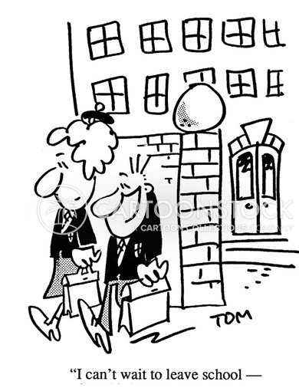
[Taken from https://www.cartoonstock.com/cartoon?searchID=CS281315
Accessed on 20 March 2021]

1.1 Assist the girl in her options and choices after grade 9:
Write out the following acronyms in full and define each of them.
1.1.1 TVET (2)
Technical Education and Vocational Training
Technical in nature and aimed to provide skills for a person related to a profession, for that person to get a job and provide a livelihood
1.1.2 NSC (2)
National Senior Certificate
Qualification received at the end of Grade 12 based on the chosen subjects – more academic in a sense than NCV
1.1.3 NCV (2)
National Certificate Vocational
Qualification based on practical skills to get Learners ready to enter the job market – more skills based and for Learners who prefer hands on learning

1.2 Explain the TWO routes you can follow to gain a tertiary qualification after completing Grade 9? (2x2) (4)
A NSC gives learners more of a general education with a stronger focus on academics – stay in school and complete Grade 10 through 12
A NCV is directed at vocational training. Students study skills in a specific field of work – at a college or institution that offers the relevant courses but structured in a different way.
Both have compulsory subjects and take the same time to complete.

[10]

