
CASE STUDY 1

Durban floods: South Africa floods kill more than 300
(https://www.bbc.com/news/world-africa-61092334)
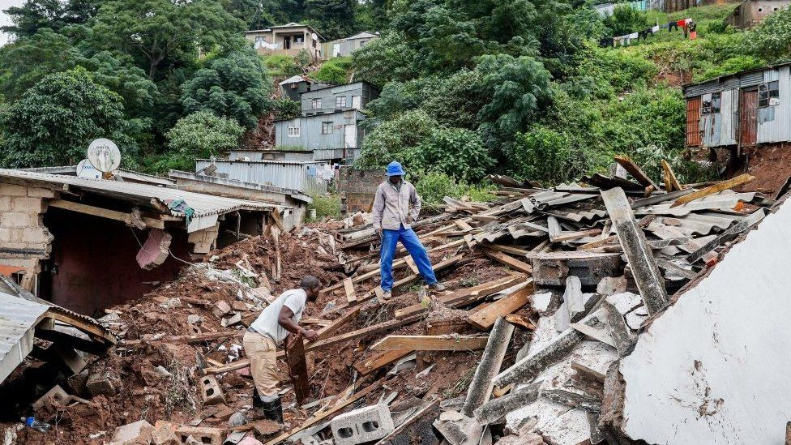
The death toll in the South African province of KwaZulu-Natal has reached more than 300, after devastating floods wreaked havoc in the area.
A state of disaster has been declared in the area, after some areas saw month’s worth of rain fall in one day.

Jomba Phiri, who lives in the region's main city, Durban, said his house had been swept away in the floods.
"I don't know where we're going to sleep now," he told Reuters news agency.
Media caption,
Volunteers in Durban are searching for trapped locals after the worst floods the coast has seen in decades. He also described the disaster as a "force of nature", which some have disagreed with. They blame poor drainage and badly built houses in low-lying areas for the high death toll.
Electricity and water treatment plants have been "flooded out", the Durban mayor told the BBC. Communications have also been disrupted with two major networks reporting that more than 900 of their cell phone towers are down.
CASE STUDY 2

Family loses everything in house fire allegedly sparked by load shedding
(https://www.news24.com/news24/southafrica/news/family-loses-everything-in-house-fire-allegedly-sparked-by-load-shedding-20220916 )

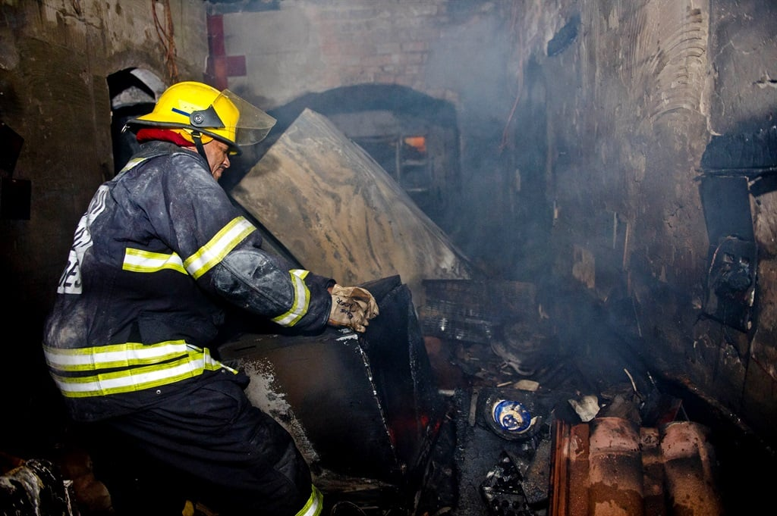
An Eastern Cape family of seven escaped with only the clothes on their backs after an explosion, allegedly caused by a power surge, set their house on fire following load shedding.
The Dlisani family from Dutywa Thaleni Village told News24 the fire broke out seconds after the power went on.

Dlisani said luckily, they were not injured but the fire destroyed everything in the house, including all electrical appliances and furniture.

CASE STUDY 3

Live in JHB, lose three years of life
(https://mg.co.za/article/2019-07-26-00-live-in-jhb-lose-three-years-of-life/)

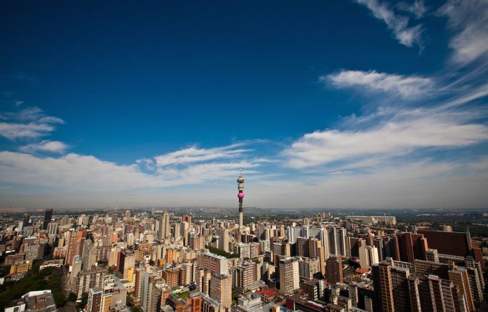
Some 13-million people live in Gauteng. Every single one of those people are breathing in air that is toxic, and is shortening their lives. For the four million people in Johannesburg, that air means people die three years earlier than they would if they were breathing Cape Town’s air.

For at least half of the time, the air in Johannesburg is unsafe. This is thanks to a mixture of dust blown into the city, exhaust fumes from the nearly five million cars in Gauteng, fires in homes, and pollution from small industries and power plants. All of this results in tiny particles in the air that people suck deep into their lungs. There they lodge and enter the blood vessels, breaking down tissue.
South Africa’s legal limits on particulate matter pollution also allow pollution levels to be at double the levels that the WHO says are safe for human health.

CASE STUDY 4
Faecal pollution severely contaminates SA’s rivers, dams – report
(https://mg.co.za/environment/2023-03-09-faecal-pollution-severely-contaminates-sas-rivers-dams-report/)
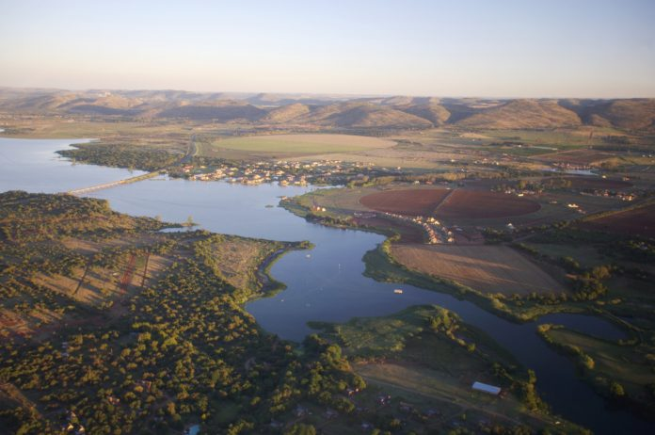

South Africa’s rivers and dams have a “severe” problem of microbial contamination from faecal pollutants; 53% of the sampled sites are a risk to people’s health risk.

If crops eaten raw are irrigated using this water, a new government report states.
The contamination of water resources by faecal pollutants poses significant risks to human and animal health because numerous pathogens are associated with faeces. “Surface water resources are usually not suitable for domestic activities such as drinking without any sort of treatment and this is evident in the data,” the report said.

CASE STUDY 5

Food security at stake as soil erosion sets in
(https://www.foodformzansi.co.za/food-security-at-stake-as-soil-erosion-sets-in/)
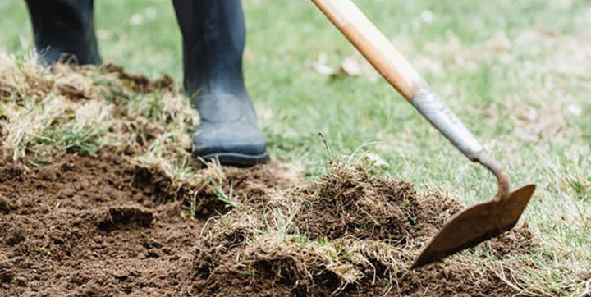
Healthy soil is a prerequisite to achieving sustainable food security. Not just that, but healthy soil creates the foundation of healthy food, which contributes to the local and global food security chain. But in Mzansi, we are losing more and more of that good soil due to soil erosion.
If the chain is disrupted because of soil erosion, understanding the causes and the effects as well as finding ways to mitigate soil erosion is important as a way forward. Agronomist Kagiso Murwa shares her expertise on soil erosion in Mzansi.
“For the erosion, when it comes to wind and rainfall, it erodes your top soils which are quite important for your crops because the most fertile layer of the soil is the topsoil. And it also causes water pollution among others, because whenever the soil is eroded to the place where the soil comes from might have been fertilised and all of those chemicals will land up in your water system,” says Murwa.

