

Grade 9 World of Work: Term 2 Week 6 – 9

GRADE 9 and BEYOND


Lesson 1 - Worksheet

Activity 1: Informal Assessment
Options after Grade 9
Study the following cartoon and answer the questions that follow.

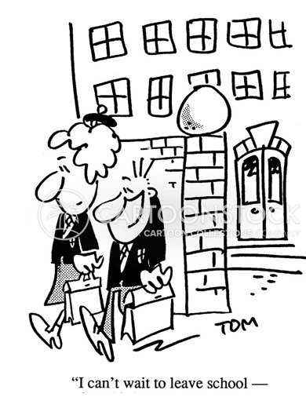
[Taken from https://www.cartoonstock.com/cartoon?searchID=CS281315
Accessed on 20 March 2021]

1.1 Assist the girl in her options and choices after grade 9:
Write out the following acronyms in full and define each of them.
1.1.1 TVET (2)
1.1.2 NSC (2)
1.1.3 NCV (2)

1.2 Explain the TWO routes you can follow to gain a tertiary qualification after completing grade 9? (2x2) (4)
[10]

