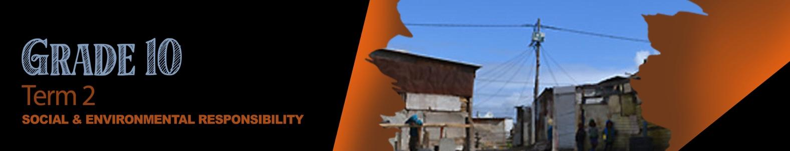


Lesson 1 - Worksheet MEMO

Activity 1:
In your own words explain these two terms:
ENVRONMENTAL JUSTICE
Everyone has a right to live in an area where they feel safe and they are not impacted by things like flooding, no access to running water or electricity etc. Risk to health and not sustainable.

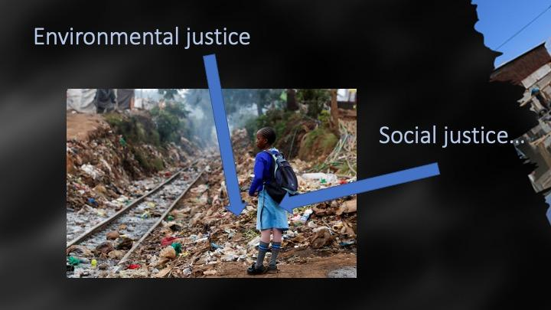
SOCIAL JUSTICE
This is the process of trying to redress the imbalance that happens amongst disadvantaged people who are impacted by poverty, discrimination (gender, race, religion, culture and abilities).
This also includes lack of access to basic services like hospitals and schools. Lack of educational opportunities.
Lack of food (healthy) causing malnutrition. Poor health because of health risks

Activity 2:
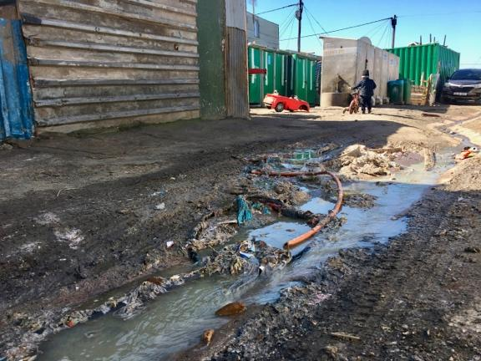
- Identify TWO examples from this image of how poverty
impacts the environment. (2x1) (2)
This could be that there is very little space and the
overpopulation causes erosion.
The overpopulation has caused flooding as sewerage spills
into the streets.
- Do people have a choice where they get to live? Motivate
your answer. (1x2) (2)
I believe people don’t really have a choice when they are
poor. They will live where they can afford to live.

- What human rights are being neglected in this community? (2x1) (2)
The right to privacy - living in such close proximity to one another there is very little privacy.
The right to basic services - no toilets and waste removal for so many people.
The right to safety - for many this area is not safe as homes cannot really lock.
- Discuss the possible negative impact of poverty on a grade 10 learner who lives in this community? (1x2) (2)
There would be no electricity to study or do homework in the evenings.
It could be far from school and dangerous for the learner to walk such a long distance.
There is also the danger of gangs and crime in the community when walking home from school.

Activity 3:
Read through the article that your group has been given and then answer the questions below. Choose a group leader to present your responses in a 1min feedback session to the class.

- Briefly describe the social injustice raised in your article.
- What was the impact on the community involved?
- Identify the rights that were violated?
- Describe the responsibility of the community / individuals to address this issue.
- Give TWO suggestions that government could implement to positively change the situation in this community.
Learners will give personal responses to this activity.

Activity 4: Reflection Questions
- Name ONE social injustice that you are aware of in your community.
- What positive influence could you have in addressing pollution at your school.
- What advice would you give the RCL to develop a culture of respect and not violence in your school?
Self-Reflective – Learners will give personal responses to this activity.

