Lesson 1 - Article
https://www.news24.com/news24/southafrica/news/violence-in-schools-models-violence-in-society-gbv-conference-hears-20191205

Violence in schools models violence in society - GBV conference hears
Canny Maphanga 05 Dec 2019
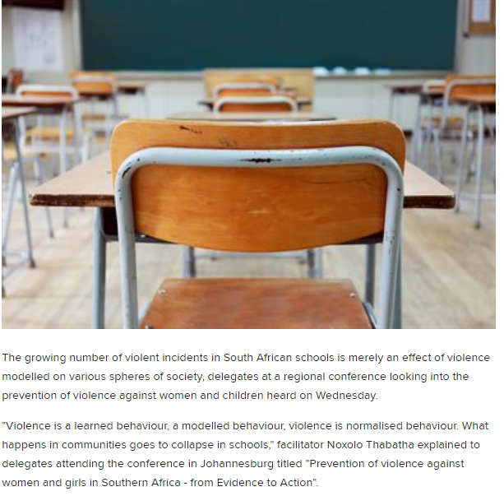

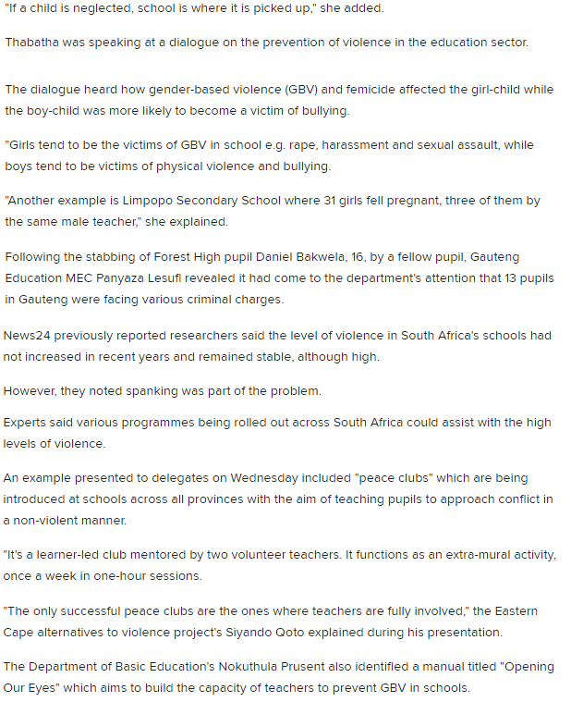
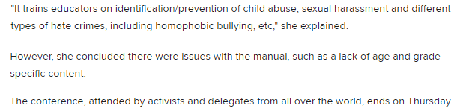

Lesson 4 – Article
https://mg.co.za/news/2020-08-27-real-action-on-gender-based-violence-a-pipe-dream-as-women-die-every-day/

Real action on gender-based violence a pipe dream as women die every day
Athandiwe Saba Sarah Smit M&G Data Desk
27 Aug 2020
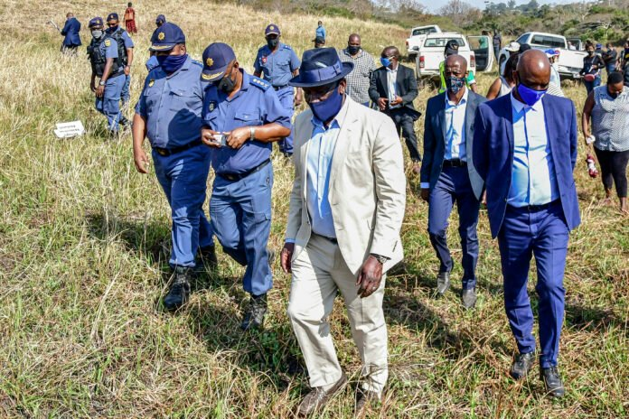Search for a serial killer: Minister of Police Bheki Cele (centre) visits the crime scene in Mthwalune on the KwaZulu-Natal South Coast earlier this month, where five women’s bodies have been discovered since March. (Photo: Gallo Images/Darren Stewart)
Backlogs, booze, testicular cancer — all factors blamed for the apparent ineptitude or unwillingness to tackle a pandemic that is silently killing women all over the country. Athandiwe Saba and Sarah Smit delve into the stories of women and children who have been murdered, raped and broken by men — and why the state is doing little more than talk

Nearly a year ago, Portia* had to leave her little girl with a neighbour so she could run to the communal toilet. When she returned, her five-year-old was no longer with the neighbour but sitting inside their one-room house crying, traumatised. Portia asked her child what happened. She wouldn’t speak. Portia’s little girl was naked from the waist down. Her pants were covered in semen.
“I asked her over and over again, what happened. Finally, she said that our neighbour umchamele [ejaculated on her]. I could see semen all over her clothes. She wouldn’t stop crying,” said Portia.
She does not want the perpetrator to be named, even though he has appeared in court for sexual assault, because this might prompt an attack on her and her daughter.
The alleged perpetrator was released on bail a few days after his arrest in October last year. According to Portia, the magistrate said that they could not keep the alleged sex offender behind bars unless the forensic laboratory had returned the DNA results.
In the year since, there has been no progress in the case.
This is not unique.
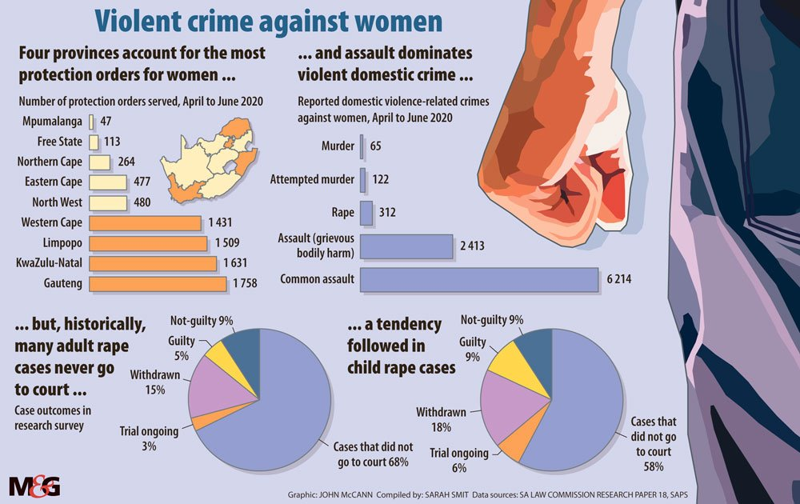
The police forensic science laboratory has a backlog of more than 35 000 specimens. This means that thousands of victims of gender-based violence, alive or dead, are waiting for justice.
The laboratory in the Western Cape has the highest backlog of the three main provinces, with 9 959 entries. The Eastern Cape has 1 433 entries, followed by KwaZulu-Natal with 1 222 entries. At national headquarters, the backlog sits at 22 430 specimen entries.
According to police spokesperson Colonel Brenda Muridili, the forensic laboratory receives an average of 1 463 gender-based-violence-related specimens for analysis every week. This equates to more than 200 cases a day.
Muridili confirmed that the forensic laboratory is experiencing delays in the procurement of consumables and the servicing and maintenance of laboratory instruments, “increasing the turnaround time for cases”. This has persisted since November last year.
Lirandzu Themba, the spokesperson for Police Minister Bheki Cele, said that the supply chain is waiting for contracts to be finalised. There has also been a management overhaul and a DNA management system has been established to monitor and address the backlogs.
Two months before the backlog started, last year, Aviwe Wellem from Dutywa was raped and murdered in her aunt’s house. The 21-year-old’s body was found sprawled over a bloody duvet cover on her bed.
Wellem’s aunt, Nokhanyiso Mbokoma, said she needs closure. “The police can’t tell us anything about the case because they can’t get the DNA results either. It’s a year now and I can’t understand why this is not a priority.”
Police spokesperson Captain Jackson Manatha told the Mail & Guardian this week that they have still not made any arrests and are waiting for DNA evidence. “The DNA results are still outstanding. The investigating officer will go himself to the Cape Town lab to find out what is the delay.”
In response to the evident failures at police-station level, with many cases stagnating, Themba said that Cele had told officers that they must improve service delivery at the station level. “It is on this minister’s watch that all stations are resourced to handle sexual violence cases through the availability of rape kits and the training of FCS [family violence, child protection and sexual offences] officers. So many strides are being made in terms of investigating cases of GBVF [gender-based violence and femicide].”
Themba said, since the start of the year, more than 300 life sentences have been handed down. “This is as a result of extensive detective work that puts together water-tight cases which investigations start at the station level.”
Yet for Portia and her little girl, the trauma continues. Standing in the yard where her daughter was sexually assaulted, she says she can’t afford to live anywhere else. A few doors down live the parents of the perpetrator, whom she says has fled to another province. The little girl has attended three counselling sessions. “We just attended our last session, and my daughter just broke down and wouldn’t stop crying. She has become extremely violent and doesn’t want any man near her,” said Portia.
On her phone, she shows the M&G a picture of her daughter wearing a pink jersey lying in bed, staring at the door with a knife in her hand.
“I had just gone out to fetch water from the tap outside, and when I came back, she was lying on the bed facing the door with that knife in her hand. I need the DNA results so we can get closure and my daughter can try to be a child again.”
The statistics show that during the lockdown, the pattern of gender-based violence changed. Statistics presented to the Parliament’s portfolio committee on police on Wednesday revealed a 7.8% increase in reported contact crimes against women — from 24 723 in the first quarter of 2019-20 to 26 658 in the first quarter of 2020-21.
Between April and June this year, there were 65 femicides, 122 attempted femicides, 2 413 assaults with the intention of causing grievous bodily harm and 6 214 common assaults on women that were reported to the police. These crimes were all attributed to domestic violence. And these are just the reported crimes.
The recent annual crime statistics reveal that there were more than 50 000 reported sexual offences last year; the majority (42 289) were rapes. But in the first quarter of this year, there were 5 805 reported rape cases, down from 9 737 in the same period last year.
Gender-based violence persisted during the lockdown and alcohol ban. A spike in the number of calls to the gender-based violence call centre during the first months of the lockdown — from 5 000 before the lockdown to 40 000 by June — was an early sign that violence against women might actually intensify during the period.
Yet last month Cele said the situation took “a serious turn” with the unbanning of alcohol on June 1. “Twenty-nine women were killed immediately. There is a strong belief that violence increases when there is a lot of the availability of alcohol,” he said.
But correlation does not mean causation, says researcher Lisa Vetten. Although Cele may believe that the ban on alcohol sales resulted in the decrease in reported gender-based violence cases, Vetten says that other factors could have caused the decrease in reported cases.
“If we look at rape, about 40% of reported rapes are by strangers. So if you take that into account, the ability of strangers to commit rape would be significantly reduced by the lockdown because women weren’t walking to and from taxi ranks or waiting at bus stops. There were also fewer men walking around at night who could break into homes. Rapes on university campuses have probably completely disappeared because students can’t socialise anymore.”
Vetten said there is no “magic bullet” to solving the country’s gender-based violence crisis. The debate around the connection between alcohol and violence against women has a long history in South Africa, she said. “I think this is just the latest iteration in that history. There is certainly an association, but the association is not causality.”
But Cele is not the only minister making sweeping statements about the causes of gender-based violence. At a Women’s Month gathering, Deputy Minister of Social Development Hendrietta Bogopane-Zulu said that breast and testicular cancers are contributors to gender-based violence because all of these are sexually related.
“Cervical cancer is one of the contributors because when women are in pain, going through treatment, they cannot perform their marital duties of providing sex to their partners, they get abused, ill-treated.”
Activist Onica Makwakwa said the deputy minister’s statement detracts from the real cause of gender-based violence: patriarchy.
Makwakwa served on the interim gender-based violence and femicide steering committee. She noted that the government’s national strategic plan on gender-based violence and femicide does not mention cancer as a factor that fuels abuse against women.
“It is troubling that we keep moving focus away from directly dealing with gender-based violence,” Makwakwa said. “At the centre of the violence is men and patriarchy. Other things are just side things. Alcohol doesn’t abuse women. Cancer doesn’t abuse women. Men abuse women.”
Dr Busi Mkwananzi, who is a researcher at the University of the Witwatersrand’s department of psychology, said interventions to reduce gender-based violence should be far wider than individual behaviour. She said the contexts that drive drunken violence must also be scrutinised.
“The link to alcohol is present because alcohol is linked to a type of masculinity. It is linked to toxic masculinities and the way that men deal with their problems. In the process of that acts of violence are heightened, not just against women, but in general,” Mkwananzi said.
“Just looking at whether individuals are drinking or not drinking is not going to assist. We need a much wider scope than that,” she added.
*Not her real name

Murders and rape cases during Women’s Month
- Hlengiwe Msimango was shot and killed in her Ekurhuleni home on August 3 by her fiancé, Mosa Ntsibande, who claimed he thought Msimango was an intruder. Her family reportedly believes it was an intentional act of violence.
- Shenice Jonathan was found murdered on the morning of August 7 in an open bushy area in Schauderville, Port Elizabeth. Jonathan reportedly suffered multiple stab wounds. The next week, hundreds of people attended a protest in support of her family.
- Zama Chiliza’s body was found on August 12 at Mthwalume, in south KwaZulu-Natal. The 38-year-old’s body was the fifth found in the area since March. Chiliza, Neliswe Dube, Nosipho Gumede, Akhone Gumede and another unidentified woman are all suspected to have been victims of a serial killer.
- Moipone Khoele’s body was found on August 13 in Bultfontein in the Free State. The 10-year-old’s hands and legs were tied with wire. Her mother, Motekoa Mailane, told The Daily Sun that when she last saw her daughter she was arguing with her (Mailane’s) boyfriend.
- Dorcas Jane “Nurse” Rathokana was admitted to Tembisa Hospital after her boyfriend allegedly doused her with paraffin and set her alight. She died on August 16. According to Voice of Tembisa FM, the suspect was arrested and charged with murder.
- Mudzunga Muvhulawa (90) and her daughter, Caroline Muvhulawa (54), were both found dead in their home in Lunungwi Village, outside Thohoyandou in Limpopo, on August 16. The Daily Sun reported that the pair were found lying in a pool of blood with multiple stab wounds. The motive for their murders is unknown.
- Asithandile “Kwasa” Zozo was allegedly stabbed to death by her ex-boyfriend on August 17 in Dutywa in the Eastern Cape. The man, Viwe Rulumeni, was arrested and charged. He was allegedly seen chasing Zozo before she was killed. Zozo reportedly organised protests in Dutywa in response to the murder of University of Cape Town student Uyinene Mrwetyana last year.
- Nomvuso Atoli’s body was found at a dumping site in Siyanyanzela informal settlement in Philippi on August 20. She sustained injuries to her head. No arrests have been made. Atoli’s sister, Landiswa, told EWN that the 22-year-old was saving up money to study at the University of Cape Town.
- Luis Simone was stabbed to death, allegedly by her daughter’s former boyfriend. The daughter of the 55-year-old, Nkateko, told The Daily Sun that her ex was abusive and, when she left him, he blamed her mother. He allegedly stabbed Simone to death on August 20. The suspect reportedly handed himself over to the police.
- An unidentified woman was shot at a school in Mthatha in the Eastern Cape, where she worked as a cleaner. The man who allegedly shot her on Monday is believed to have been in a relationship with the woman. The suspect was arrested on Tuesday.
- Tshilidzi Masase was allegedly raped and beaten to death after she attended a party in Ivory Park on Monday. Community members reportedly beat a man suspected of the crime.
- Matsie Dhladhla and her two children were found murdered in her home in Protea Glen, Soweto, on Monday. She was found with stab wounds to her stomach and neck, The Daily Sun reported. Her two children’s throats were cut.
- Ayanda Mnyaka was also found dead on Monday. Her body was found in her bed in her home in Marikana, Port Elizabeth. According to The Daily Sun, Mnyaka’s boyfriend woke her mother in the early hours of the morning and confessed to the murder. Police confirmed that a suspect was arrested on murder charges.
- Two unidentified women, a 21-year-old woman and her 43-year-old mother, were allegedly shot and killed by a man identified as the younger woman’s boyfriend. The pair were killed in their home in Vosloorus on Tuesday.

