



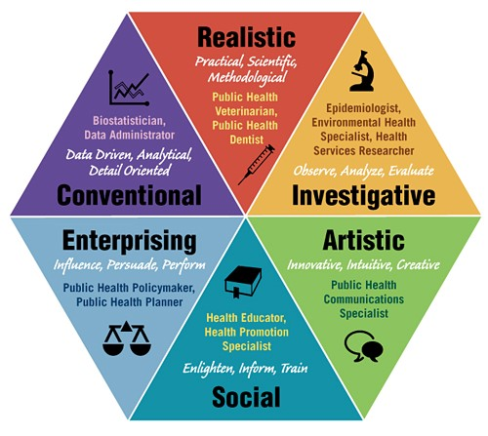
WORLD OF WORK
CONTENT SUMMARY

LESSON 1 & 2
Holland’s Six Occupational Personality Types
- Holland proposed a theory that personality factors of an individual influences their career choices.
- They intend to work with people who have same preferences as them at work, chose to prefer job where their present skill and abilities can be optimally used to improve their career graphs while also be satisfied with their job performance.
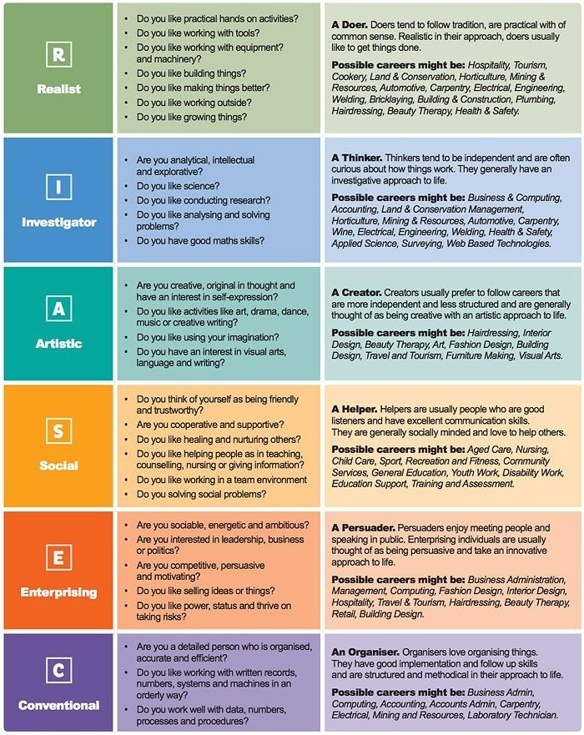
- Our strengths will help us figure out which categories we fall into.

ESSENTIAL WORKERS
Definition of Essential Workers:
The meaning generally applies to workers in law enforcement and public safety, food production, health care providers and emergency personnel, among others.
We can identify “essential workers” as those who conduct a range of operations and services in industries that are essential to ensure the continuity of critical functions – this can be within the public or private sector.

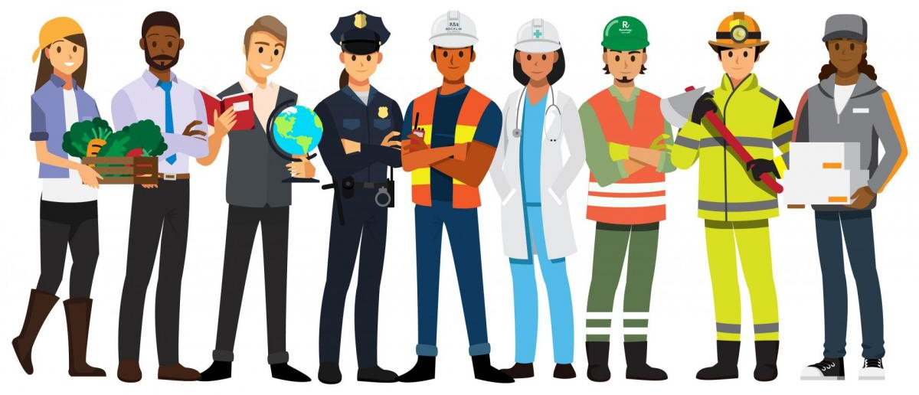

LESSON 3 & 4
For each category we take the following aspects into consideration:
Careers: What careers are in this category?
Interests: What interests are related to this category?
Abilities: What type of abilities do you need for this category?
Thinking and Learning Skills: What thinking and learning skills are required in this category?
Subjects: What subjects are related to this category?
THINKING AND LEARNING SKILLS:

SCHOOL SUBJECTS:

LESSON 5
THE ROLE OF WORK IN RELATION TO SA’S SOCIAL AND ECONOMIC NEEDS
NEEDS: the basic daily needs include things like water, food, clothes and shelter. There are other things that we cannot survive without. Needs are a necessity – they are things we cannot do without.
Needs and Wants are two different things – wants are luxury items, things that we may like to have, but are not essential.
- SOCIAL NEEDS: These are the needs of groups of people- for example, security, health care, education, transportation, recreation.
- ECONOMIC NEEDS: People need money to meet their basic as well as social needs if people are unemployed, they do not earn money and are unable to support their economic needs.

Being part of a COMMUNITY:
- As an individual you belong to many different communities- some communities are very small others are very big. The smallest of which is your family or your neighbourhood, it could be your school and from there your residential area, your province and the biggest community you are part of is your country.
- Every single community has needs, these needs are satisfied by the provision of goods and services.
- South Africa's main social and economic challenges is being able to meet the needs of the unemployed and counteract poverty.
- The South African government needs to provide goods and services such as shelter security health care education recreation and transport.

How does work meet our NEEDS?
We all have basic needs – and for those needs to be fulfilled, they must be able to pay for them.
For this to happen, people need to be working and earning money.
In return for doing the work, they receive REMUNERATION (payment in money). Some people have their own businesses and earn an income from their work.
Two of SA’s biggest Economic Needs are Employment and Money. If people are unemployed, they are not able to pay for goods and services.
People who are employed contribute positively to the country’s economy by: PAYING TAXES, SPENDING MONEY, and CREATING WORK.
SOCIAL NEEDS are met by the Government – because they supply services such as water, electricity, housing, police, health services, education, recreation, and transport.
Those services are funded by TAXES – the main source of the Governments income.
There are THREE MAIN TYPES of TAXES: Income Tax, Company Tax and Value Added Tax (VAT).
Taxes are paid to South African Revenue Services (SARS).

TAXES
People work and in return they get a SALARY From that salary they pay TAXES Taxes are collected by SARS and form the Governments largest income The Government then uses those TAXES to provide services to the Public.

