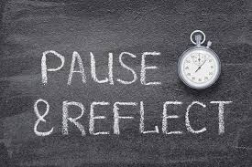
Reflection:
Complete the question boxes below.
Use key words and short sentences to answer the questions.

Where do I see myself?
What have I learnt so far?

What has been the most interesting?
What has been most beneficial for me?

What do I need help with?
My questions:

How will opportunities in the workplace help me one day?

