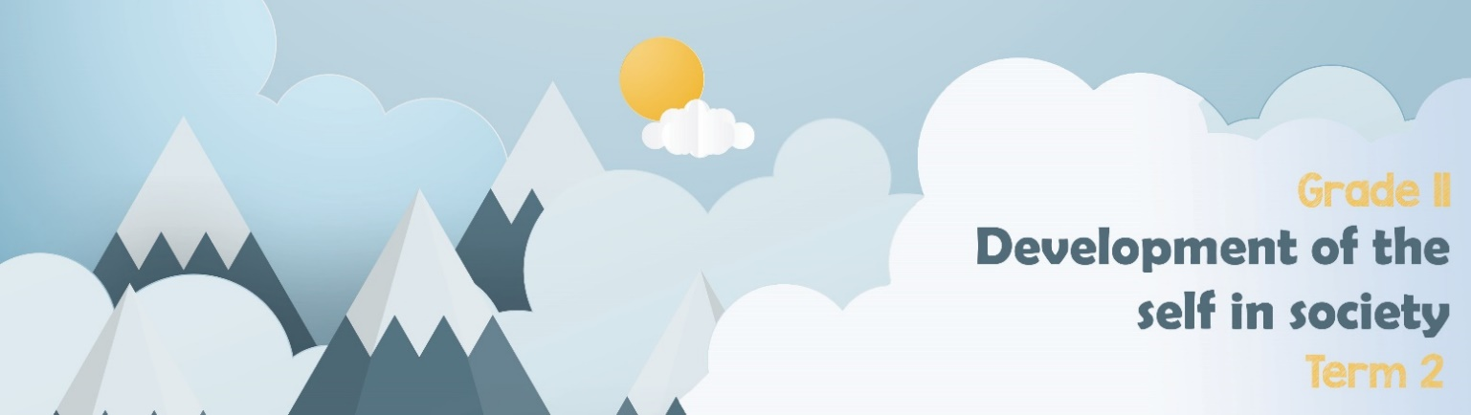
Content Summary
Lesson 1: Research gender-based violence in SA and in the world
The different forms of gender-based violence include:
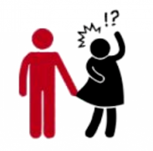
Sexual- Any sexual act performed on an individual without their consent. Sexual violence can take the form of rape or sexual assault or sexual harassment.
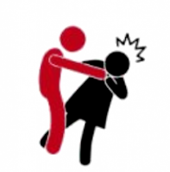
Physical- Any act which causes physical harm as a result of unlawful physical force. Physical violence can take the form of, among others, serious and minor assault, deprivation of liberty and manslaughter. We often see this form of abuse in domestic situations.
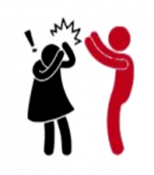
Psychological- Any act which causes psychological harm to an individual. Psychological violence can take the form of, for example, emotional abuse, mental abuse, coercion, defamation, verbal insult or harassment.

- Domestic violence: This happens when one person is close in relationship or marriage and tries to dominate the other person. The abuser uses fear, guilt to manipulate and control.
- Femicide: the killing of a woman or girl, in particular by a man and on account of her gender.

Lesson 2: The causes of gender-based violence
Definitions:
- Gender roles are the different roles, behaviour and activities that society thinks are appropriate for women and men.
- Power inequality means that some people have more rights and opportunities than others.
- Bigotry is when someone is disliked because of their culture.
- Sexism is prejudice or discrimination based on one's sex or gender. Sexism can affect anyone, but it primarily affects women and girls. It has been linked to stereotypes and gender roles and may include the belief that one sex or gender is intrinsically superior to another.
- LGBTQI+ This term refers to a community of people, both male and female- Lesbian, Gay, Bisexual, Transgender, Queer, Questioning, Intersex and many other gender and sexual identities. These terms refer to the different groups within the gay culture.
- Sexual orientation- According to researchers Susan Cochran and Vickie Mays, sexual orientation includes the following dimensions:
- sexual attraction
- sexual behaviour
- sexual fantasies
- emotional, social, and lifestyle preferences
- self-identification.

- Abuse of power includes:
- Physical Abuse: this includes physical harm like choking, pushing, beating, drowning, strangling etc. This could also include intentionally starving a person.
- Family- Incest: This is sexual intercourse between people who are closely related and would not be allowed to marry by law.
- Cultural- Mourning period: Many cultures have different rituals surrounding mourning. In some cultures, there are different roles for men and women. E.g. woman wearing only black clothing during the entire mourning period whereas a man doesn’t have to wear any particular mourning clothes.
- Social- Domestic violence: This happens when one person is in a close relationship or marriage and tries to dominate the other person. The abuser uses fear and guilt to manipulate and control. It also has a social impact.

Lesson 3: The negative effects on the health and well-being of an individual and
community
Individual:
The physical effects of GBV include:
- Bruises
- Broken bones and teeth
- Rope or strap marks
- STI’s, HIV, AIDs
- Bald spots where your hair has been pulled out
- Burn marks from cigarettes, irons or hot water
- Unwanted pregnancies
- Death

The emotional effects of abuse:
- Fear of the other person
- Depression
- Fear for your personal safety
- Anger towards the abuser and yourself
- Feelings of guilt because you think you may be responsible for the abuse.
- Afraid to trust other people
- Absolute feelings of hopelessness and helplessness

The psychological effects of abuse:
- Increased likelihood of substance abuse
- Suicidal thoughts and actions like “cutting”
- PTSD- post traumatic stress disorder
- Persistent nightmares in children
- Increased anxiety

The effect and how GBV contributes to broken family structures
- Children suffer emotional damage when they watch their mothers and sisters abused.
- Two parent homes breakup and children are torn between parents.
- In the broken home, the new female head struggles against increased poverty and social repercussions.
- Teenagers act out of distress and bully others.
- Academics suffer under the pressures from the home environment.

Increase in social ills:

- Strains education
- Slows community progress
- Poverty
- Unemployment
- Inequality
- Women’s economic dependency
- Alcohol abuse
Gender-based violence has had a contributing effect on the following sectors of society as a whole:
Inability to build trusting relationships
- Rejection, ostracism and social stigma at community level – victims struggle to trust people in relationships, even with those who have good intentions.
- Reduced ability to trust, because they are blamed, stigmitised by family, friends and society.
- Acute fear of future violence, which extends beyond the individual survivors to other members in community – which is often the reason to rather not trust anyone. (privacy)
- Vulnerability – they always feel judged and people tend NOT to listen with respect, or acknowledge the autonomy of survivor / victim, the abuse and injustice- which leads to fear of initiating or building new relationships.

Increase in social ills:
- Job loss which leads to unemployment, due to absenteeism because of violence.
- Drug- abuse - which in turn can limit their income-generating opportunities
- Poverty and malnutrition
- Negative impact on women’s income generating power, which often leads to prostitution.
- It affects job performance and leads to lateness, decreased job retention and career advancement, and this affects unequal opportunities.
- Victims of gender discrimination lose motivation and morale necessary to perform their jobs effectively, which also leads to job losses(unemployment).
Increased pressure on healthcare system:
- Hospitals need to cater for more cases of gender-based violence, filling up the emergency rooms.
- This in turn impacts the number of people needing assistance in clinics and more women needing alternative living arrangements to prevent further abuse.
- Increased number of HIV and AID victims … because of rape
- Increased number of women with sexually transmitted illnesses ...
- Women / young women need mental health support because of trauma …
Increased pressure on judicial system:
- Increased number of cases that need to be brought to trial.
- Prisons are full of perpetrators waiting for trial which becomes an increased expense on government.
- Increased administration of managing documentation and evidence in GBV cases.

Lesson 4: Exploring strategies to reduce and prevent gender-based violence

STRATEGIES to PREVENT/ REDUCE GBV:
EXPLORE MASUCULINITY: Programs which address masculinities attempt to explore what "makes a man". The central idea is to educate boys from the earliest age that violence (against anyone) is wrong, that the prevailing definition of masculinity in any society is not the only alternative, and that even though they are physically different, girls are entitled to the same rights and opportunities as men.


JUDICIARY: The criminalization of all forms of GBV - domestic violence, rape, sexual harassment,
psychological violence etc. has been an important step in eliminating it. What remains is the consistent application of these laws, the implementation of penalties, and a greater focus on rehabilitating convicted perpetrators. Other legal responses to GBV have included: legal aid services; training of police and judicial personnel; women's police stations; legal advocacy and lobbying; training of family, criminal, immigration and juvenile court lawyers and bar association advocacy.
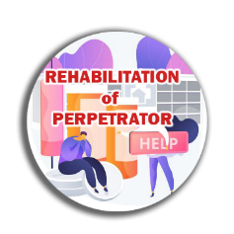
REHABILITATION OF PERPETRATORS- Working with the perpetrators of violence (batterer-intervention programs) has been a controversial and occasionally successful response. While victim assistance services are a useful band-aid to address an existing problem, this approach targets efforts at the source of the problem, attempting to change violent men's behaviour.


School systems are instrumental to stopping GBV before it starts. Regular curricula, sexuality
education, school counselling programs and school health services can all convey the message that violence is wrong and can be prevented, suggest alternative models of masculinity, teach conflict-resolution skills and provide assistance to children/adolescents who may be victims or perpetrators of violence. Integrating GBV as a subject into psychology, sociology, medicine, nursing, law, women's studies, social work and other programs enables providers to identify and tend to this problem.

Religious counselling, support groups, education programs, study groups and assistance programs can address GBV with their participants/worshippers. Most religions emphasize the importance of peace and tolerance. Framing a discussion of GBV in the context of religious tenets is one way to foster awareness and discussion of the problem. It may also be a way to identify and assist victims who do not feel comfortable talking to a health care provider or police officer.


The media is a key conduit for making GBV visible, advertising solutions, informing policy-makers and educating the public about legal rights and how to recognize and address GBV. Newspapers, magazines, newsletters, radio, television, the music industry, film, theatre, advertising, the internet, posters, leaflets, community notice boards, libraries and direct mail are all channels for providing information to victims and the general public about GBV prevention and available services.


Training health care providers to recognize and respond to gender-based violence is one of the most important ways of identifying and assisting victims. Not just obstetrician/gynaecologists but all health care professionals must learn to recognize the signs: hospitals (especially emergency room staff); public and private health clinic staff; general/family practitioners; internists; paediatricians; psychiatrists; nurses and the staff of family planning clinics.


A number of studies have shown that involving entire communities in recognizing, addressing and working to prevent GBV is one of the surest ways of eliminating it. To be optimally effective, community networks must bring together all of the responses outlined above, integrating members from all sectors of the community: families; businesses; advocacy groups/civil society; public services such as police, fire fighters and medical examiners; social services such as welfare, unemployment, public housing and health; education; the media and officials from national, state/provincial and local/municipal governments. Community interventions must send a clear message about what gender-based violence is, the different forms it can take, why it is wrong and how to prevent it.

Do not be afraid to speak out about abuse. You need to be somebody that tells others to report abuse. Abusers cannot be stopped if we do not say something. IF you are being abused:
Go to the police, report it! They can assist you with a restraining order. If you are under 18, they will put a social worker on your case to assist you.

Be an activist for the rights of everybody (including the victims of GBV)

