
Programs which address masculinities attempt to explore what "makes a man". The
central idea is to educate boys from the earliest age that violence (against anyone) is wrong, that the prevailing definition of masculinity in any society is not the only alternative, and that even though they are physically different, girls are entitled to the same rights and opportunities as men.

Brainstorm THREE strategies that can be implemented in South Africa to bring about change in the way men think about women.

Strategies for South Africa

The criminalization of all forms of GBV - domestic violence, rape, sexual harassment, psychological violence etc. has been an important step in eliminating it. What remains is the consistent application of these laws, the implementation of penalties, and a greater focus on rehabilitating convicted perpetrators. Other legal responses to GBV have included: legal aid services; training of police and judicial personnel; women's police stations; legal advocacy and lobbying; training of family, criminal, immigration and juvenile court lawyers and bar association advocacy.
Brainstorm THREE strategies that can be implemented in South Africa to bring about change in the way perpetrators treat women.
Strategies for South Africa
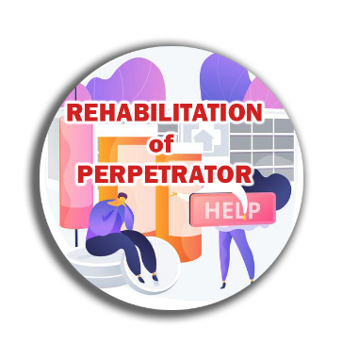
Working with the perpetrators of violence (batterer-intervention programs) has been a controversial and occasionally successful response. While victim assistance services are a useful band-aid to address an existing problem, this approach targets efforts at the source of the problem, attempting to change violent men's behaviour.
Brainstorm THREE strategies that can be implemented in South Africa to bring about change in the way perpetrators treat women.
Strategies for South Africa


School systems are instrumental to stopping GBV before it starts. Regular curricula, sexuality education, school counselling programs and school health services can all convey the message that violence is wrong and can be prevented, suggest alternative models of masculinity, teach conflict-resolution skills and provide assistance to children/adolescents who may be victims or perpetrators of violence. Integrating GBV as a subject into psychology, sociology, medicine, nursing, law, women's studies, social work and other programs enables providers to identify and tend to this problem.

Brainstorm THREE strategies that can be implemented in South Africa to bring about change in the education system.
Strategies for South Africa


Religious counselling, support groups, education programs, study groups and assistance programs can address GBV with their participants/worshippers. Most religions emphasize the importance of peace and tolerance. Framing a discussion of GBV in the context of religious
tenets is one way to foster awareness and discussion of the problem. It may also be a way to identify and assist victims who do not feel comfortable talking to a health care provider or police officer.

Brainstorm THREE strategies that can be implemented in South Africa to bring about change in the faith-based organisation’s support for women who have been abused and educate the public.

Strategies for South Africa


The media is a key conduit for making GBV visible, advertising solutions, informing policy-makers and educating the public about legal rights and how to recognize and address GBV. Newspapers, magazines, newsletters, radio, television, the music industry, film, theatre, advertising, the internet, posters, leaflets, community notice boards, libraries and direct mail are all channels for providing information to victims and the general public about GBV prevention and available services.

Brainstorm THREE strategies that can be implemented in South Africa by the media to bring about change in creating awareness about gender-based violence.
Strategies for South Africa

Training health care providers to recognize and respond to gender-based violence is one of the most important ways of identifying and assisting victims. Not just obstetrician/gynaecologists but all health care professionals must learn to recognize the signs: hospitals (especially emergency room staff); public and private health clinic staff; general/family practitioners; internists; paediatricians; psychiatrists; nurses and the staff of family planning clinics.

Brainstorm THREE strategies that can be implemented in South Africa hospitals to bring about change in dealing with gender-based violence.

Strategies for South Africa

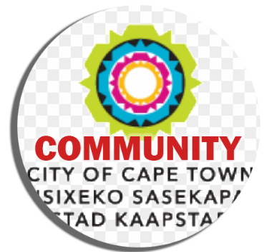
A number of studies have shown that involving entire communities in recognizing, addressing and working to prevent GBV is one of the surest ways of eliminating it. To be optimally effective, community networks must bring together all of the responses outlined above, integrating members from all sectors of the community: families; businesses; advocacy groups/civil society; public services such as police, fire fighters and medical examiners; social services such as welfare, unemployment, public housing and health; education; the media and officials from national, state/provincial and local/municipal governments. Community interventions must send a clear message about what gender-based violence is, the
different forms it can take, why it is wrong and how to prevent it.
Brainstorm THREE strategies that can be implemented in your local community to bring about change in dealing with gender-based violence.
Strategies for South Africa

