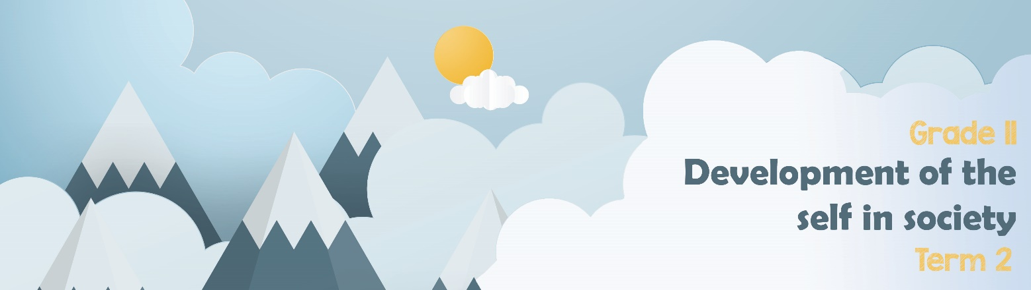
Lesson 4 – Worksheet MEMO

Activity 1: INFORMAL ASSESSMENT
In a very short while, you will need to be able to write an LO assessment. This activity has been
given to allow you time to practice the kinds of questions that would appear in an examination.
Read the extract below and answer the questions that follow.

AWARENESS – GENDER BASED VIOLENCE
Violence against women and children in South Africa has reached epic proportions.
So often we see women protesting this; women calling for action or for community involvement, interventions, and support.
However, if we are to effectively deal with this crisis, and put an end to the high numbers of violence against women, then we need to see an increased male involvement.
[Anonymous]

  - Define the term gender-based violence and state THREE forms of this type of violence. (1+3)(4)

Gender-based violence: involves violence / abuse mainly directed at women and girls ()

Any THREE relevant answers for ONE mark each
Gender-based violence could include:
- Physical ()
- Sexual ()
- Psychological harm. ()

  - Discuss THREE possible signs of emotional abuse in young people who have been
exposed to gender-based violence. (3x2)(6)

Any THREE of the below or any relevant answers for TWO marks each
(i.e. ONE mark for statement and ONE mark for qualifier / explanation)
Exposure to gender-based violence may cause young people to…
- be aggressive/nasty towards others () as a strategy to protect themselves. () / being in a violent environment, they accept it as only way to communicate ()
- struggle to control their emotions / have extreme outbursts () as they do not know how to deal with the hurt / emotional pain they are suffering. ()
- act in a way that is not appropriate for their age () as they have been exposed to situations which forced them to adopt that type of behaviour. ()
- not able to show emotion because of lack of social skills () as they do not know how to connect with / behave around people. ()
- become withdrawn () as they have been stripped of their dignity / confidence / self-worth. ()

  - Why do you think males are not as involved in campaigns against gender-based
violence? (2x2)(4)

Any TWO of the below or any relevant answers for TWO marks each
(i.e. ONE mark for statement and ONE mark for qualifier / explanation)
Some men may distance themselves because they may …
- feel that they are not guilty of such acts () so they do not need to involve themselves in any such campaigns. ()
- have been an abuser/perpetrator before () so they may still feel too guilty about it/they are hypocritical / phoney / false / fake. ()
- think that there are enough men out there who can represent them () so they do not bother to get involved. ()
- know about other men who are guilty of such acts () so they feel guilty for not exposing them / that they may betray those men. ()
- it is below them / afraid of being seen as less man / afraid they will be mocked by peers because men do not show empathy or they are conservative or patriarchal system

  - Suggest THREE practical ways in which men who show their support against
gender-based violence can get more men involved in awareness campaigns. (3x2)(6)

Any THREE of the below or any relevant answers for TWO marks each
(i.e. ONE mark for statement and ONE mark for qualifier / explanation)
Men who are activists already can…
- engage in online discussions with those who are not yet on board () to sell the idea of getting involved to them in that way. ()
- invite some of their colleagues / friends whom they know are not involved () to make them aware of your own involvement. ()
- start talking openly in random conversations to people about the campaign () in an attempt to raise awareness right where they are / in their own inner circles. ()
- get some of their important contacts to donate money to organisations that are working to end violence against women and children () by being silent partners to this cause. ()

[20]
Activity 2: INFORMAL ASSESSMENT
- Name TWO campaigns other than the 16 Days of Activism or any other Educational
or social and legal support available for the victims. (2x1)(2)

Any TWO relevant answers for ONE mark each
- Stop Gender Violence: A national Campaign
- Raising her Voice- POWA
- White Ribbon South Africa
- #FairnessFirst: taking a stand against GBV with brothers for life
- #Starts with me

- Analyse why gender violence remains a human rights violation in the country despite
numerous campaigns in the community and government to eliminate it. (2x4)(8)

Gender -based violence remains a human right violation because:
- South Africa is still characterised by divisions on the basis of race, class and gender, inherited from its violent apartheid past, and the GBV pandemic in South Africa is rooted in unequal power in gender relations/ patriarchy/homophobia/sexism, so the harmful discriminatory beliefs/ human rights violation and practices still lives and GBV goes on.
- South Africa has a high unemployment rate adding abuse of alcohol as counter strategy to deal with it leads to the high rates of violence against women and violating the right of women and men, and the perpetrators are often never held accountable.
- The continued stereotyping of women in the media, further shape the way in which society perceives and responds to violence against women, Such reporting often leads to people blaming women for violence, and therefore survivors feeling guilty and blaming themselves for violence and allow violence to continue.
- South Africa has progressive laws and policies related to GBV and sexual-related violence. These laws give expression to the constitutional rights to equality, human dignity, life and freedom and security of the person; however, the scope and prevalence of GBV that currently plagues the South African landscape suggests that there is a lack of political will to deal with this challenge because the state response and implementation of GBV-related policies and legislation has been lacking.

Any TWO of the above for FOUR marks each.
(i.e. To be awarded the full FOUR marks for an ANALYSIS question:
candidates must give a statement, () elaborate on the statement,
() qualify the statement () and give an outcome.())

- Critically discuss strategies with which Faith-Based Organisations (FBOs) could mobilise the community against GBV. (2x4)(8)

FBOs could …

- conduct seminars in which the topic of GBV features prominently () so that diverse views on this problem could be heard () for people to gain more knowledge on the topic() so that they can change their views/perspectives towards the problem. ()
- invite victims of GBV to church gatherings () so that they may tell their stories () in order for people to understand how it affects the victims() and want to help all people to avoid GBV situations in future. ()
- organise an interfaith dialogue () with all the members of the congregation ()where religious leaders could openly discuss the problem () thus empowering them with skills to detect it amongst congregants. ()
- host panel discussion on GBV () that could be viewed by multiple people from their congregation/ the public ()in which experts in the topic could share experiences of how GBV affects society () so as to sensitize the general public not to fall victim to it. ()
- develop posters in which GBV issues are addressed () that can be placed around their premises/ in their community/ in areas that have high instances of GBV ()as some people prefer to read on their own, than to attend meetings/conferences () so that the message could cover a large scope/so that the message could be received by people of different socio-economic status. ()
- be proactive by considering women/ other genders to be leaders in the different churches () and make a clear effort to treat them as authorities/ leaders/ people in positions of power () as that could gradually inculcate appreciation of skills that people possess in doing certain things () and that may change the view that women are entirely depended on men for their livelihood. ()
- host a protest against GBV/ create awareness campaigns () which express dissatisfaction with the current state of GBV ()and this would help educate the local population about GBV/ provide a possible discourse with local government() which could also create greater cohesion within the community against GBV. ()
- create a safe place for victims of GBV to come forward and talk in private or public() as many people who are affect by GBV are fearful and need this space to speak freely ()this would help survivors of GBV feel safe enough to discuss their trauma/ share their experiences in these spaces ()and work towards healing from their experiences().
- host a fund raiser/ use weekly collections() to gain money to support anti-GBV NGOs within the community() these funds could help create safe houses/ provide counselling services for women outside the faith-based organisations () this would cause women to feel safer as they will have other places to go outside of the faith-based education that are safe. ()

Any TWO of the above for FOUR marks each.
(i.e. To be awarded the full FOUR marks for a CRITICALLY DISCUSS
question: candidates must give a statement, () elaborate on the
statement, () qualify the statement () and give an outcome ()) [18]

Activity 3: Take a moment to reflect on what you have learnt about
yourself today.

- Why do you think some people find it difficult to report abuse? What advice would you give them?

- What changes can you make in your own attitude towards gender-based violence in South Africa?

- What changes can you make in your own attitude towards unequal relations and power
inequality between genders.

Learners will have different responses to the reflection and therefore there is no memo for
this section.

