
Content Summary

Lesson 1: Environmental issues that cause ill-health.
Introduction:
We know that environmental issues refer to the impact on natural resources because of the misuse or overuse by humans. Let’s take a moment to see if you can remember what the term ”environmental justice” means from Grade 10?

The use of harmful substances in food production

Sometimes these environmental issues directly impact the health of the people that live in a community. Some of these environmental issues are obvious like flooding or pollution. Did you know that the way that animals are farmed for human consumption could also impact your health? With the large demand of meat for the increasing world population, many farming institutions use growth hormones or antibiotics to speed up the growth process of the animals. Some substances are put in food to make it last longer or look more appealing. Many of these substances could negatively impact your health.

Most times we eat food not even knowing what is in it. We think that because it’s sold in a store, there can’t be anything bad for us in it. Sometimes these meats have been tested.

- Some foods like meat / milk contain antibiotics. These antibiotics were originally given to animals to prevent diseases. When we drink the milk or eat the meat, we could become immune to antibiotics. When we need to take antibiotics because we’re sick, it doesn’t work.
- Some foods contain pesticides which were originally used to kill insects when growing crops. When humans ingest these vegetables, the pesticides are absorbed into the human body fat. Over time they have been known to make people ill.
- Food additives like sodium benzoate often found in fizzy cooldrink to add colour and flavour. Humans respond in different ways to these substances. Some develop chest diseases like asthma and others it impacts their ability to concentrate.
- Many sweets that have a shiny surface have been coloured - which comes from insects like beetles or sprayed with shellac which comes from an insect like a cockroach. Humans could have allergic reactions to these insects, not to mention be severely “grossed out” by the thought of eating insects.

Inhumane farming methods:
As a group you were required to discuss this image. Ensure that you can answer these questions:
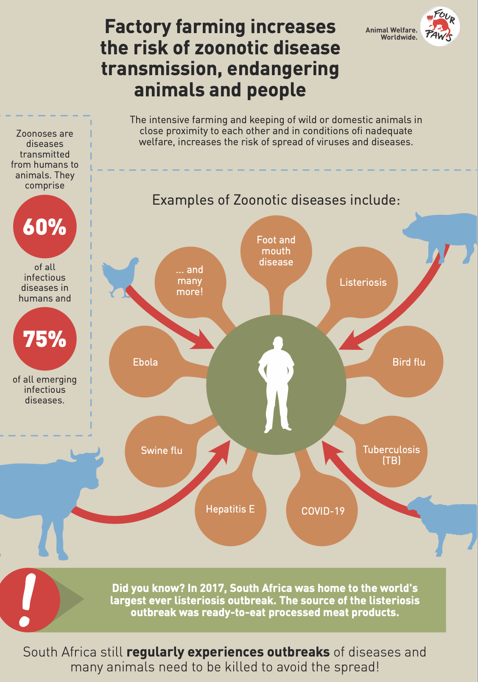
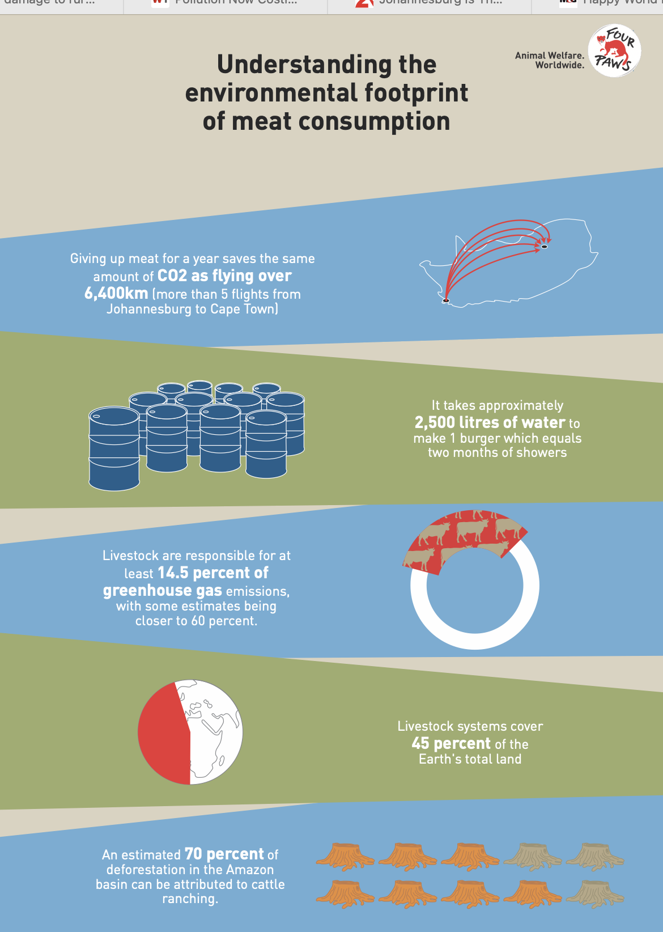

1) Discuss the impact on a local community being infected with one of these diseases indicated on the slide?
2) Explain how eating less meat could improve the welfare of animals.
3) In your group, discuss how you as a grade 11 learner could create awareness at school about factory farming.

It is unpleasant to realise that South Africa continues to allow such cruel methods of farming. We can take a stand by educating our peers about these conditions and taking part in protests where we are aware that this kind of cruelty exists. Some of you might even encourage your parents to read the labels on food and rather buy free range meat. But remember there is also the reality that not everyone can afford to live on free-range chicken as its much more expensive than other food. The aim of this lesson is to educate you, so that you get to make your own choices.

Impact of degradation on society:
Use the following questions as a guideline to be able to discuss the following environmental hazards:
- An explanation of why this is an environment issue.
- How this issue causes ill heath for humans?
- Examples of this environmental hazard in your local community?
- THREE suggestions on how you as high school learners could prevent this environmental hazard from happening at your school.

Discuss the following environmental hazards:
- Soil erosion
- Pollution
- Radiation
- Floods
- Fires

Just to summarise, we have covered the following main environmental hazards in these case studies:
- Soil erosion
- Pollution
- Floods
- Fires
Radiation is also an environmental hazard. The most common form of radiation we are aware of is from the UV rays of the sun. Too much time exposed to the sun could result in a short-term sun burn or long term this could result in skin cancer.

Lesson 2: Environmental issues that cause ill-health:

Introduction:
Today we continue by looking at the impact of the depletion of certain resources would have on humans. Let us use an example. A few years ago, in Cape Town there was a drought that impacted the lives of many people. Water is not only used to drink, but also in the production of many products. For months after the drought, there was a shortage of certain products in stores because they could not be mass produced without water.

When we have a large population of people on the planet and limited resources like fish, meat or trees, it will not be long before there are less and less resources for us to use.

- Impact of depletion of resources such as:
- Fishing stocks - Many people depend on the ocean to feed their families and prevent them from starvation. Overfishing is the concept of catching so many adult fish in the sea or in a dam that not enough remain to breed and increase again. We can see that since 1950, overfishing has had a radical impact on the oceans eco-system. With the decrease of fish available, families will be impacted as they don’t have food. Others that earned an income from selling their fish will no longer have a job.
- Firewood - People rely on firewood for heating and cooking. Some people will also cut down wood and sell firewood to earn an income. With the depletion of these resources, there will be less trees, which means less carbon dioxide will be removed from the atmosphere.
- Land - As more crops are planted on land and the soil is not given time to recover, this impacts the topsoil and then in the future, the crops won’t grow again. As areas become more populated, more houses and buildings go up and there is less place for natural resources like trees and plants to grow.

Remember that as these resources are depleted whether its fish, firewood or land, the health of those in the communities are impacted. Without fish, people will lack good nutrients and oils to keep them healthy. Without trees, there will be increased air pollution because of all the CO2 in the air. Without land to grow crops, people will get hungry as there won’t be enough crops to feed all the people.

We need a positive attitude towards the environment, so that we contribute towards change rather than just ignore what is going on around us.

- Dealing with environmental factors that cause ill-health on a personal level:
- Attitudes
- Safety
- First aid skills
- Coping with disasters

So how can we be positive in the light of all these scary possibilities?

- Firstly, you need to realise you cannot change the things that do happen. Be optimistic and look for a positive solution rather than complaining and pitying yourself.

- Secondly, you need to have a plan for the more likely environmental hazards that you might encounter. E.g., if you live near a river there is a chance of flooding, or pollution or if you use gas cylinders for cooking there is a chance of a gas leak and therefore a fire.

- Put together a first aid kit for your home and learn how to help someone in an emergency. Go on a first aid course to be prepared in the event of an emergency.

Refer to the infographic poster you were required to do for homework. You were highlighting the FOUR main parts to your family action plan. Think of disasters that could occur in your home or community based on your location. Think of things like a fire outbreak or an earthquake or flooding. Your emergency action plan needs to include a focus on:
- Possible hazard in your area?
- Attitude? How to remain positive and calm?
- What to do when this emergency occurs? How to escape?
- Where to meet as a family in the case of an emergency?
- A list of what you should include in your home emergency kit.
- Who to contact in an emergency?

Lesson 3: Environmental issues that cause ill-health:

Climate change: Climate change is a much larger and more long-term problem. This refers to the changes that take place in the earth’s atmosphere, temperatures, patterns that affect rainfall and sever weather patterns. With the increase in human population where we breathe out CO2 into the atmosphere as well as the CO2 from burning, the earth’s atmosphere has begun to change in a negative way. Another term you will come across today is global warming. This refers to the increase in temperature of the earth's atmosphere.

It’s not enough to just identify we have a problem. We need to make changes to the way we live every day. We refer to these changes as mitigation. Mitigation are the steps taken now to reduce the effects that will directly impact the future. Adaption involves putting in place strategies / daily habits to make a positive impact on climate change.
- E.g. As cars produce large amounts of carbon monoxide gas, we mitigate by riding cars less and adapt by using bicycles instead or using a car-pool to prevent more cars on the road.

With the increase of climate change around the world, there is a clear impact on:
- Eco-systems
- Oceans
- Humans
- Weather patterns
We have seen over the last few lessons that climate change is impacting the world around is. As more floods occur, eco-systems are impacted. The oceans are experiencing an increase in temperature as the glaciers melt. This impacts an increase in water levels. Islands like Venice have seen an increase in water, slowly pushing the shoreline back. As these changes occurs, humans are directly impacted. We have seen how an increase in severe weather conditions, people lose their homes, their lives and in many cases, they need to start over again. There have been reports all over the world of more severe tornados or tsunamis than ever before.
In the words of Greta Thunberg, “We can’t just continue living as if there was no tomorrow, because there is a tomorrow.” It’s time for you to make a stand!

Being proactive means mitigating and adapting. Becoming someone that actively aims to minimise climate change. This means to lessen your carbon footprint which minimizes the greenhouse effect that leads to global warming which in turn leads to climate change. E.g. Choose to ride your bicycle rather than drive a car. Remember some of these examples from your worksheet.

  - Recycling- recycle paper or plastic so that less trees are cut down for paper.
  - Collect rainwater/ shower water and use it in the garden to lessen the use of our water supply.
  - Plant indigenous trees that survive droughts and produce oxygen by absorbing the CO2 in the air.
  - Carefully consider where to build houses- don’t build in a flood zone and consider the eco-systems in that area.

Lesson 4: Environmental issues that cause ill-health:
Responsible citizenship: Identify and participate in a community service that address a contemporary environmental issue indicating how this may harm certain sectors of society more than others
Let’s just briefly recap on community services that address these contemporary environmental issues. Some of you highlighted:
- Pollution by dumping plastic and organizations that have gotten involved in educating the public on how to recycle. In some cases, the municipalities have arranged that recycling is collected from local communities.
- Remember there are also communities like those who live in extreme poverty that have limited resources of land as many people live in a small space. Many of these communities are the first to be severely impacted by rain or fire.

Here are a few other examples of how you could make a difference and ways to participate in a community service that addresses a contemporary environmental issue.
- Start a campaign.
- Volunteer at an organization, NPO or NGO
- Start a recycling program at your school.
- Educate your community on how to save water by making posters.
- Get involved in a beach or river cleanup advertised on social media.
- Create awareness about inhumane farming methods and the dangers of certain foods
You can now add possible community services that you can take part in (keep your research in mind)

