


Lesson 4 – Worksheet MEMO

Activity 1:

Question 1
Choose the correct answer and write only the letter (A-D) next to the question number
(1.1.1 to 1.1.3), for example 1.1.4. D.
1.1.1 Global warming leads to ……
A. overfishing
B. harmful farming methods
C. pollution
D. climate change

1.1.2 Statistics show that over half of South Africans do not have access to enough food.
The specific term for this is:

- Food security
- Injustice
- Food production
- Unequal food access

1.1.3 An example of a violation of people’s environmental rights is:
A. Residents that use an open field near a school as a dumping ground.
B. A beautiful woman being physically abused by her partner.
C. School children not receiving textbooks at the start of the school year.
D. A farmer spraying his corn crops with non-harmful pesticides.
(3x1) (3)

- Give ONE word/term for EACH of the following descriptions. Write only the word/term next to the question number (1.2.1 to 1.2.5).

  - Farming methods that are cruel to animals. (1) Inhumane √

    - When a resource has been used entirely or is in danger of becoming completely exhausted/reduced. (1)
Depletion √

    - The belief that all citizens should receive equal access to the environmental resources
of a country. (1)
Environmental Justice

1.2.4 A gradual increase in the overall temperature of the earth's atmosphere generally attributed to the greenhouse effect caused by increased levels of carbon dioxide,
CFCs, and other pollutants. (1)
Global Warming

1.2.5 The movement of the upper layer of earth or dirt. (1)
soil erosion

(5x1) (5)

Question 2

2.1.1 Define the term environmental disaster, citing ONE example to substantiate your answer. (1+2) (3)
Events that happen suddenly and cause suffering to many people
Relevant example
floods, / tornados,/ fires,/ plane crashes

2.1.2 Discuss ONE thing that should form part of a family emergency plan. (1x2) (2)
ANY ONE √√
A plan of your home, showing exits
Something to warn people/bell/whistle/vuvuzela
A list of important phone numbers
A place where your family can meet in case they lose each other
A list of what you would include in your emergency kit

2.1.3 Describe TWO positive actions teenagers could take to decrease their carbon
footprint at home. (2x2) (4)

Any TWO of the below or any relevant answers for TWO marks each.
(i.e. ONE mark for statement and ONE mark for qualifier / explanation)

- Teenagers could make sure to switch off all electronic devices that are not in use which would mean less electricity would be used and less coal would have to be burned in order to make electricity.
- Suggest that parents buy products with a good energy rating so that they don’t use up excess electricity, water etc.
- Reduce waste by buying products that aren’t individually packed which would decrease the amount of plastic going into landfills.
- They could eat less meat which would mean less animals producing methane gas.
- Recycle as many products as possible so that they can be reused instead of polluting the environment

Question 3

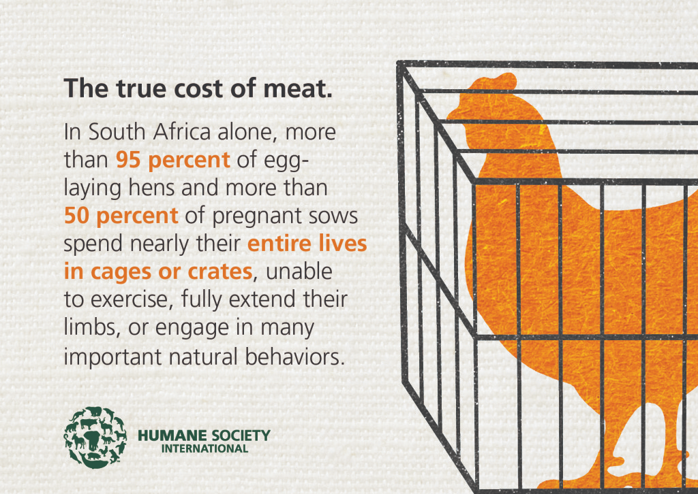
Study the image below and answer the questions that follow.
[Adapted from: http://www.eategrity.co.za Accessed on 15 February 2021]

Write paragraphs on inhumane farming practices in South Africa.

Use the following as a guideline:

- Define the term ‘inhumane farming practices’ and name TWO reasons why
inhumane farming practices have occurred in South Africa’s farming industry. (1+2) (3)

Inhumane farming practices:
Procedures which are implemented in the rearing of farm animals where animals are treated as products instead of creatures, leading to horrible living conditions and mistreatment.

Any TWO of the below or any relevant answers for ONE mark each.

Possible reasons for inhumane farming practices:
- Farmers prioritise production over humane treatment.
- Lack of education on how animals should be treated.
- Farmers don’t feel that they have the space or facilities to provide better conditions.
- The industry is growing too fast/ there is a growing demand.
- False belief that animals don’t feel/ get hurt.
- Greed for money.

- Discuss FOUR inhumane farming practices that can cause harm to animals. (4x2) (8)

Any FOUR of the below or any relevant answers for TWO marks each.
(i.e. ONE mark for statement and ONE mark for qualifier / explanation)

- Animals are crammed into extremely small spaces which means that they cannot walk about freely/ stand properly.
- Animals must often live in extremely over-crowded pens or structures which can lead to diseases / distress.
- Animals are often slaughtered in ways that don’t kill them immediately due to time constraints so the animals must suffer unnecessarily.
- Often, animals are mutilated e.g. have horns, teeth, etc. removed so that they don’t hurt each other which can hurt animals if not done correctly or make it difficult for to function normally.
- Baby animals are taken away from their mothers at an extremely young age, which causes the animals extreme stress/ deprives the baby of its mother’s milk.
- Animals can be force-fed through a tube to fatten them up faster which means that the animals often have to eat more than they can physically handle .
- They are fed steroids to fatten them up faster, which can cause health problems / make them uncomfortable because they are not designed to digest steroids.

- Recommend THREE ways that South African citizens can decrease inhumane farming practices. In your answers, indicate how EACH recommendation could make farms more likely to employ more humane farming practices. (3x3) (9)

Any THREE of the below or any relevant answers for THREE marks each.
(i.e. ONE mark for statement, ONE mark for qualifier / explanation, ONE mark for outcome)

- South Africans could eat less meat, dairy and eggs which would lessen the demand for meat and the pressure on the industryThis would mean that South African farmers would not feel as much pressure to produce enough meat and not feel so pressed for time that they must fatten animals faster or kill them faster.
- They could ensure that they only purchase organic, free-range products which ensure that their animals are treated fairly This would take away money from farmers who are farming inhumanely and force them to change their stance.
- They could protest inhumane farming practices which would show their dissatisfaction with the current practices and let farmers know that consumers are unhappy This would mean that farmers may change their ways for fear of losing customers.
- Citizens could post about inhumane farming practices on their social media pages to spread awareness and bring more people to the cause This would mean that fewer consumers would support farms with inhumane farming practices.
- Shop for all animal products at farmers markets, where farmers that support humane farming practices sell their products where citizens can support smaller farms that treat animals fairly This will empower these smaller farms to over-take the inhumane bigger farms.
[20]

Activity 2: Reflection
Write a paragraph about the presentation today that most inspired you. List how it inspired you to get involved in community services. Include in your paragraph how this group activity has changed your opinion on climate change – and the role of mitigation and adaptation.

Below is a list of practical ways to participate in a community service that addresses a contemporary environmental issue:

- Start a campaign.
- Volunteer at an organization, NPO or NGO
- Start a recycling program at your school.
- Educate your community on how to save water by making posters.
- Get involved in a beach cleanup advertised on social media.
- Create awareness about inhumane farming methods and the dangers of certain foods.

Of these, my choice would be: ______________________________________

Learners will give personal responses to this activity.

