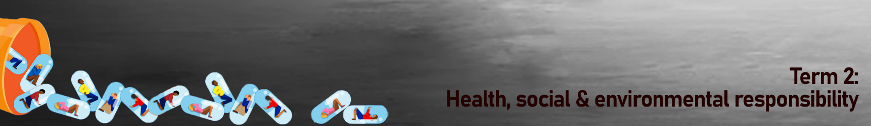
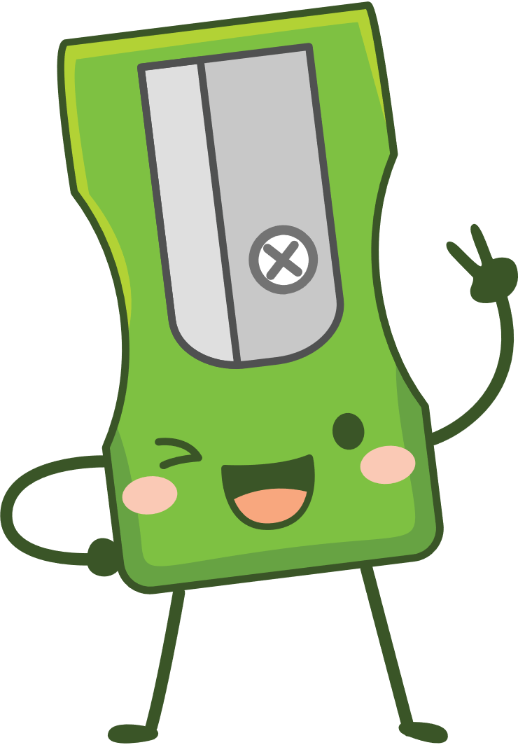
Content Summary
Lesson 1:
Social factors that contribute to substance abuse including community and media
Social factors like family, community, sports teams and the media have a direct influence on what we believe about ourselves, what we believe is important and what we choose to do. These factors also play a major influence on addictions and substance abuse.

- Substance Abuse: The use of illegal drugs or the use of prescription or over-the-counter drugs or alcohol for purposes other than those for which they are meant to be used, or in excessive amounts. Substance abuse may lead to social, physical, emotional, and job-related problems.
- The different kinds of addictions:

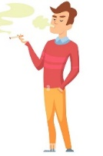
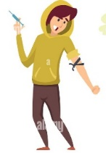

Tobacco

Illegal drugs

Prescription

Medication

Alcohol addiction

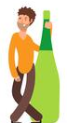

When a person uses these substances often they result in addictions. For a teenager to be addicted to drugs during their developmental years will greatly impact their bodies.

Remember the following are all true!
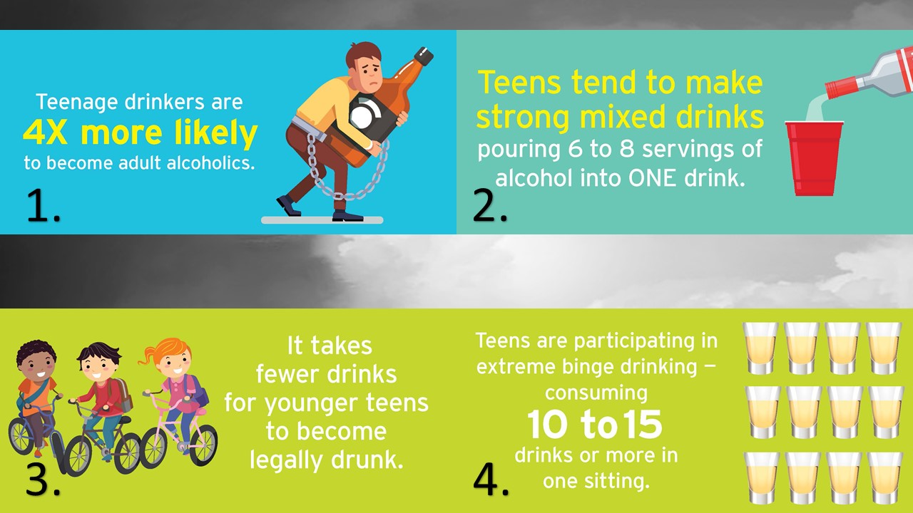
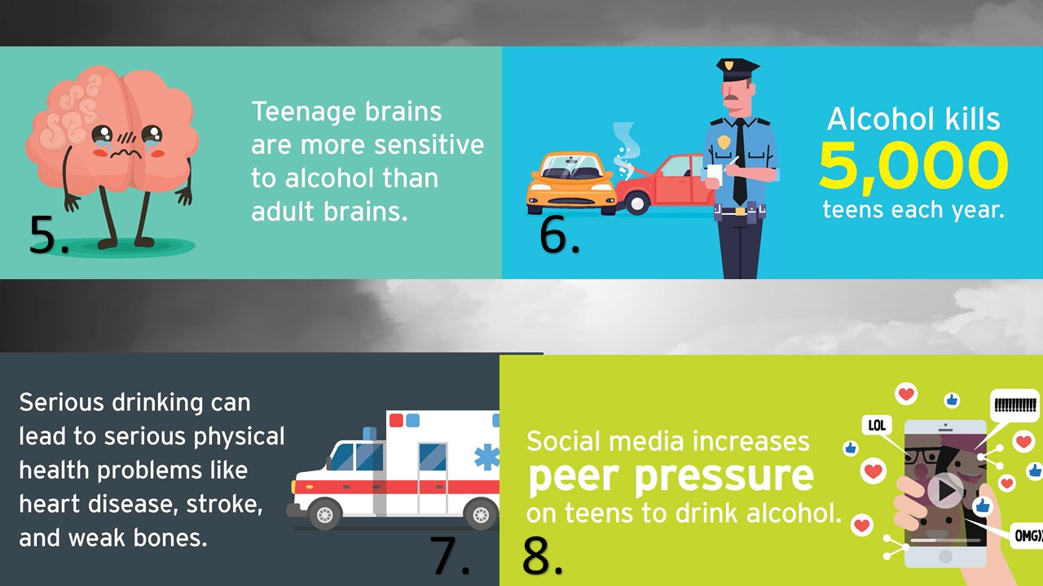
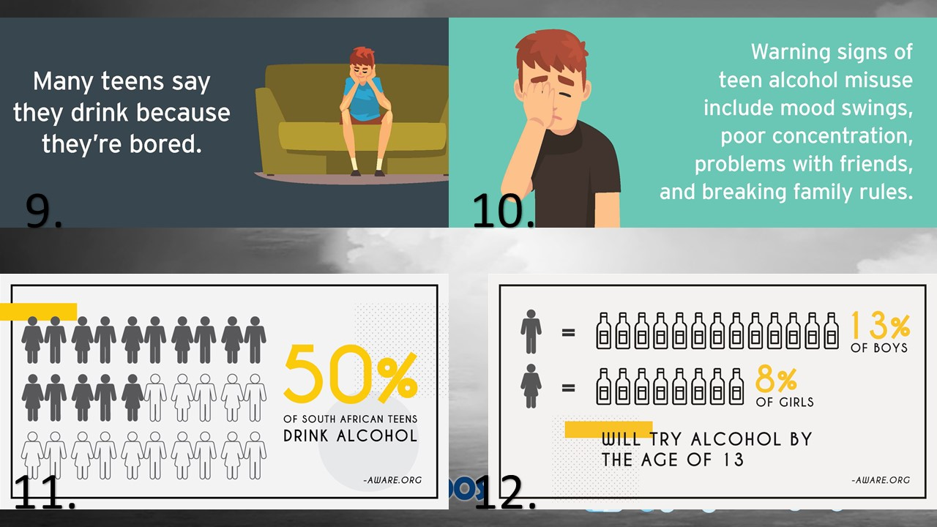
We know the media influences the way we dress, what we think is cool and even our behaviour. Sometimes this influence can be positive but sometimes the influence can be negative. Sometimes the movie stars we follow are promoting substance abuse as “cool”. Remember to challenge the false messages about drugs and alcohol being fun from the media. Know the facts and make the right choices.
Lesson 2:
Appropriate behaviour to stop and avoid substance abuse: refusal and decision- making skills

Most teenagers don’t want to do drugs, but they struggle to turn down their friends. They’re worried their friends will think they’re “not cool” or the worst “not want to be friends anymore”.
The best way to prevent getting addicted to substances like drugs or alcohol is to have strong decision-making skills and refusal skills. Saying “No” comes from having planned responses and practicing.
How to say “No”!
- Give an excuse like:
You could say:
- I can’t stay; I’ve got to help my dad with something.
- That stuff makes me sick.
- No way. I think you just want me to get in trouble.

2) Teens can also just be honest with their friends:
You could say:
- I’m not into that.
- My mom would kill me if she found out.
- I don’t have time for drugs.

3) Use some humour - deflect the situation by making a joke out of it.
Avoid using derogatory humor so you don’t offend anyone else.
You could say:
- No thanks, I need all the brain cells I can get."
- "Doesn’t that stuff stunt your growth? I’m too short already! “

4) Offer another option - offer an alternative that you could do instead.
If you are with your friends, suggest doing an activity or grabbing a bite to eat. It might just be the push they need to put down the drugs or alcohol and do something a little safer. For example:
You could say:
- "I’m good. Wanna go play basketball?"
- "No thanks. Let’s go grab some food.“

5) Explain the dangers of taking drugs
This works well if your close friends are offering you something. Keep in mind that this may not make you very popular, and there’s no guarantee that your friends will heed your advice. Say things like:
You could say:
- "No thanks. That stuff is so bad for you."
- "Haven’t you heard about the kids on the news who died from doing that?“

Lesson 3:
Long and short term consequences of substance abuse: link to crime, violence and educational outcomes
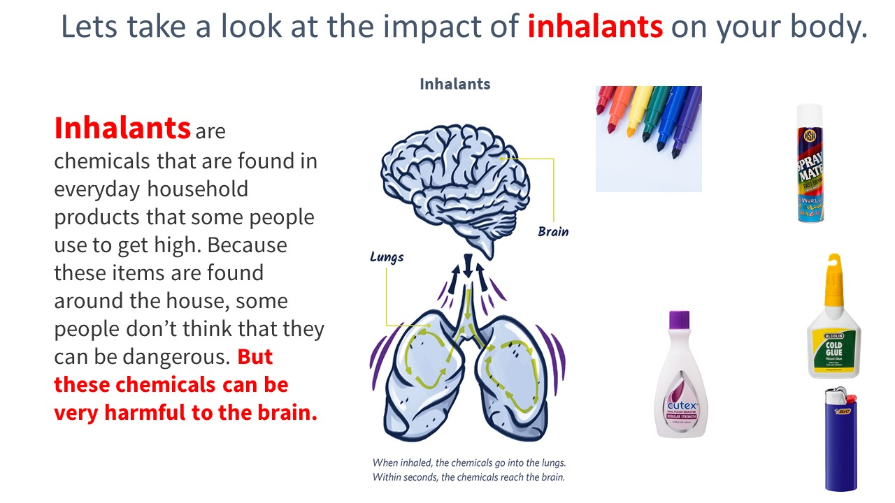
Some products that people inhale:
- Lighters * Nail polish remover * Felt-tip markers * Room fragrances * Spray paint
- Paint thinner * Hair spray * Whipped cream cans * Cleaning products * Keyboard cleaner

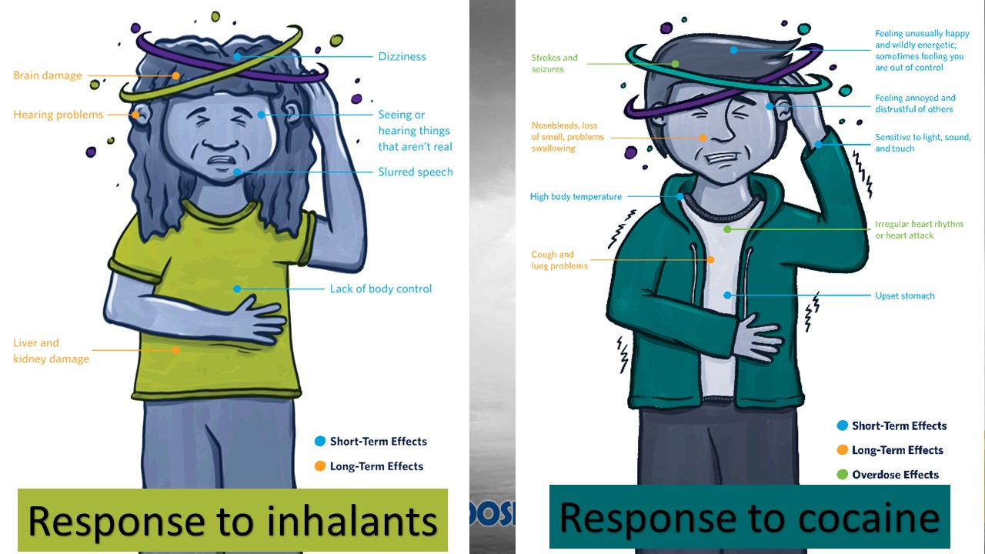
Cocaine changes how the brain works by increasing the amount of a chemical called dopamine in parts of the brain that control reward and motivation. If you use it often, your brain will get used to the large amount of dopamine produced by the drug, and other healthy activities will seem less interesting or fun. You will want more and more of the drug just to feel normal.

Short-Term Effects
High body temperature
Feeling unusually happy and wildly energetic; sometimes feeling you are out of control
Feeling annoyed and distrustful of others
Sensitive to light, sound, and touch
Upset stomach
Long-Term Effects
Nosebleeds, loss of smell, problems swallowing
Cough and lung problems
Overdose Effects
Strokes and seizures
Irregular heart rhythm or heart attack

Rehabilitation options: where to find help, care and support
It’s very difficult to just stop taking drugs when a person is addicted. Many drug addicts feel very alone and believe it’s impossible to overcome drug addiction. Because drugs change the way a person’s brain works and as a result their behaviour, an addict would need professional help to fully recover.
Some symptoms include:
- Withdrawal from family and friends
- Change of behaviour- increase impulsive or anger (mood swings)
- New group of friends
- General self-care- body odour etc is ignored.
If you’re worried your friend might be addicted to drugs, what could you do?
- Recommend they talk to a teacher/ counsellor at school for advice
- Speak to their parents or older siblings to take them to see their doctor
- The doctor might book them into a rehab clinic where specialised help for overcoming addictions can be found.
- In South Africa you could also visit websites like Alcoholics Anonymous or Lifeline
Grade 8’s, you are in a unique time of your life where sometimes you think you can do what you want and nothing bad is going to happen to you. You think you’re invincible. Playing with substance abuse is not a game. You will lose! Learn this lesson now rather than after years of substance abuse and you’re struggling to overcome addiction and get your life back.

