


Lesson 4 - Worksheet

Activity 1:

Question 1
Choose the correct answer and write only the letter (A-D) next to the question number (1.1.1 to 1.1.3), for example 1.1.4. D.
1.1.1 Global warming leads to ……
A. overfishing
B. harmful farming methods
C. pollution
D. climate change

1.1.2 Statistics show that over half of South Africans do not have access to enough food.
The specific term for this is:

- Food security
- Injustice
- Food production
- Unequal food access

1.1.3 An example of a violation of people’s environmental rights is:
A. Residents that use an open field near a school as a dumping ground.
B. A beautiful woman being physically abused by her partner.
C. School children not receiving textbooks at the start of the school year.
D. A farmer spraying his corn crops with non-harmful pesticides.
(3x1) (3)

- Give ONE word/term for EACH of the following descriptions. Write only the word/term next to the question number (1.2.1 to 1.2.5).

  - Farming methods that are cruel to animals. (1)
    - When a resource has been used entirely or is in danger of becoming completely exhausted/reduced. (1)

    - The belief that all citizens should receive equal access to the environmental resources
of a country. (1)

    - A gradual increase in the overall temperature of the earth's atmosphere generally attributed to the greenhouse effect caused by increased levels of carbon dioxide,
CFCs, and other pollutants. (1)

    - The movement of the upper layer of earth or dirt. (1)

(5x1) (5)

Question 2

2.1.1 Define the term environmental disaster, citing ONE example to substantiate your
answer. (2+1) (3)

2.1.2 Discuss ONE thing that should form part of a family emergency plan. (1x2) (2)

2.1.3 Describe TWO positive actions teenagers could take to decrease their carbon
footprint at home. (2x2) (4)

Question 3

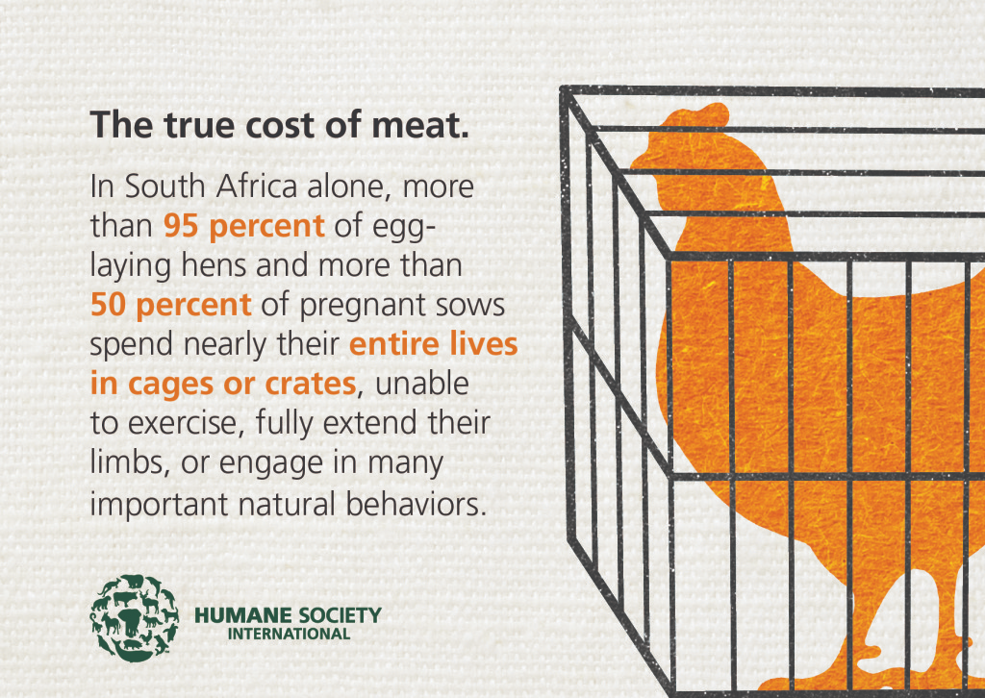
Study the image below and answer the questions that follow.

[Adapted from: http://www.eategrity.co.za Accessed on 15 February 2021]

Write paragraphs on inhumane farming practices in South Africa.

Use the following as a guideline:

- Define the term ‘inhumane farming practices’ and name TWO reasons why
inhumane farming practices have occurred in South Africa’s farming industry. (1+2) (3)

- Discuss FOUR inhumane farming practices that can cause harm to animals. (4x2) (8)

- Recommend THREE ways that South African citizens can decrease inhumane
farming practices. In your answers, indicate how EACH recommendation could
make farms more likely to employ more humane farming practices. (3x3) (9)

[20]

Activity 2: Reflection
Write a paragraph about the presentation today that most inspired you. List how it inspired you to get involved in community services. Include in your paragraph how this group activity has changed your opinion on climate change – and the role of mitigation and adaptation.

Below is a list of practical ways to participate in a community service that addresses a contemporary environmental issue:

- Start a campaign.
- Volunteer at an organization, NPO or NGO
- Start a recycling program at your school.
- Educate your community on how to save water by making posters.
- Get involved in a beach cleanup advertised on social media.
- Create awareness about inhumane farming methods and the dangers of certain foods.

Of these, my choice would be: ______________________________________

