

Grade 9 World of Work: Term 2 Week 6 – 9
GRADE 9 and BEYOND

Lesson 3 – Worksheet MEMO

Activity 1: Informal Assessment

Study the cartoon below and answer the questions that follow.

[Taken from https://salaw.com/views-insights/comic-what-would-you-do-if
an-employee-was-pretending-to-be-sick-may-edition/
Accessed 20 February 2022]
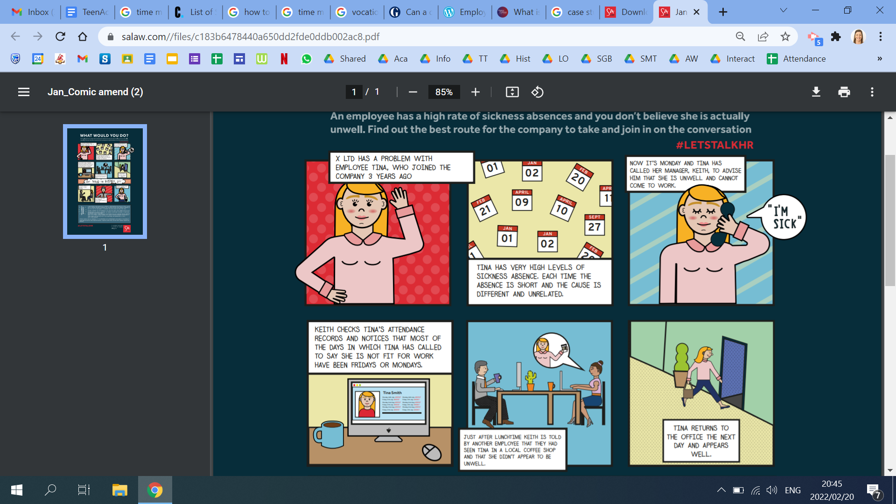

1.1 Define the term ‘employee rights’. (1x1) (1)
- Human rights relating to labour relations between employees and employers ✔
OR
- The rights of workers to be treated in a fair and legal way. ✔
1.2 Provide THREE rights employees must be given in any workplace. (3x1) (3)
Any THREE of the below for ONE mark each
- A safe working environment ✔
- Adequate pay for hours worked ✔
- Scheduled working hours ✔
- Being given adequate breaks ✔
- Leave - including sick leave and holidays ✔

1.3 Every worker has rights at their work. However, they have a responsibility to be at work
every day. Explain TWO reasons how high employee absenteeism can be detrimental for
a business. (2x2) (4)
Any TWO of the below for TWO marks each
(i.e. ONE mark for statement and ONE mark for qualifier / explanation)
- Lack of production/ service ✔ this can cause a loss of income for a business✔
- Additional workload on other employees✔ this can cause added stress or a decrease in work satisfaction from other employees✔
- Lack of customer service✔ which could develop a bad reputation for the business ✔
1.4 Recommend TWO ways that Tina’s employer can ensure in the future that employees
do not take advantage of sick leave. (2x2) (4)
Any TWO of the below for TWO marks each
(i.e. ONE mark for statement and ONE mark for qualifier / explanation)
- Remind employees about the number of days that they may take as sick leave ✔ Appeal to them that these are only for sick leave and not for any other reason✔
- Put in a policy that a doctor’s note is needed for absence on either side of a weekend/ for an extended period of absence ✔ this will make it more difficult for employees to take advantage of sick leave. ✔
- Have workshops to educate/ make employees aware of their responsibilities to the company✔ thereby making them aware of their legal responsibilities as staff to not take advantage of sick leave. ✔
- Have the regulations / policy regarding sick leave visible in strategic places in the workplace✔ thereby ensuring that employees cannot plead ignorance about what is expected✔
- Reward employees who only take sick leave for valid reasons✔ this will encourage other employees to also only take sick leave when necessary. ✔

(12)

