

Grade 9 World of Work: Term 2 Week 6 – 9
GRADE 9 and BEYOND

Lesson 3 - Worksheet

Activity 1: Informal Assessment

Study the cartoon below and answer the questions that follow.

[Taken from https://salaw.com/views-insights/comic-what-would-you-do-if
an-employee-was-pretending-to-be-sick-may-edition/
Accessed 20 February 2022]
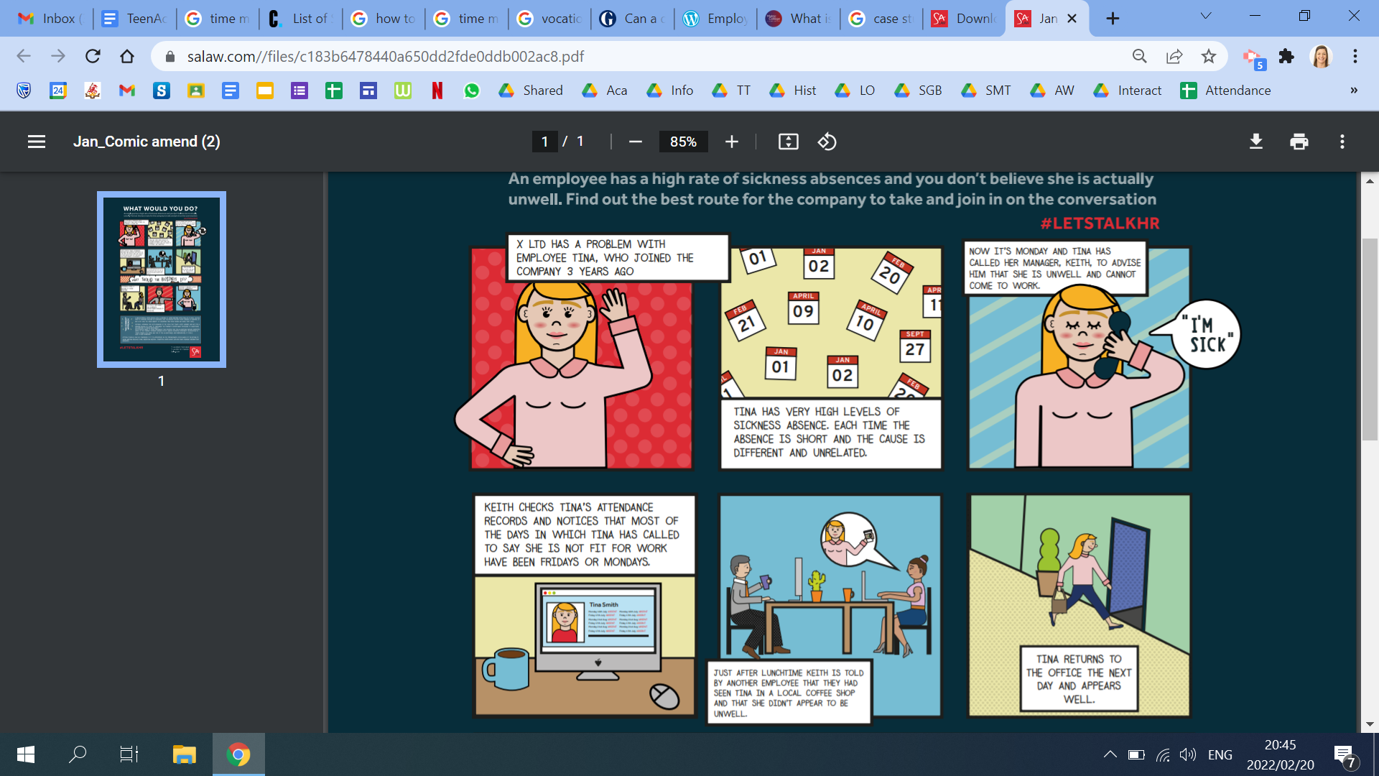

1.1 Define the term ‘employee rights’. (1x1) (1)

1.2 Provide THREE rights employees must be given in any workplace. (3x1) (3)

1.3 Every worker has rights at their work. However, they have a responsibility to be at work
every day. Explain TWO reasons how high employee absenteeism can be detrimental for
a business. (2x2) (4)

1.4 Recommend TWO ways that Tina’s employer can ensure in the future that employees
do not take advantage of sick leave. (2x2) (4)

(12)

