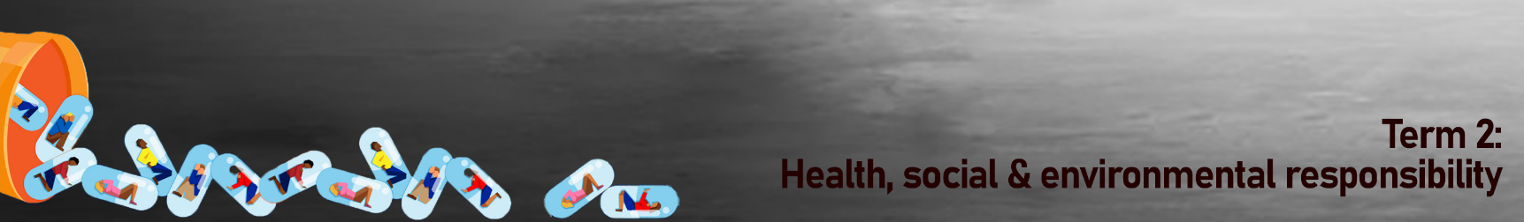
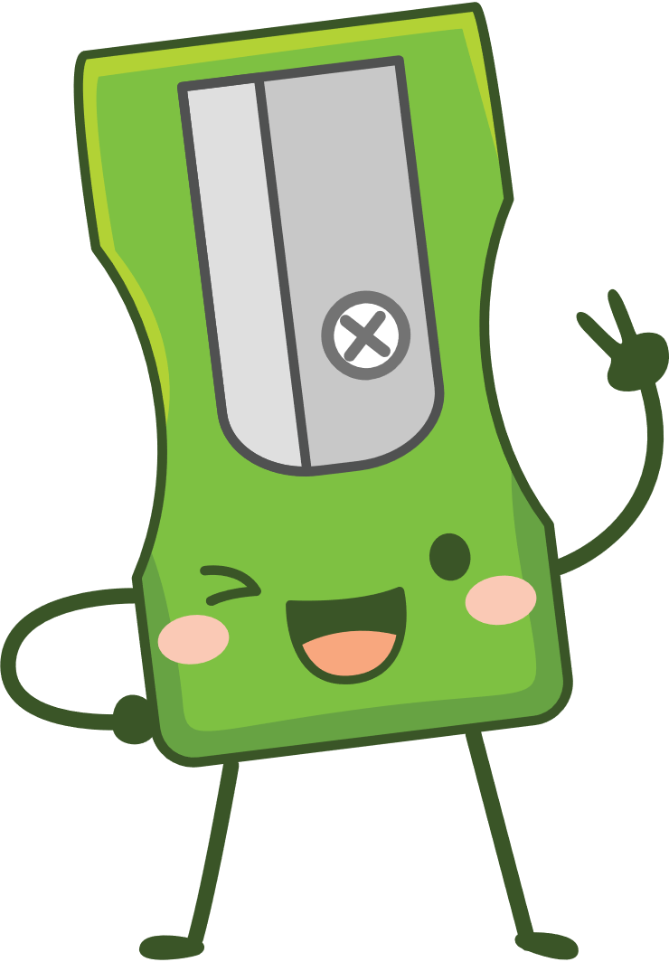
Lesson 3 – Worksheet

Activity 1:
Complete the missing words of the short and long term effects of inhalants on your body.
are chemicals that are found in everyday products that some people use to get high. Because these items are found around the house, some people don’t think that they can be . But these chemicals can be .

Some Products That People Inhale:

* Nail polish remover * ___ *

Room fragrances * ___ * Paint thinner * ___________

Whipped cream cans * Cleaning products * Keyboard cleaner

_____________changes how the brain works by increasing the amount of a chemical called ___________ in parts of the brain that control reward and motivation. If you use it often, your brain will get used to the large amount of dopamine produced by the drug, and other healthy activities will seem less interesting or fun. You will want _______________________ just to feel normal.

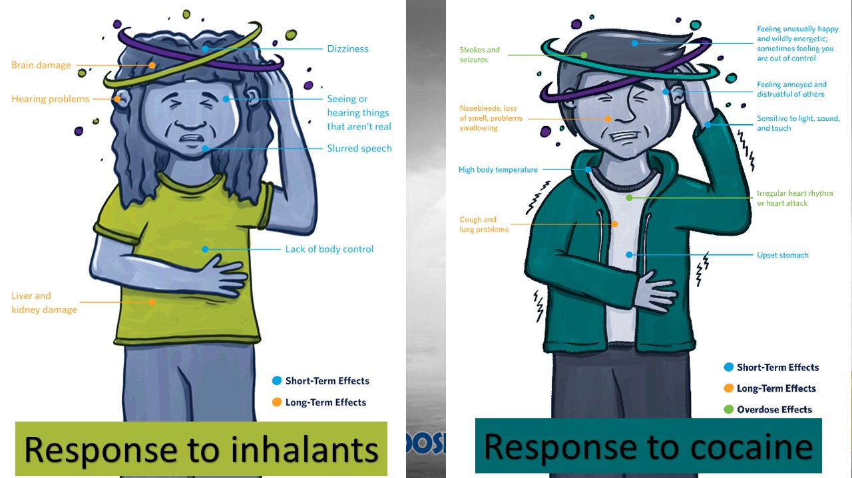
Look at the illustrations of the short and long term effects of inhalants and cocaine and then answer the questions below:
- Name THREE short term effects of inhalants and explain the impact these effects would have on a grade 8 student. (3x2)(6)
_____________________________________________________________________________________________________________________________________________________________________________________________________________________________________________________________________________________________________________________________________________________________________________
_________________________________________________________________________
2) What is the danger of overdosing on cocaine? (2x1)(2)
__________________________________________________________________________________________________________________________________________________

- Give TWO examples of how a cocaine addiction would impact a Grade 8 learners relationship with friends and family. (2x1)(2)
__________________________________________________________________________________________________________________________________________________
Activity 2: Read the following extract from two articles.
IN RECOVERY? AS COVID RECEDES, SA'S GROWING SUBSTANCE ABUSE PROBLEM REVEALED
and
Drug Abuse in South Africa’s Townships
JOHANNESBURG - "I sat this morning with a police officer who starts drinking early afternoon at work without a problem. There is no control.

Another 20-year-old man told Eyewitness News that Cat was his drug of choice and to support his addiction he had resorted to crime. “With the pandemic we had to stay at home, begging for something but no one will tell you to go to school,” he said.

They are both receiving help from local NGO Eagles of Hope. Chairperson Mandla Mnisi said that the pandemic had hit children and young adults the hardest. “They didn’t go to school and after a minute on the street, they get influenced by drugs,” Mnisi said.

Later, Eyewitness News spoke to siblings aged 12, 13 and 15 who hadn’t been to school since the start of the pandemic. Their parents relied on a R1,700 grant to provide for the five-member family. That works out to just R340 for each person for the entire month. The oldest remarked: “I’m just smoking glue, dagga and cigarettes. We feel great when we are smoking. When someone hits us, we don’t feel it.”

and
BRAMPTON, Ontario — Substance abuse triggers 60 percent of crimes in South Africa. In order to finance their habits, youths turn away from school in order to scavenge the community for any means of an earning. During school hours, education is replaced with combing dump sites. At these sites, they look for anything worth saving and eventually selling. Stealing from neighbors is another option which often results in public beatings. Many girls become sex workers in order to make a living. Families implode when drug users place addiction over love.
In South Africa’s townships, drug abuse is not a lifestyle choice, but a characteristic of poverty.

Children must be taught that it is possible to be financially secure in their future, while drug addicts must be taught that it is never too late to rebuild their lives.

- Use a highlighter to identify every example of where substance abuse has led to crime, violence or a disruption in education.

- Choose THREE of the examples you highlighted and explain HOW the short or long term effects of substance abuse has resulted in crime, violence or a disruption in education.
(3x2)(6)
_______________________________________________________________________________________________________________________________________________________________________________________________________________________________________________________________________________________________________________________________________________________________________________________
- Can you identify ONE organisation from the article that tries to assist teenagers who
struggle with substance abuse? (1x1)(1)
_________________________________________________________________________

- Describe the impact that substance abuse has on the teeangers’ education in these articles.
(2x2)(4)

____________________________________________________________________________________________________________________________________________________________________________________________________________________________________________________________________________________________________________

Activity 3: Reflection Activity
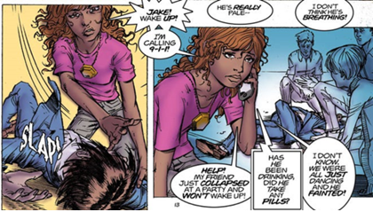
- After this series, what have you learnt that you feel will impact your choices to say NO to Substance Abuse?
____________________________________________________________________________________________________________________________________________________________________________________________________________________________________________________________________________________________________________

- What physical activities could you do with your friends rather than take drugs?
____________________________________________________________________________________________________________________________________________________________________________________________________________________________________________________________________________________________________________

