


Lesson 3 - Worksheet

Activity 1:

As a group discuss the following points in response to the video clip:

- What are some of the relationships between climate change and biodiversity?
- What has been physical impact on communities in South Africa?

- What has been the impact on the South African weather?

- How has South Africa been proactive?
- How do floods impact the health of local communities?

Activity 2:
Read through the list on the slide and provide THREE examples below of what YOU could do to lessen global warming. This means to lessen your carbon footprint which minimizes the greenhouse effect that leads to global warming which in turn leads to climate change.
E.g. Choose to ride your bicycle rather than drive a car.

Activity 3:

As a group you need to plan your interview. Your interview needs to include:
- Someone explaining the name of an organization in your community and the environmental issue that they address OR someone explaining why your group have chosen to interview certain people.
- An interview with someone at this organization explaining how they are impacting on climate change. OR interview members of the community asking how they have tried to positively impact on climate change.
- Include an additional FIVE questions to add insight into this organization.
- Lastly, interview the group members to find out how they intend to participate in community services?
- (Note to teacher- The learners will be presenting these videos to the class in the next lesson. It would also be a wonderful promotion for LO as a subject to upload them onto the school website. However, if you choose to go that route, please ensure that learners and parents have signed a POPI Act release which gives you permission to share their images.)
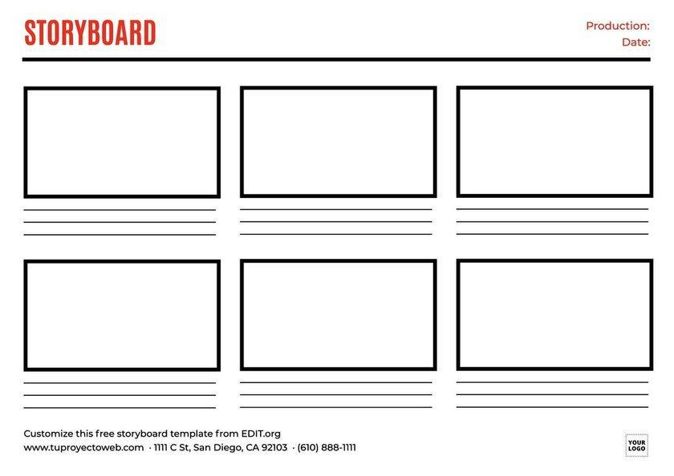

Activity 4:
Reflect on the following:
- Have you considered the importance of climate change on your future and that of your children one day? How would you change the way you live now, knowing that the planet will be a different place in 20 years time if we don’t change our bad habits?

- Explain ONE strategy you could propose to your school RCL to address the issue of climate change.

- Reflect on how you could use social media to create awareness?

