


Lesson 3 - Worksheet

Activity 1:
The following include a list of what the constructive thinker would say. You are required to
describe ONE example of a situations for each of these points.
Eg. See failure as an opportunity to learn something new - Sometimes if I don’t do as well as I hoped in a test, then I know I need to go over the questions and see where I went wrong and practice the correct answer.
2)

5)

1)

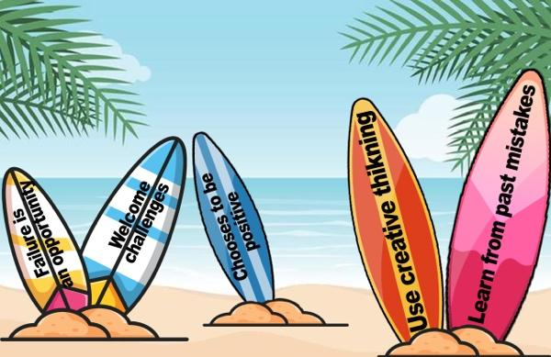

3)

4)

- See failure as an opportunity to learn something new.
- Welcomes challenges with a positive attitude.
- Chooses to be positive in the midst of a problem situation.
- Uses creative thinking - thinking “out the box” - to come up with other possible solutions that is not the obvious choice that most people would make.
- Being a person who learns from past mistakes and applies this knowledge in new situations.
Activity 2:
This activity will be done as a group but each individual in the group needs to record their responses below.

Using the thinking skills (social and constructive) you have learnt through experience today in your groups, you will begin to start planning how your group will make an impact on your community. If you have no idea where to start, look at the list of some groups of people on the slide 6. You could also choose your own group of people.
As a group, fill in your group planning.
  - Start by brainstorming the obvious NEEDS in your community.

2) As a group, what do you need to research this week before next lesson to see how you
can get involved and help.

3) Write up a questionnaire of 5 questions to ask people in your community what they
suggest on how you and your group can help. Groups could even interview using their
cellphones.

4) Can you suggest where/ how you can volunteer to help with this issue?

5) Identify ONE practical way you could redress this social injustice this week for a person.

Activity 3: Reflection Questions
As we end this lesson, reflect on what you have learnt today.

Refer to the list of what a constructive thinker would say in Activity 1:
- Identify TWO of these statements that would be difficult for you?

- How could you make an effort to change this attitude?

