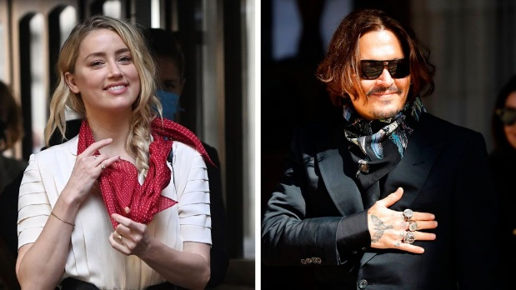
CHARACTERS
Read the following article to understand your character and what issues exactly you have brought to trial. This trial is to determine WHO is guilty of GBV? Your lawyers will ask you questions using the info from the two articles. You get to be creative in your responses. Prepare with the other characters. Your story will support the evidence. Remember what the effects of abuse are and include examples in your responses. Work as a team and manage your time well. You only have 10min!
AMBER HEARD vs JOHNNY DEPP
The witnesses include:
Amber Heard- wife- abuser
Johnny Depp- husband - abuser
Cindy- best friend of Amber and confident
Wynona Ryder- friend of Johnny Depp

Inside the Johnny Depp court case (BBC News)
By David Sillito
Media correspondent (2 November 2020)
https://www.bbc.com/news/entertainment-arts-54506759

In May 2016, Amber Heard, a 30-year-old actress, arrived at a Los Angeles court seeking a restraining order against her husband, the Hollywood star Johnny Depp.
As she left the building, she found herself surrounded by photographers, journalists and film crews. On her cheek was what appeared to be a mark. The court was also shown photographs of what looked like facial bruising.
She said Depp had "violently" attacked her and in a rage had thrown a mobile phone at her face with "extreme force". There were also allegations of other incidents of domestic violence. She said she had endured "excessive emotional, verbal and physical abuse" and "angry, hostile, humiliating and threatening assaults". Depp denied the abuse.
The restraining order was granted, and soon after the marriage was over.
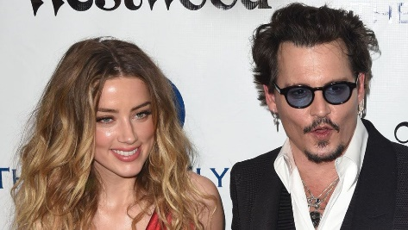
Four years later the couple were back in court, but this time in London. However, this was not Amber Heard's case - she had not chosen to be here. This was a libel action Depp had brought against a British newspaper, The Sun.
At the heart of the case was his assertion that the allegations of physical abuse were an "elaborate hoax". Depp employed one of the best-known libel
barristers in the country to try to prove the claims were untrue.
Over the next three weeks, Heard arrived at court each day and walked past her former husband's fans, who were convinced that it was their hero who was the victim and it was she who had assaulted him. In court her story, photos, memories and the accounts of her friends were all exposed to the world and said by Depp's team and supporters to be part of a plot to falsely prove that he was, as The Sun had claimed in April 2018, a "wife beater".

The Royal Courts of Justice are huge, gothic and deeply solemn. It's a place of stone arches and hushed tones. And in July it was almost empty. I say almost, because there were a few people - a handful of journalists hurrying through security, and also lingering in the hallways and passages a scattering of Depp fans.
One woman showed me her arms, which were covered in tattoos of Johnny Depp. Another man arrived each day dressed as Jack Sparrow, the star's character in Pirates of the Caribbean.
And then at around 10:00 each day they would gather at the door to Court 13. As Depp walked past they would offer messages of support and, towards the end of the case, he was seen giving them all a hug. A little chant of "Johnny, Johnny" could be heard as he walked into court.
Ten minutes later, he was sitting in the witness stand trying to convince a High Court judge he was not a "wife beater".

The accusations were shocking. Heard said she had been assaulted by him on more than 14 occasions. She said she had, at times, been in fear for her life and left with a broken nose, black eyes and split lip. Vicious, drunken tirades had, she said, lasted for days. There was also a 15th allegation too traumatic and personal to be heard in open court.
It felt like a criminal trial; Depp was being accused of repeated assaults on his former partner, the sort of violence that has sent others to prison. But this wasn't a criminal trial.
It was easy to forget this was a libel battle between Depp and News Group Newspapers, the publishers of The Sun, because no-one from the newspaper was called to the witness stand. Dan Wootton, the journalist whose article had said there was "overwhelming evidence" that the actor was a "wife beater" was not even on the list of 79 names cited in the trial's documents.
And what a list of names it was. The case began with an email exchange about the perils of addiction between Depp and Sir Elton John and then continued with references to a bewildering cast of characters. James Franco, Marilyn Manson, Elon Musk, Winona Ryder, Kate Moss and Vanessa Paradis were all guest stars in a story that took a private world of the Hollywood A-list and blew it apart.
We were shown text messages and video footage of meetings in lifts. The super-rich spend millions protecting their privacy and here was a couple revealing a telephone directory's worth of secrets. No star would do this unless they felt there was something bigger at stake. For Depp, that was restoring his reputation.

Why London?
Amber Heard was 22 when she met Johnny Depp on the set of the film The Rum Diary in 2009. He was 23 years older and in a long-term relationship with singer and actress Vanessa Paradis. Heard's wife at the time was the artist Tasya Van Ree.
Two years later, Heard was living with Depp in a penthouse in downtown LA, Depp having separated from Paradis, his partner of 14 years. Heard and Depp married in February 2015, and just over a year later it was over.

Since then, Amber Heard has become a vocal campaigner on the issue of domestic and sexual abuse. The UN Human Rights Campaign named her as a Human Rights Champion for her work promoting women's rights. She became an Ambassador for Women's Rights for the American Civil Liberties Union (ACLU) and she has given speeches and written in the Washington Post and New York Times about her experience of domestic violence.
In the era of Me Too, she was a leading figure, speaking up for women who had suffered in silence by revealing the abuse she had endured at the hands of one of the most powerful people in Hollywood. She was Amber Heard, actor, model, activist and domestic abuse survivor.

When Johnny Depp described her accusations as a hoax, he was not just challenging her story, he was ripping away the foundations of her public profile. There was a lot at stake here.
The entire process, which involved an almost brutal public examination of a couple's private life, has been a warning to anyone who wants to use the courts to restore a reputation.
It was clearly a deeply troubled relationship, but the case depended on proving who had done what to whom.
And in the end, the judge decided it was true to describe Depp as a "wife beater" and the Sun’s allegations were "substantially true".

2) A complete timeline of Johnny Depp and Amber Heard's tumultuous relationship. (INSIDER News)
Jacob Sarkisian and Zac Ntim Mar 25, 2021, 2:56 PM
https://www.insider.com/johnny-depp-amber-heard-relationship-timeline-2020-7

After Johnny Depp lost his high-profile libel case against the publishers of The Sun newspaper over a 2018 article that described him as a "wife-beater," the actor announced that he has been "asked to resign" from the upcoming "Fantastic Beasts 3."
Depp has vehemently denied the claims of abuse but was once again denied permission to appeal the court's ruling in March 2021. Court of Appeal judges said the original hearing "was full and fair" and that the trial judge "gave thorough reasons for his conclusions which have not been shown even arguably to be vitiated by any error of approach or mistake of law."
Depp had previously been in relationships with Winona Ryder (from 1989 to 1993), Kate Moss (1994 to 1998), and Vanessa Paradis (1998 to 2012).
Here's a complete timeline of their tumultuous relationship.
In 2009, Depp met Heard on the set of 'The Rum Diary'
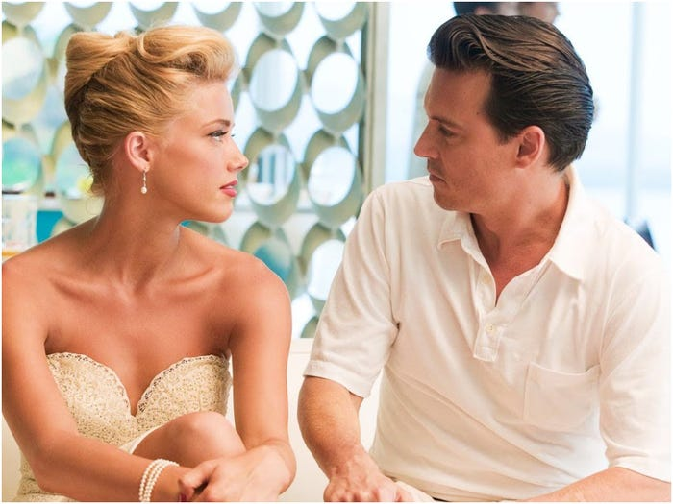
Johnny Depp and Amber Heard in "The Rum Diary." FilmDistrict
Depp and Heard were dating by early 2012

In a court filing, Heard wrote that she and Depp began dating "around the end of 2011 or the start of 2012." It was also in 2012 that Depp and long-time partner Paradis publicly announced their separation after 14 years of dating. Depp had two children with Paradis: Lily-Rose (born in 1999) and John Christopher (2002).
Heard split up with partner Tasya van Ree at the same time. USA Today reported that Heard was arrested in 2009 on a charge of physically assaulting then-girlfriend van Ree at Seattle-Tacoma International Airport in Washington. The two got into a disagreement after Heard allegedly grabbed and hit van Ree's arm.
All charges were dropped, however, with van Ree herself saying that Heard was "wrongfully" accused by cops who "misinterpreted and over-sensationalized" the incident.

In 2015, Depp and Heard married in a private ceremony. On May 23, 2016, Heard filed for divorce from Depp and also obtained a temporary restraining order against the Oscar-nominated actor. She alleged that Depp had physically abused her during their relationship, and said it was usually while under the influence of drugs or alcohol.
She alleged that at the time of filing for divorce, an incident had recently taken place in which Depp threw his phone at her, leaving her with a bruised face. However, a police spokesman told People that an investigation into the domestic incident radio call found that no crime had taken place.
Depp denied these accusations and through his representatives said Heard was "attempting to secure a premature financial resolution by alleging abuse."
A $7 million settlement was reached out of court on August 16, 2016
Heard testified under oath at a deposition, but a settlement was eventually reached after she withdrew her request for a domestic violence restraining order. She also rescinded her spousal support request of $50,000 a month.
Depp and Heard also released a joint statement, saying: "Our relationship was intensely passionate and at times volatile, but always bound by love. Neither party has made false accusations for financial gain."
It continued: "There was never any intent of physical or emotional harm."
Heard received $7 million from the divorce but donated it to charity, according to People.
In 2017, the divorce was finalized

Amber Heard filed for divorce in 2016. The Hollywood Reporter reported that a non-disparagement clause was inserted into the settlement that prevented either party from saying anything negative about the high-profile relationship and break-up.
In December 2018, Heard wrote an op-ed for The Washington Post saying she was abused

Heard alleges that Depp physically abused her. The Sun UK
Heard wrote an op-ed for The Washington Post in which she spoke about the treatment of women in domestic abuse cases.
In the op-ed, Heard wrote: "I became a public figure representing domestic abuse, and I felt the full force of our culture's wrath for women who speak out." Depp himself was never mentioned by name. In 2019, Depp sued Heard for $50 million for defamation over the WaPo article. The suit said that Heard "is not a victim of domestic abuse, she is a perpetrator," and denied that Depp ever abused her. Instead, the suit said that Heard's allegations were part of an "elaborate hoax to generate positive publicity" for the actress.
Depp's lawyers said: "The op-ed depended on the central premise that Ms. Heard was a domestic abuse victim and that Mr. Depp perpetrated domestic violence against her."
In a court filing that attempted to dismiss Depp's defamation suit, Heard detailed multiple instances of alleged abuse that she said occurred during their marriage and referred to him as "the Monster," per Variety.

Heard claimed that she still had scars on her arms and feet from an incident where Depp allegedly threw her through a ping pong table and dragged her through broken glass.
In 2020, phone recordings were released in which Heard admitted to 'hitting' Depp. In January, phone recordings obtained by the Daily Mail were released. In these recordings, Heard admitted to "hitting" Depp.
Heard is heard saying: "I'm sorry that I didn't ... hit you across the face in a proper slap, but I was hitting you, it was not punching you. Babe, you're not punched. "I don't know what the motion of my actual hand was, but you're fine, I did not hurt you, I did not punch you, I was hitting you." Meanwhile, Depp said in the recording: "I left last night. Honestly, I swear to you because I just couldn't take the idea of more physicality, more physical abuse on each other. "Because had we continued it, it would have gotten f---ing bad. And baby, I told you this once. I'm scared to death we are a f---ing crime scene right now," Depp continued.
Heard replied: "I can't promise you I won't get physical again. God, I f---ing sometimes get so mad I lose it."
On July 7 2020, the three-week libel trial began.

Ryder and Paradis both provided statements in Depp's defense.
Ryder wrote: "The idea that he is an incredibly violent person is the farthest thing from the Johnny I knew and loved. I cannot wrap my head around these accusations."
Meanwhile, Paradis wrote that Heard's accusations are "nothing like the true Johnny I have known, and from my personal experience of many years, I can say he was never violent or abusive to me."
The trial began in early July, and lasted three weeks. Depp alleged that Heard defecated in his bed and punched him, which Heard denies. Depp also accused Heard of having extra-marital affairs with James Franco and Elon Musk, which Heard also denies.
Heard, meanwhile, accused Depp of physically abusing her, and has also accused him of throwing a phone at her face, which she says left her bruised. Furthermore, Hear said that Depp threatened to kill her on several occasions.
On November 2 the court ruled against Depp in the libel trial

Johnny Depp has strenuously denied all claims that he was violent towards Heard and in a statement published shortly after the ruling, his lawyers said: "This decision is as perverse as it is bewildering.
"Most troubling is the judge's reliance on the testimony of Amber Heard, and corresponding disregard of the mountain of counter-evidence from police officers, medical practitioners, her own former assistant, other unchallenged witnesses and an array of documentary evidence which completely undermined the allegations, point by point.
"All of this was overlooked. The judgment is so flawed that it would be ridiculous for Mr. Depp not to appeal this decision. In the meantime, we hope that in contrast to this case, the ongoing libel proceedings in America are equitable, with both parties providing full disclosure rather than one side strategically cherry-picking what evidence can and cannot be relied upon."
Depp has also launched a $50m case against Heard in the US over a column she penned for the Washington Post about her experience as a victim of domestic violence. While Depp is not named in Heard's piece, his legal team insists that it is strongly inferred that the article is about him.
"My resolve remains strong and I intend to prove that the allegations against me are false," Depp added. "My life and career will not be defined by this moment in time."
In March 2021, Depp was once again denied permission to appeal against the high court ruling by the Court of Appeals in London

During the evidence given at the application hearing, Depp's lawyers said that they had not received a fair trial and presented "fresh evidence" that alleged Amber Heard lied about donating her full $7 million divorce settlement to charity. Depp's lawyer Andrew Caldecott QC told the court that Heard's claim about the donation was a "calculated and manipulative lie" that "tipped the scales against Mr. Depp from the very beginning," The Guardian reported.

