

Grade 9 World of Work: Term 2 Week 6 – 9
GRADE 9 and BEYOND
Lesson 2 – Worksheet MEMO

Design your FUTURE Roadmap on this page.
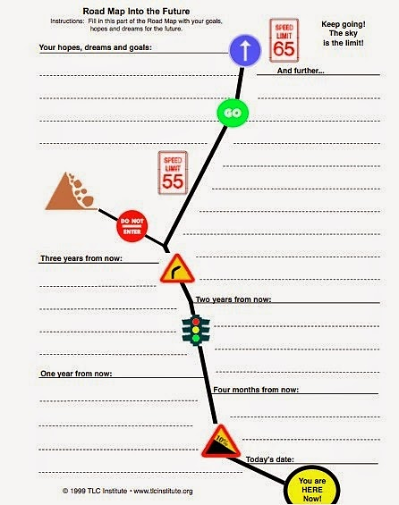

Learner will give personal responses for this activity.

Activity 2: Informal Assessment

Study the image and text below and answer the questions that follow.


[Taken from https://oecdskillsandwork.wordpress.com/2015/07/29
/employability-is-vocational-education-better/
Accessed 20 February 2022]
At the end of Grade 9, learners can decide to remain in school and complete their NSC or they can pursue an NVC. Both these choices come with pro’s and con’s.
Source: Anonymous

Write paragraphs on human rights.
Use the following as a guideline.

- Differentiate between a ‘National Senior Certificate’ and a ‘National Certificate Vocational’.
(2x1) (2)
National Senior Certificate is a certificate that signals to learners and guardians that the individual has successfully completed his/her required years of schooling✔ whereas a National Certificate Vocational is a qualification created to provide workplace-based skill sets in various career fields that are in demand in South Africa ✔

- Discuss TWO positive outcomes of pursuing vocational training. (2x2) (4)
Any TWO of the below or any relevant answers for TWO marks each
(i.e. ONE mark for statement and ONE mark for qualifier / explanation)
- A vocational school teaches hands-on, applied skills✔ that makes learners more employable for practical work✔
- Vocational school graduates tend to go into the career they trained for✔ This alleviates any indecision ✔
- Vocational training is the action of teaching or learning practical skills or type of behaviour✔ which may benefit to learners who enjoy more practical learning ✔
- Recommend TWO practical ways to help learners to make informed decisions about
what they should do after Grade 9. (2x2) (4)
Any TWO of the below for TWO marks each
(i.e. ONE mark for statement and ONE mark for qualifier / explanation)
- Speak to their LO teacher ✔ As they will be able to provide information about different options ✔
- Research what qualifications are needed for their potential career field ✔ this will let them see if they should leave school in Grade 9 of if they need to stay on and finish grade 12 ✔
- Speaking to people who have attended TVET colleges/ universities ✔ This may allow them to get a better understanding of what to expect at these different facilities ✔

(10)

