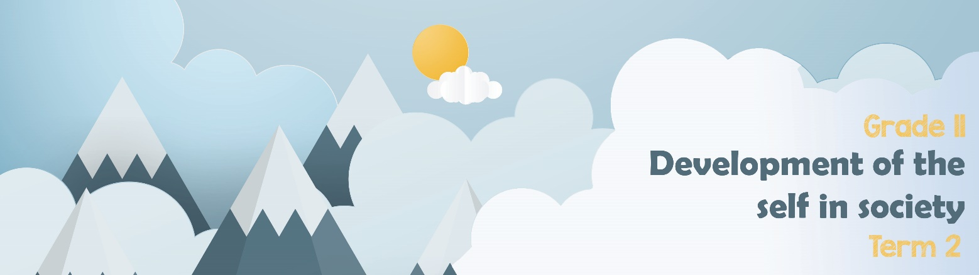

Lesson 3 – Worksheet MEMO
Activity 1: Complete the following from your Lesson 3 - PowerPoint.
The emotional effects of GBV include:
- Fear of the other person
- Depression
- Fear for your personal safety
- Anger towards the abuser and yourself
- Feelings of guilt because you think you may be responsible for the abuse.
- Afraid to trust other people
- Absolute feelings of hopelessness and helplessness

The psychological effects of GBV include:
- Increased likelihood of substance abuse
- Suicidal thoughts and actions like “cutting”
- PTSD- post traumatic stress disorder
- Persistent nightmares in children
- Increased anxiety

The physical effects of GBV include:
- Bruises
- Broken bones and teeth
- Rope or strap marks
- STI’s, HIV, AIDs
- Bald spots where your hair has been pulled out
- Burn marks from cigarettes, irons or hot water
- Unwanted pregnancies
- Death

Negative effects on individual health and well-being
Negative effects on the family
The effect and how it contributes to broken family structures:
- Children suffer emotional damage when they watch their mothers and sisters abused.
- Two parent homes break up and children are torn between parents.
- In the broken home, the new female head struggles against increased poverty and social repercussions.
- Teenagers act out of distress and bully others.
- Academics suffer under the pressures from the home environment.

Activity 2: Informal Assessment
You have had an opportunity to see the effect gender-based violence has had on individuals and families. In the space provided, brainstorm and explore how GBV contributes to the following sectors of society as a whole.
Refer to the following in your brainstorm:
Learners could include some of the following points:

Inability to build trusting relationships
- Rejection, ostracism and social stigma at community level – victims struggle to trust people in relationships, even with those who have good intentions.
- Reduced ability to trust, because they are blamed, stigmitised by family, friends and society.
- Acute fear of future violence, which extends beyond the individual survivors to other members in community – which is often the reason to rather not trust anyone. (privacy)
- Vulnerability – they always feel judged and people tend NOT to listen with respect, or acknowledge the autonomy of survivor / victim, the abuse and injustice- which leads to fear of initiating or building new relationships.
Increase in social ills:
- Job loss which leads to unemployment, due to absenteeism because of violence.
- Drug- abuse - which in turn can limit their income-generating opportunities
- Poverty and malnutrition
- Negative impact on women’s income generating power, which often leads to prostitution.
- It affects job performance and leads to lateness, decreased job retention and career advancement, and this affects unequal opportunities.
- Victims of gender discrimination lose motivation and morale necessary to perform their jobs effectively, which also leads to job losses(unemployment).
Increased burden on healthcare system:
- Hospitals need to cater for more cases of gender-based violence, filling up the emergency rooms.
- This in turn impacts the number of people needing assistance in clinics and more women needing alternative living arrangements to prevent further abuse.
- Increased number of HIV and AID victims … because of rape.
- Increased number of women with sexually transmitted illnesses ...
- Women / young women need mental health support because of trauma …
Increased burden on judicial system:
- Increased number of cases that need to be brought to trial.
- Prisons are full of perpetrators waiting for trial which becomes an increased expense on government.
- Increased administration of managing documentation and evidence in GBV cases.

BROKEN RELATIONSHIPS
JUDICIAL
HEALTHCARE
SOCIAL
I
LLS
IMPACT ON SOCIETY
Activity 3: HOMEWORK REFLECTION
Take a moment to reflect on your response to the trial between Amber Heard and Johnny Depp in class. Write a short essay in which you summarise what you have learnt. Include comments on the following:
- How GBV contributes to many broken family structures
- Financial impact on Heard and Depp.
- Psychological impact of GBV.
- Burden on the judicial system.

This essay focuses on the learner’s experience of the lesson and therefore there is no memo guideline.

