

Grade 9 World of Work: Term 2 Week 6 – 9
GRADE 9 and BEYOND
Lesson 2 - Worksheet
Activity 1:
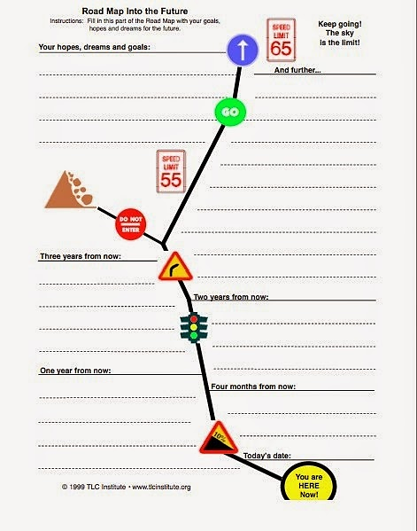
Design your FUTURE Roadmap on this page.
Activity 2: Informal Assessment

Study the image and text below and answer the questions that follow.
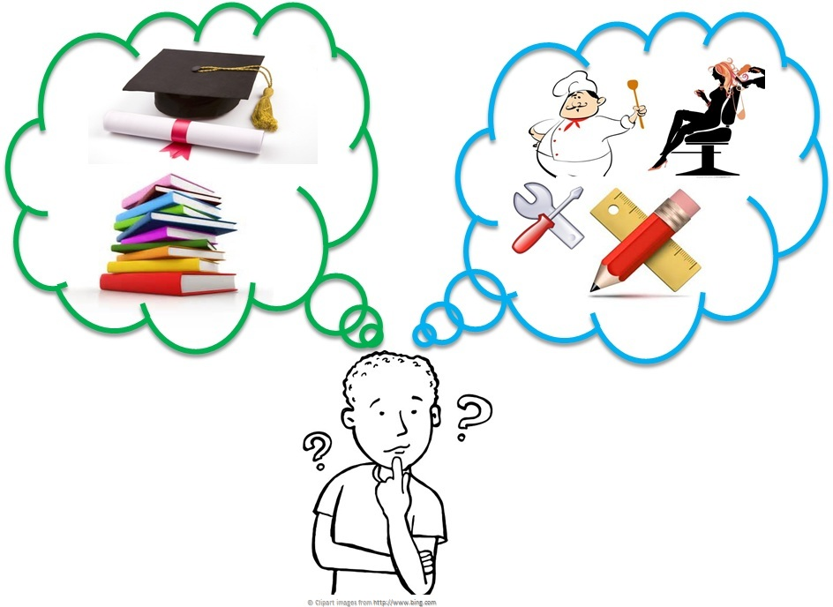

[Taken from https://oecdskillsandwork.wordpress.com/2015/07/29
/employability-is-vocational-education-better/
Accessed 20 February 2022]
At the end of Grade 9, learners can decide to remain in school and complete their NSC or they can pursue an NVC. Both these choices come with pro’s and con’s.
Source: Anonymous

Write paragraphs on human rights.
Use the following as a guideline.

- Differentiate between a ‘National Senior Certificate’ and a ‘National Certificate Vocational’.
(2x1) (2)

- Discuss TWO positive outcomes of pursuing vocational training. (2x2) (4)

- Recommend TWO practical ways to help learners to make informed decisions about
what they should do after Grade 9. (2x2) (4)

(10)

